SEC Form 3
FORM 3 | UNITED STATES SECURITIES AND EXCHANGE COMMISSION
 | Washington, D.C. 20549
 | Washington, D.C. 20549 |  | OMB APPROVAL
 | INITIAL STATEMENT OF BENEFICIAL OWNERSHIP OF SECURITIES
 | INITIAL STATEMENT OF BENEFICIAL OWNERSHIP OF SECURITIES |  | OMB Number: | 3235-0104
 |  |  | Estimated average burden
 | Filed pursuant to Section 16(a) of the Securities Exchange Act of 1934 |  | hours per response: | 0.5
or Section 30(h) of the Investment Company Act of 1940
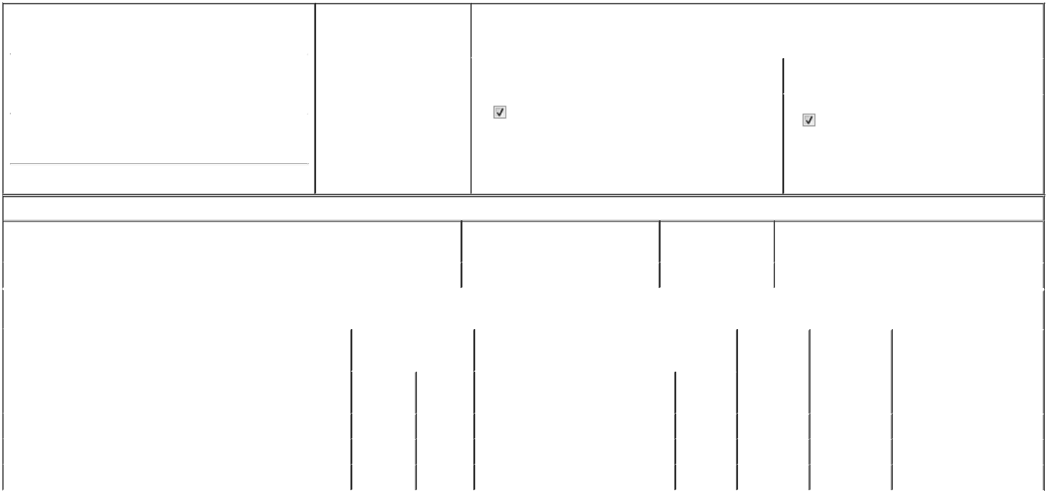

1. Name and Address of Reporting Person* |  |  |  |  |  | 2. Date of Event Requiring
 |  | Hinson Kristoffer L |  |  |  | Statement (Month/Day/Year)
 |  |  |  |  | 05/11/2026
 |  | (Last) | (First) |  | (Middle)
 |  | 8020 KATY FREEWAY
(Street)
 |  | HOUSTON | TX |  | 77024

3. |  | Issuer Name and Ticker or Trading Symbol
CROWN CASTLE INC. [ CCI ]
4. |  | Relationship of Reporting Person(s) to Issuer |  |  | 5. | If Amendment, Date of Original Filed (Month/Day/Year)
(Check all applicable)
 |  | Director |  | 10% Owner
 |  |  |  | 10% Owner | 6. | Individual or Joint/Group Filing (Check Applicable Line)
 |  | Officer (give title |  | Other (specify below) | 6. | Individual or Joint/Group Filing (Check Applicable Line)
 |  | below) |  | Other (specify below) |  | Form filed by One Reporting Person
 |  | EVP and CCO |  |  |  | Form filed by More than One Reporting Person

(City) (State) (Zip)

Table I - Non-Derivative Securities Beneficially Owned

1. Title of Security (Instr. 4) | 2. Amount of Securities Beneficially | 3. Ownership Form: | 4. Nature of Indirect Beneficial Ownership (Instr. 5)
 | Owned (Instr. 4) | Direct (D) or Indirect
 |  | (I) (Instr. 5)

 | Common Stock, $0.01 Par Value |  |  |  | 500⁽¹⁾ | I | By 401(K) Plan
 |  |  | Table II - Derivative Securities Beneficially Owned
 |  | (e.g., puts, calls, warrants, options, convertible securities)
 | 1. Title of Derivative Security (Instr. 4) |  | 2. Date Exercisable and |  | 3. Title and Amount of Securities Underlying |  | 4. | 5. Ownership | 6. Nature of Indirect Beneficial
 |  |  | Expiration Date |  | Derivative Security (Instr. 4) |  | Conversion | Form: Direct | Ownership (Instr. 5)
 |  |  | (Month/Day/Year) |  |  |  | or Exercise | (D) or Indirect
 |  |  |  |  |  |  | Price of | (I) (Instr. 5)
 |  |  |  |  |  | Amount or | Price of | (I) (Instr. 5)
 |  |  |  |  |  | Amount or | Derivative
 |  |  | Date | Expiration | Title | Number of | Security
 |  |  | Exercisable | Date | Title | Shares
 | Time RSUs | (2) |  | (2) | Common Stock | 1,049 | (3) | D
 | Time RSUs | (4) |  | (4) | Common Stock | 3,036 | (3) | D
 | Time RSUs | (5) |  | (5) | Common Stock | 7,185 | (3) | D
 | Explanation of Responses:

1. Represents shares previously acquired in transactions exempt under Rule 16b-3(c).

2. 100% of these Time Restricted Stock Units ("RSUs") are scheduled to vest on February 19, 2027.

3. Each RSU is issued pursuant to the Crown Castle Inc. 2022 Long-Term Incentive Plan, as amended, and represents a contingent right to receive one share of common stock.

4. Approximately 50% of these Time RSUs are scheduled to vest on February 19 of each of 2027 and 2028.

5. 33 1/3% of these Time RSUs are scheduled to vest on February 19 of each of 2027, 2028 and 2029.

Remarks:

Exhibit List Exhibit 24 - Power of Attorney

 | /s/ Inge Pasman, Attorney-in-Fact |  |  | 05/21/2026
 | ** Signature of Reporting Person |  | Date
Reminder: Report on a separate line for each class of securities beneficially owned directly or indirectly.
* If the form is filed by more than one reporting person, see Instruction 5 (b)(v).
** Intentional misstatements or omissions of facts constitute Federal Criminal Violations See 18 U.S.C. 1001 and 15 U.S.C. 78ff(a).
Note: File three copies of this Form, one of which must be manually signed. If space is insufficient, see Instruction 6 for procedure.
Persons who respond to the collection of information contained in this form are not required to respond unless the form displays a currently valid OMB Number.



