UNITED STATES

SECURITIES AND EXCHANGE COMMISSION

Washington, D.C. 20549

SCHEDULE 14A

Proxy Statement Pursuant to Section 14(a) of the Securities

Exchange Act of 1934 (Amendment No. )

Filed by the Registrant x

Filed by a Party other than the Registrant ☐

Check the appropriate box:

- Preliminary Proxy Statement

- Confidential, for Use of the Commission Only (as permitted by Rule 14a-6(e)(2))

- Definitive Proxy Statement

- Definitive Additional Materials

- Soliciting Material under §240.14a-12

Crown Castle Inc.

(Name of Registrant as Specified In Its Charter)

(Name of Person(s) Filing Proxy Statement, if Other Than the Registrant)

Payment of Filing Fee (Check all boxes that apply):

- No fee required.

- Fee paid previously with preliminary materials.

- Fee computed on table in exhibit required by Item 25(b) per Exchange Act Rules 14a-6(i)(1) and 0-11.



April 6, 2026

Dear Stockholder:

It is our pleasure to invite you to attend the 2026 Annual Meeting of Stockholders ("Annual Meeting") of Crown Castle Inc. ("Company" or "Crown Castle"), which will be held on May 20, 2026, at 9:00 a.m. Central Time. The meeting will be held in virtual meeting format only, via live webcast, at www.virtualshareholdermeeting.com/CCI2026. The Notice of Annual Meeting and Proxy Statement ("Proxy Statement") accompanying this letter describe the business to be conducted at the Annual Meeting.

The Board of Directors ("Board") welcomes this opportunity to have a dialogue with our stockholders and looks forward to your comments and questions regarding the Company. You can find information about the Company and its strategy to create long-term stockholder value in "Item I. Business—Strategy" of our Annual Report on Form 10-K for the year ended December 31, 2025 ("2025 Form 10-K").

We have elected to furnish proxy materials and our Annual Report for the year ended December 31, 2025, which includes a copy of our 2025 Form 10-K ("2025 Annual Report"), to many of our stockholders over the internet pursuant to Securities and Exchange Commission rules, which allows us to reduce costs associated with the Annual Meeting. On or about April 6, 2026, we intend to send most of our stockholders a Notice of Internet Availability of Proxy Materials ("Proxy Materials Notice") containing instructions on how to access our Proxy Statement and 2025 Annual Report and how to submit proxies. Those who do not receive a Proxy Materials Notice will receive a copy of the Proxy Statement and 2025 Annual Report by mail, unless they have previously requested delivery of materials electronically. The Proxy Materials Notice also contains instructions on how you can elect to receive a printed copy of the Proxy Statement and 2025 Annual Report, if you only received a Proxy Materials Notice.

It is important that your shares be represented at the Annual Meeting, regardless of the number you may hold. Whether or not you plan to attend, please promptly cast your vote in one of the ways outlined in the following Proxy Statement in order to have your shares voted at the Annual Meeting.

We appreciate your continued support of Crown Castle, and we look forward to seeing you on May 20, 2026.

Kind Regards,
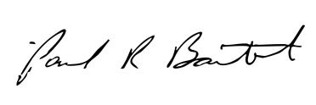

P. Robert Bartolo

Chair of the Board of Directors

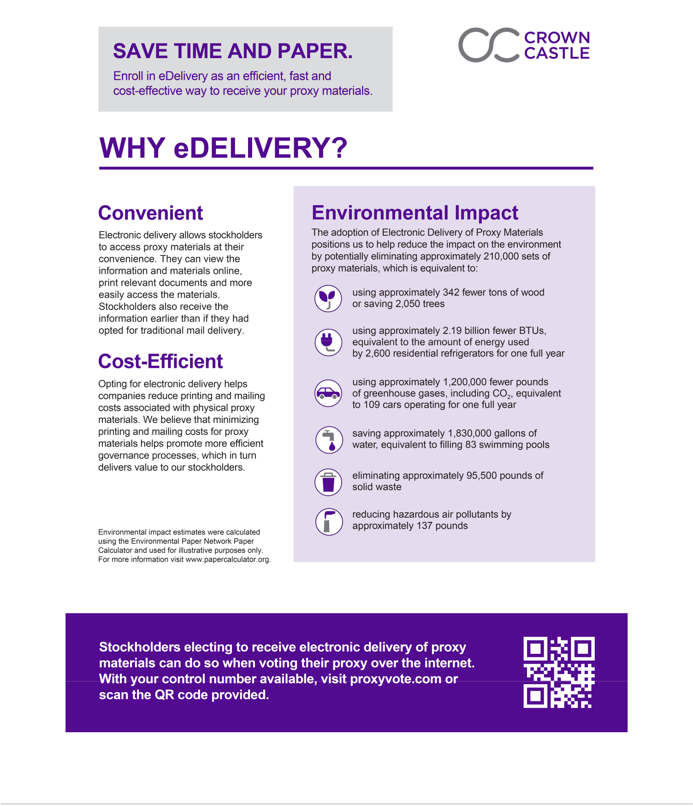



NOTICE OF ANNUAL MEETING OF STOCKHOLDERS

May 20, 2026

9:00 AM (Central Time)

April 6, 2026

Dear Stockholder:

You are invited to the 2026 Annual Meeting of Stockholders ("Annual Meeting") of Crown Castle Inc. ("Company"). The Annual Meeting will be held in a virtual meeting format only, via live webcast, on Wednesday, May 20, 2026. At the Annual Meeting, stockholders will be asked to consider and vote upon the following matters:

Company Proposals

- the election of nine (9) director nominees for a one-year term;

- the ratification of the appointment of PricewaterhouseCoopers LLP as our independent registered public accountants for fiscal year 2026;

- a non-binding, advisory vote to approve the compensation of our named executive officers; and

- transact such other business that properly comes before the Annual Meeting or any adjournment or postponement thereof.

Only stockholders at the close of business on March 23, 2026 ("Record Date"), will be entitled to vote at the Annual Meeting, unless a new record date is set or the meeting is adjourned or postponed ting. Please submit your proxy in advance of the Annual Meeting in any of the following ways:

- Mail. Mark, sign, date and return the proxy card or voting instruction form (see instructions on the Notice of Internet Availability of Proxy Materials ("Proxy Materials Notice") on how to request a printed proxy card or voting instruction form).

- Phone. Call the toll-free number listed on your proxy card or voting instruction form or follow the voting instructions provided by your bank, broker or other nominee to determine whether you may vote by telephone.

- Internet. Visit the website listed or scan the QR code located on your proxy card or voting instruction form or Proxy Materials Notice and follow the instructions provided.

Have your proxy card or voting instruction form or Proxy Materials Notice in front of you when submitting a proxy by phone or the internet; the proxy card contains important information that is required to cast your vote. Alternatively, you may vote your shares at the Annual Meeting. For important information regarding attending and voting at the Annual Meeting, see "VI. Information About the Annual Meeting."

Your vote is important. To be sure your vote counts and to ensure a quorum, please submit your proxy in one of the ways previously outlined, whether or not you plan to attend the Annual Meeting.

By Order of the Board of Directors,
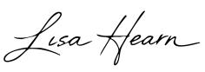

Lisa Hearn

Corporate Secretary

- Proxy Statement Summary

- Election of Directors

Proposal 1

Nominees for Director

Board Matrix

Board Leadership Structure

Meetings

Director Time Commitments

Risk Oversight

Board Committees

Board Independence

Board Compensation

Director Compensation Table for 2025

Director Stock Ownership Guidelines

Certain Relationships and Related Transactions

- Ratification of Appointment of Independent Registered Public Accountants

Proposal 2

Audit Committee Matters

Audit Committee 2025 Report

IV. Executive Compensation

Proposal 3

Executive Officers

TABLE OF CONTENTS

Page

- Compensation Discussion and Analysis

- Compensation and Human Capital Committee 2025 Report

- Summary Compensation Table

- All Other Compensation Table

- Grants of Plan-Based Awards in 2025

- Outstanding Equity Awards at 2025 Fiscal Year-End

18 | Option Exercises and Stock Vested in 2025
18 | Potential Payments Upon Termination of Employment
18 | CEO Pay Ratio

- Pay Versus Performance

- V. Other Matters

- Beneficial Ownership of Common Stock

- Delinquent Section 16(a) Reports

- Stockholder Recommendation of Director Candidates

- Stockholder Nominations and Proposals for 2027 Annual Meeting

28 Expenses Relating to this Proxy Solicitation

- Available Information

- Householding of Proxy Materials

29 Stockholder Communications

- VI. Information About the Annual Meeting

- Appendix A, Independence Categorical Standards

- Appendix B, Non-GAAP Financial Measures

Page

33

54

55

57

59

61

64

65

68

69

75

75

77

77

77

78

78

78

79

80

A-1

B-1

Unless this proxy statement ("Proxy Statement") indicates otherwise or the context otherwise requires, the terms, "we," "our," "Crown Castle," "our Company," "the Company" or "us" as used in this Proxy Statement refer to Crown Castle Inc. and its predecessor (organized in 1995), as applicable, each a Delaware corporation.

CROWN CASTLE INC. 2026 PROXY STATEMENT

2026 Proxy Statement Summary
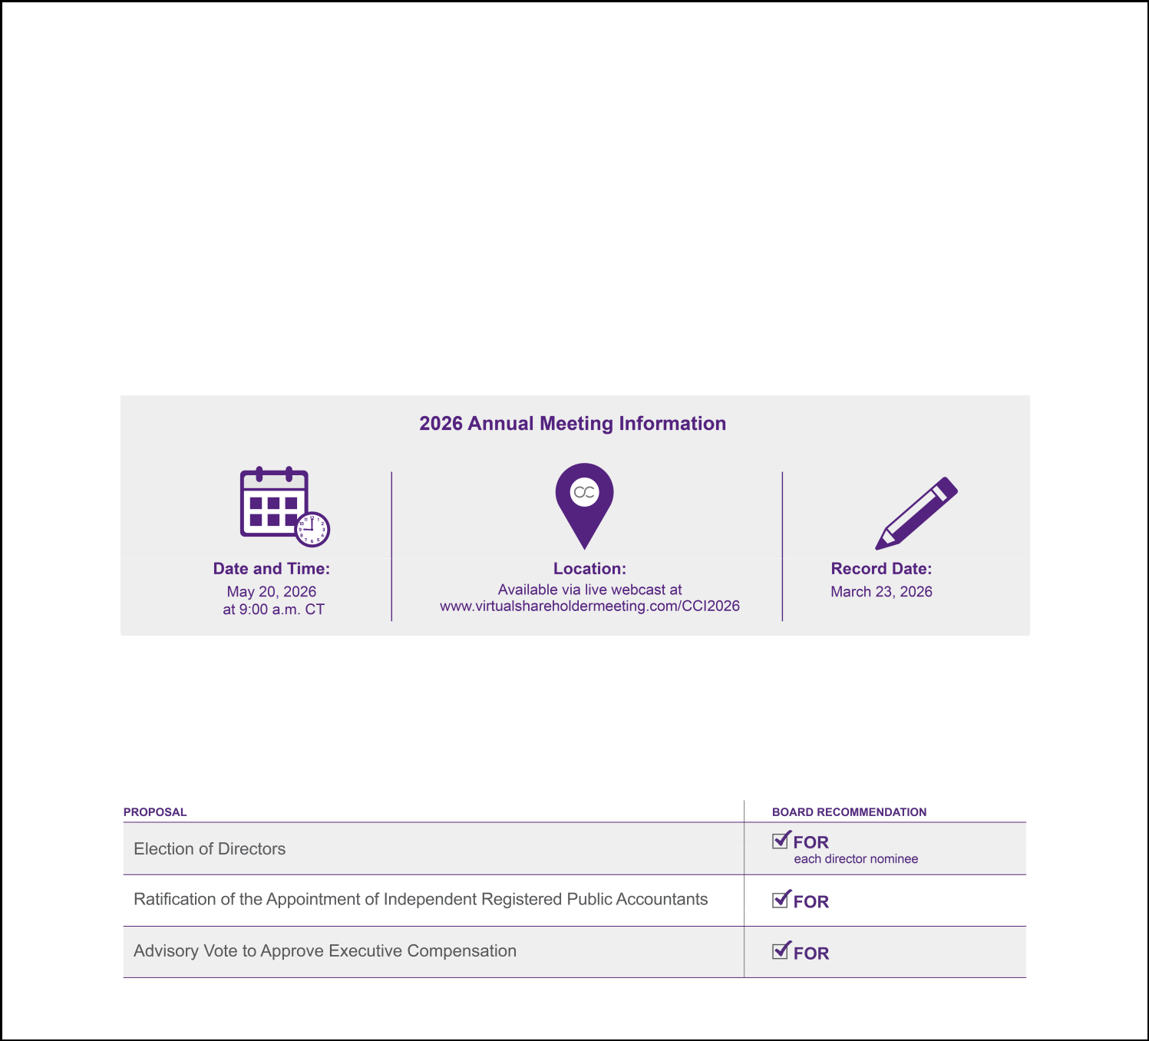

I. PROXY STATEMENT SUMMARY

This Proxy Statement Summary highlights information contained elsewhere in the Proxy Statement. This summary does not contain all of the information you should consider, so please read the entire Proxy Statement carefully before voting. For additional information regarding our 2025 performance, see the Company's Annual Report on Form 10-K for the year ended December 31, 2025 ("2025 Form 10-K").

The proxy materials are being distributed via mail or made available via the internet to our stockholders on or about April 6, 2026.

2026 Annual Meeting of Stockholders

You are invited to attend the 2026 Annual Meeting of Stockholders ("Annual Meeting"). All stockholders as of the March 23, 2026 ("Record Date"), or their duly appointed proxies, may attend the Annual Meeting online at www.virtualshareholdermeeting.com/CCI2026. For additional information about the Annual Meeting, see "VI. Information About the Annual Meeting."

Voting Matters and Board Recommendations

The following table summarizes the three proposals to be voted on at the Annual Meeting and the voting recommendation of our Board of Directors ("Board") for each proposal. We will also act on other business that may be properly raised before the Annual Meeting.

CROWN CASTLE INC. 2026 PROXY STATEMENT

1

2026 Proxy Statement Summary
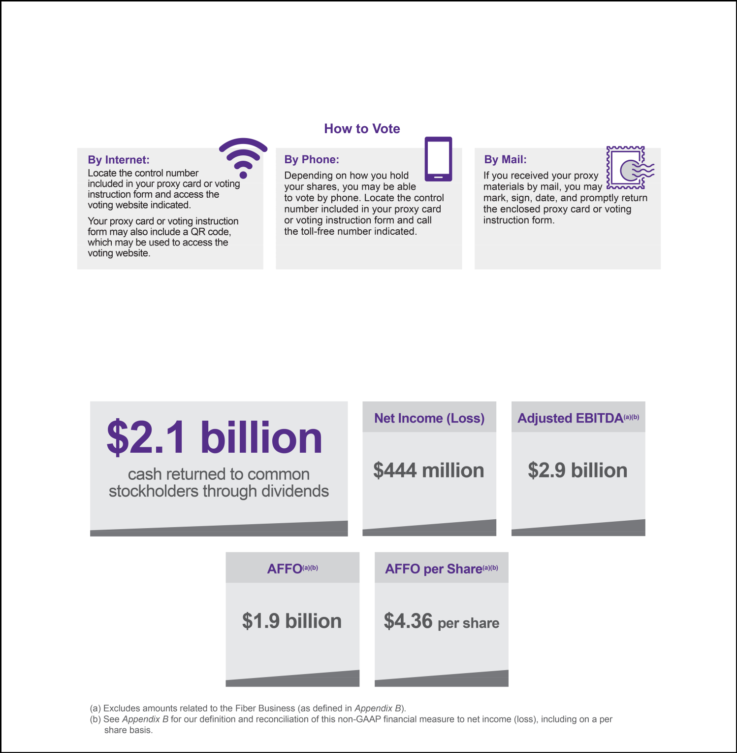

How to Vote

Your vote is very important. We encourage you to cast your vote or submit your proxy by one of the methods shown below. For detailed voting instructions, see "VI. Information About the Annual Meeting."

2025 Business Performance Highlights

Our strategy is to create long-term stockholder value via a combination of (1) growing cash flows generated from our existing portfolio of towers, (2) returning a meaningful portion of our cash generated by operating activities to our common stockholders in the form of dividends and (3) investing capital efficiently to grow cash flows and long-term dividends per share.

2025 Key Financials and Highlights

CROWN CASTLE INC. 2026 PROXY STATEMENT

2

2026 Proxy Statement Summary
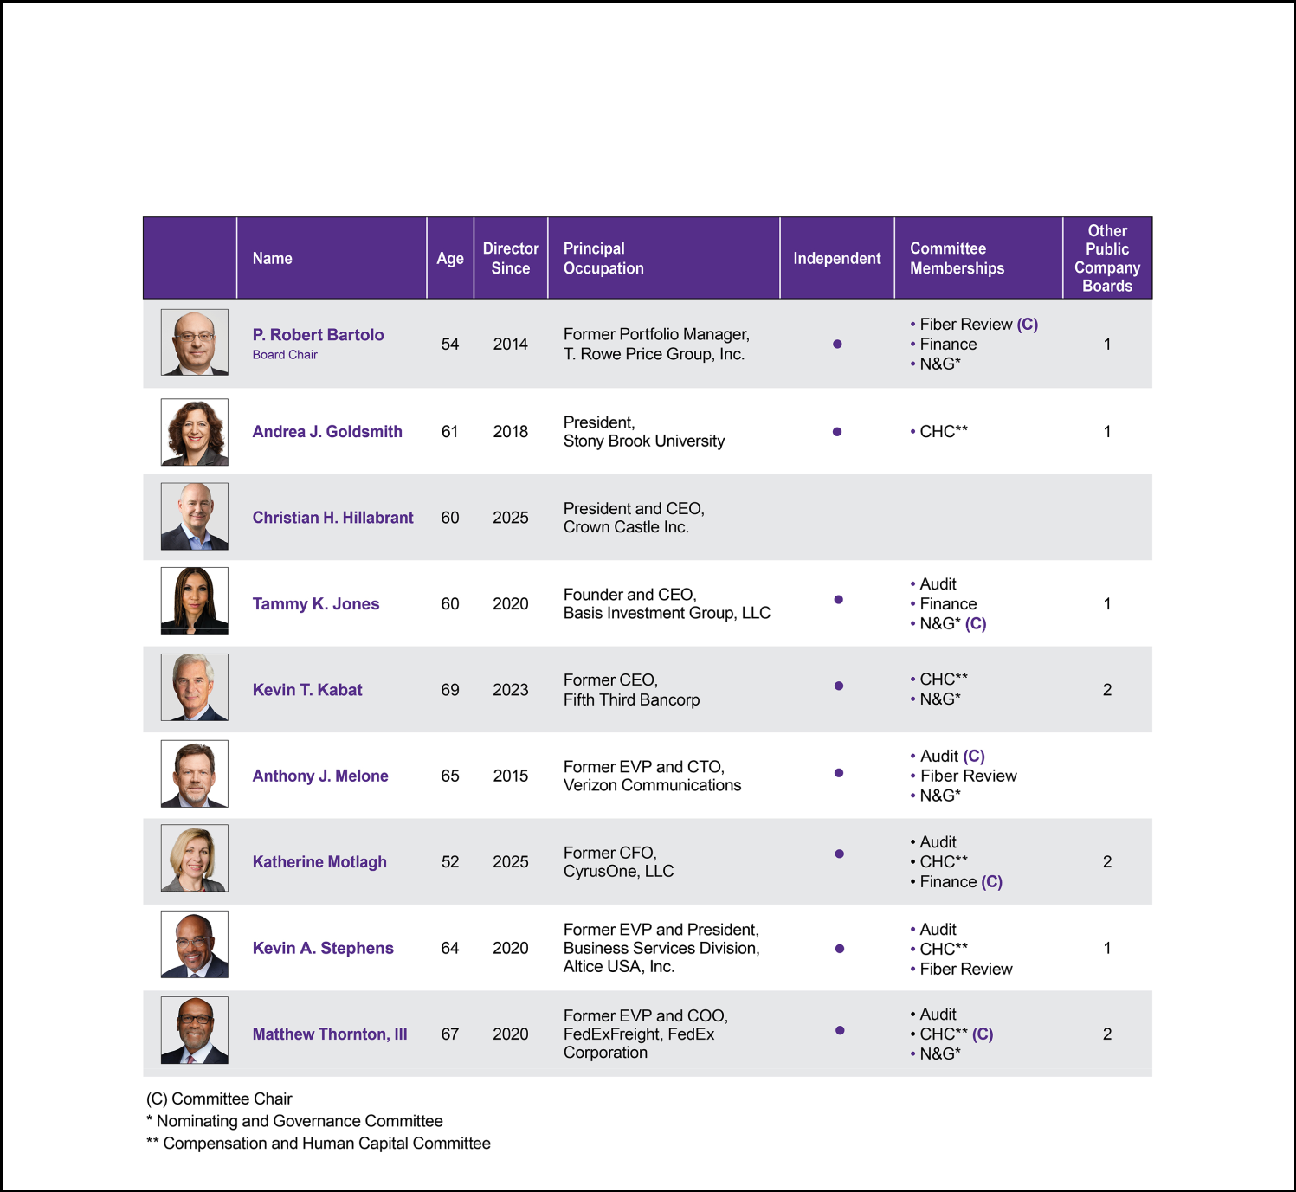

Snapshot of the Director Nominees

The following tables provide summary information about our director nominees, all of which have the unanimous recommendation of the Board. For additional information about our director nominees, see "II. Election of Directors—Nominees for Director."

CROWN CASTLE INC. 2026 PROXY STATEMENT

3

2026 Proxy Statement Summary


Corporate Governance Highlights

We recognize the importance of a robust corporate governance framework to promote the interests of our stockholders. Our corporate governance highlights include:

ü Annual election of directors by majority vote | ü Stock ownership and retention guidelines
ü No supermajority vote requirements | ü Annual CEO, Board and committee evaluations
- Range of director nominee tenures, with an average _{ü} _{One-share, one-vote standard} tenure of 5.7 years

ü Separate CEO and independent Board Chair ü Mandatory retirement age (72 years of age)

ü Regular Board executive sessions ü Proxy access

ü Stockholder ability to call special meetings ü No "poison pill"

2025 Sustainability Highlights

We are dedicated to operating responsibly and ethically as we strive to meet the growing need for data and connectivity through our shared wireless infrastructure model, which is inherently sustainable. By building once and using our infrastructure for multiple tenants, we lower the total number of assets that would otherwise be needed, reducing resource use and overall emissions.

Governance Structure

The Board is actively engaged in the oversight of our strategy for long-term sustainability and value creation, including overseeing and assessing our risk management strategy. The Nominating and Governance Committee ("N&G Committee") assists the Board in overseeing our sustainability strategies, goals and initiatives, receiving quarterly updates from senior management on related risks, opportunities and progress.

2025 Progress

During 2025, we advanced our sustainability strategies, including our goal to be carbon neutral in Scope 1 and 2 emissions by 2025 by sourcing of renewable energy to power our operations and converting our tower lighting systems to LED, resulting in reduced energy costs and improved operational efficiency. The safety and reliability of our infrastructure are central to our business and the communities we serve. Our assets are widely distributed across the U.S., which helps limit the impact of any single weather event on our operations. We proactively assess and maintain our assets to maximize resilience against extreme weather events and other risks.

Additional information regarding our sustainability initiatives and progress is available through the Investors section of our website at https://investor.crowncastle.com. The additional information on our website, including our most recent sustainability report, is not, and shall not be deemed to be, incorporated by reference into this Proxy Statement or any other filings with the Securities and Exchange Commission ("SEC") unless expressly noted in any such other filings.

Executive Compensation

Rewarding improvement in our financial and operating results and the creation of stockholder value are key characteristics of our compensation philosophy, which serves as the foundation of our executive compensation program. To align the interests of our executives with those of our stockholders, the focus of our executive compensation program is on incentive compensation that emphasizes "pay-for-performance," rewarding our executives for performance against pre-established financial goals and total stockholder return ("TSR"). Our executive compensation program is discussed in detail in section "IV. Executive Compensation."

CROWN CASTLE INC. 2026 PROXY STATEMENT

4

2026 Proxy Statement Summary
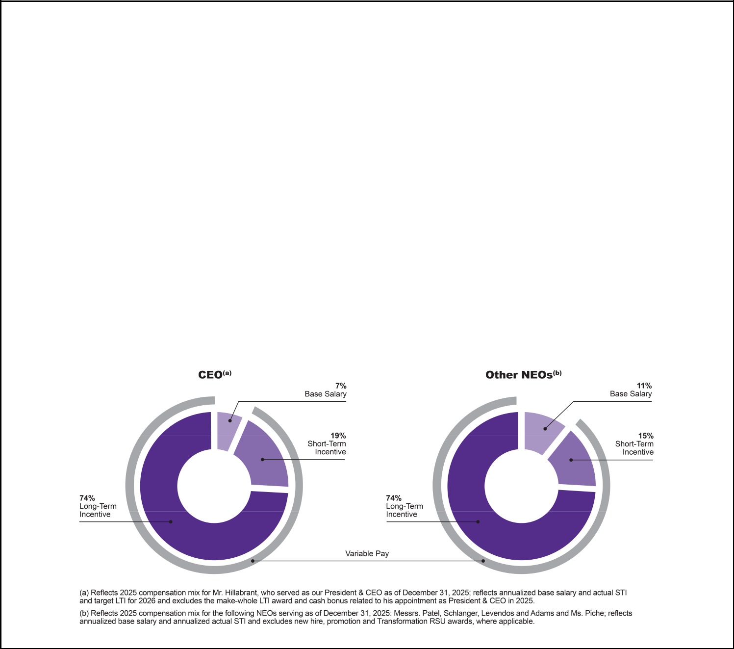

Alignment of Pay and Performance

We seek to align the interests of our named executive officers ("NEOs"), including our chief executive officer ("CEO"), with the interests of our stockholders. Our executive compensation program aims to reward performance against specific, strategic, financial and operational goals that the Compensation and Human Capital Committee ("CHC Committee") believes are critical to the Company's long-term success and the achievement of sustainable long-term stockholder return. For additional information regarding the alignment of pay and performance, see "IV. Executive Compensation—Compensation Discussion and Analysis— Executive Summary."

2025 Pay Components

As part of our executive compensation program, we provide our NEOs with a base salary, short-term incentives ("STIs") and long-term incentives ("LTIs"). We allocate compensation among these components based on our belief that the majority of executive compensation should be paid in the form of performance-based, variable compensation, with a greater emphasis on "at risk" pay for executives who have greater responsibility for the business. As illustrated below, during 2025, the compensation pay mix for Christian H. Hillabrant, our CEO as of December 31, 2025, and certain of our other NEOs, who served as executive officers of the Company as of December 31, 2025, reflects our objectives of linking pay to performance and aligning executives' interests with those of our stockholders.

The compensation pay mix for our other NEOs reflects the average compensation for these NEOs as a group, excluding our CEO, for 2025. For an individual breakdown of the compensation allocation for each of our NEOs, see "IV. Executive Compensation— Compensation Discussion and Analysis—Executive Compensation Elements."

CROWN CASTLE INC. 2026 PROXY STATEMENT

5

2026 Proxy Statement Summary
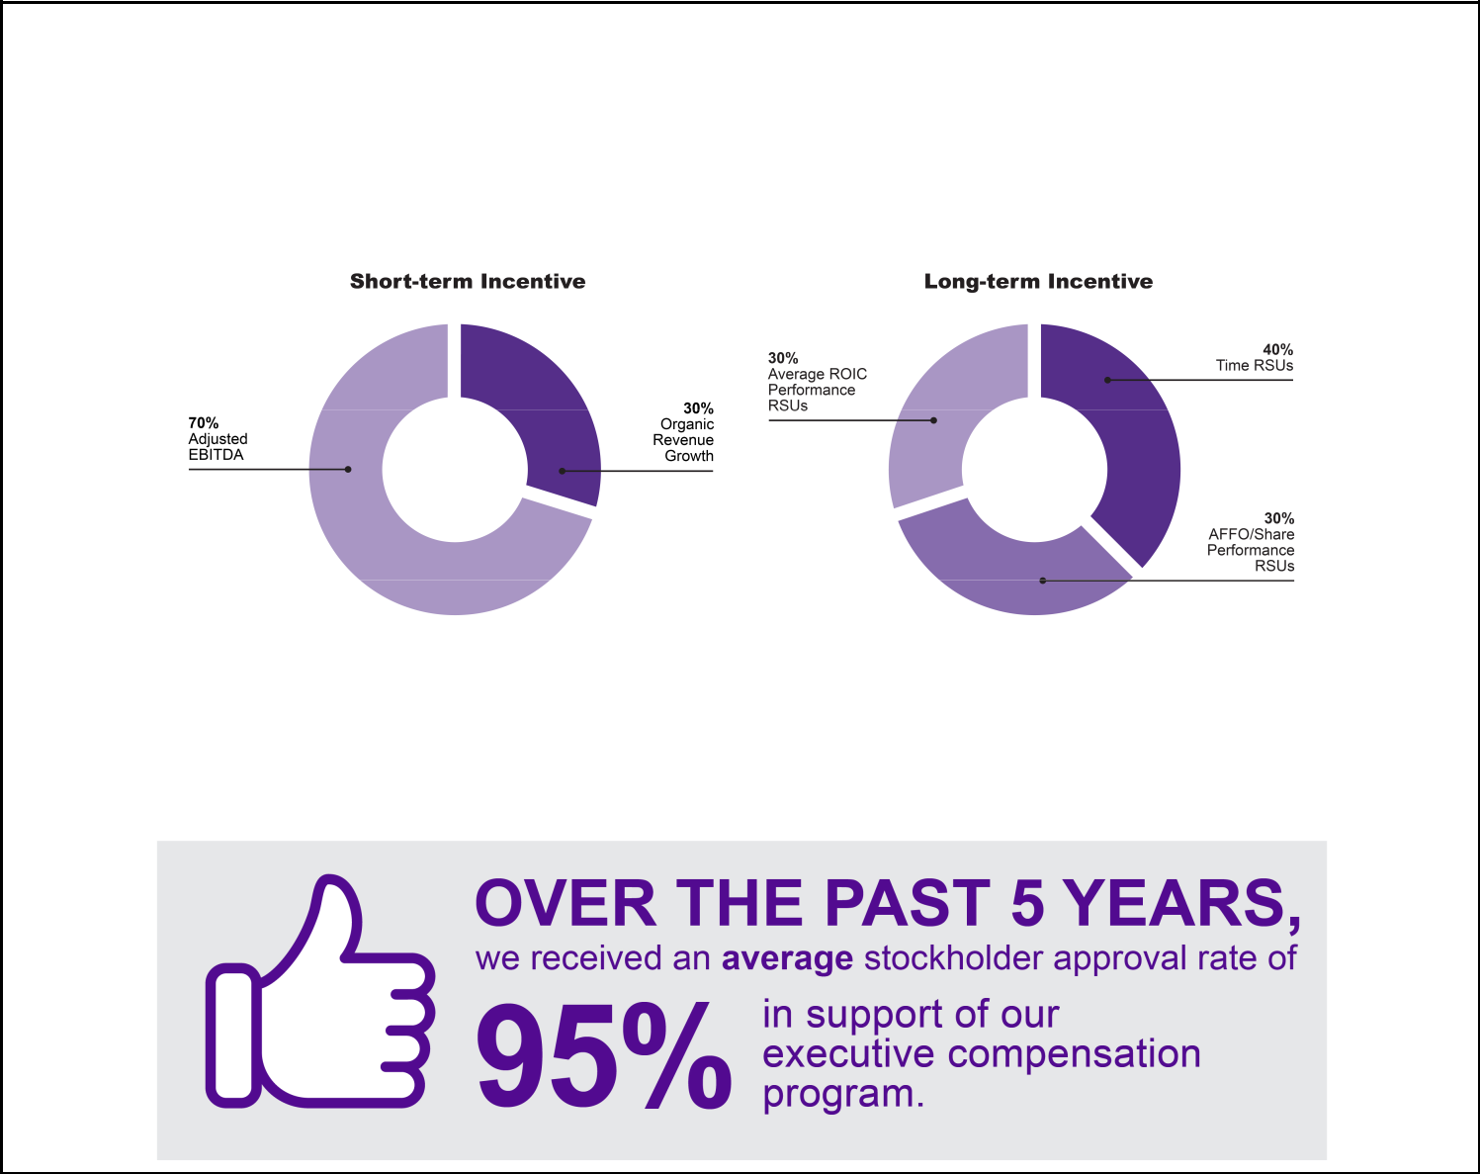

The following illustrates the make-up of, and performance metrics attributable to, the STIs and LTIs awarded to eligible NEOs in 2025. For additional information on the STIs and LTIs, see "IV. Executive Compensation—Compensation Discussion and Analysis —Executive Compensation Elements."

Say-on-Pay

Our stockholders have historically approved our say-on-pay proposal at a high rate, with approximately 93% of votes cast in favor of our executive compensation program at our 2025 annual meeting of stockholders ("2025 Annual Meeting"). Over the past five years, the average stockholder approval of our executive compensation program was 95%.

CROWN CASTLE INC. 2026 PROXY STATEMENT

6

- ELECTION OF DIRECTORS Proposal 1

Pursuant to our Amended and Restated Certificate of Incorporation ("Charter"), all directors of the Board hold office for a term expiring at the first succeeding annual meeting of stockholders after their election, with each such director holding office until his or her successor shall have been duly elected and qualified ("Annual Term").

The nominees for director at the Annual Meeting are: P. Robert Bartolo, Andrea J. Goldsmith, Christian H. Hillabrant, Tammy K. Jones, Kevin T.

Kabat, Anthony J. Melone, Katherine Motlagh, Kevin A. Stephens and Matthew Thornton, III. Each nominee is currently a member of the Board.

If elected at the Annual Meeting, each nominee shall hold office as a director for an Annual Term.

The Board is currently composed of 10 directors, and we have 9 director nominees standing for election at the Annual Meeting. Mr. Genrich will not be standing as a nominee for director at the Annual Meeting and will serve on the Board until the expiration of his current term as director at the Annual Meeting. The Board has approved a reduction in the size of the Board to 9 directors, effective upon the election of directors at the Annual Meeting.

As described under "II. Election of Directors—Board Leadership Structure—Consideration of Director Nominees" below, in considering candidates for election to the Board, the N&G Committee and the Board will generally consider, among other factors, whether prospective nominees are able to read and understand basic financial statements, have relevant business experience, have industry or other specialized expertise and have high moral character.

Each nominee has consented to be nominated and has expressed his or her intention to serve if elected. The Board expects that each of the nominees for director will be able and willing to serve as a director. If any nominee is not available, the proxies may be voted for another person nominated by the current Board, or the size of the Board may be reduced. For information about the nominees, see "II. Election of Directors— Nominees for Director."

P The Board unanimously recommends a vote FOR the following nine (9) director nominees:

• | P. Robert Bartolo | • | Tammy K. Jones | • | Katherine Motlagh
• | Andrea J. Goldsmith | • | Kevin T. Kabat | • | Kevin A. Stephens
• | Christian H. Hillabrant | • | Anthony J. Melone | • | Matthew Thornton, III

CROWN CASTLE INC. 2026 PROXY STATEMENT

7

Nominees for Director

P. Robert Bartolo Age: 54 Director Since: 2014
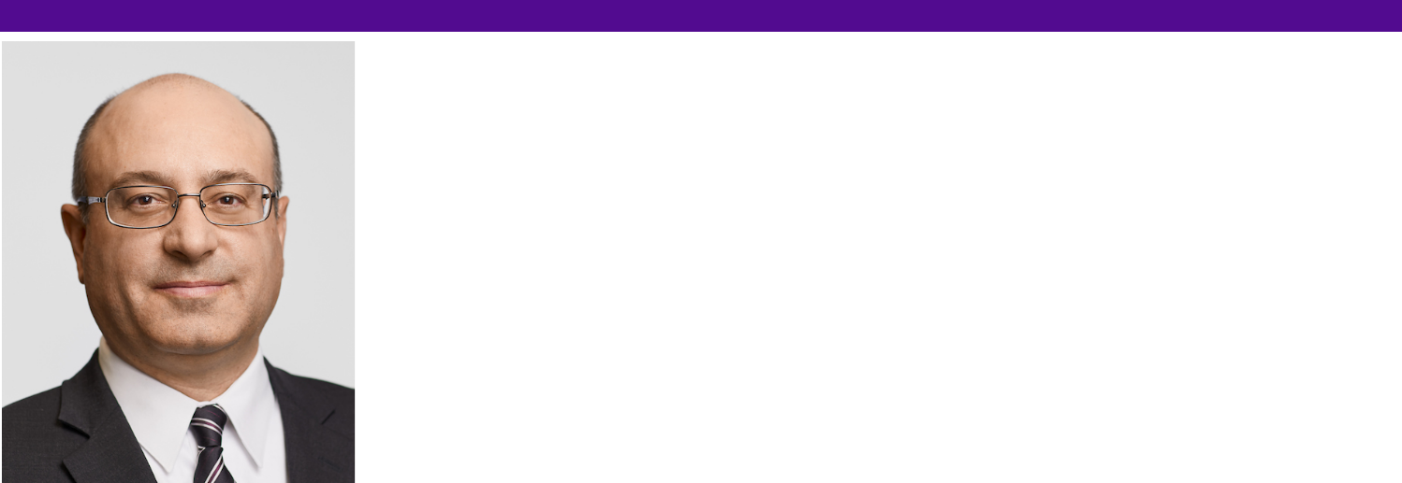

Board Chair (since 2022)

Committees:

- Fiber Review, Chair

- Finance

- N&G

Other Public Company Directorships:

- Cable One, Inc. (NYSE: CABO) (since 2023)

Education:

- B.S., University of Southern California

- M.B.A., Wharton School at the University of Pennsylvania

Experience:

- T. Rowe Price Group, Inc. (NASDAQ: TROW) ("T. Rowe Price"), global investment management company

  - Executive Vice President ("EVP"), U.S. Growth Stock Fund and Chairman, U.S. Growth Stock Fund Investment Advisory Committee (2007 – 2014)

  - Vice President ("VP") and Portfolio Manager, U.S. Equity Division (2005 – 2014)

  - Co-Portfolio Manager, Media and Telecom Fund (2005 – 2007)

  - Analyst, Telecom, Tower & Cable (2002 – 2007)

- MGM Resorts International (NYSE: MGM) ("MGM Resorts"), global hospitality and entertainment company
  - Director of Finance (1997 – 2000)

- Deloitte & Touche LLP, multinational professional services network

  - Senior Auditor (1994 – 1997)

Skills and Qualifications:

- Financial and Accounting – Acquired financial expertise through his prior role as an auditor with one of the Big Four international accounting firms, his CFA designation and his service as Director of Finance at MGM Resorts, where he was responsible for regulatory filings and corporate development analysis, including the $6.4 billion acquisition of Mirage Resorts. His experience was further enhanced through a decades long career in the global investment management sector as a portfolio manager at T. Rowe Price.

- Wireless/Telecom Industry – Gained deep understanding of our business and the telecommunications industry, including business strategies around the deployment of towers, through his experience assessing companies in telecommunications and related industries while serving at T. Rowe Price as a Telecom, Tower & Cable analyst, being named Institutional Investor magazine's best buy-side telecommunications analyst in 2003 and 2005.

- Risk Management – Developed in-depth business analysis acumen, including identification and mitigation of risk, in his roles at T. Rowe Price, where he managed what was at the time the firm's largest mutual fund, the Growth Stock Fund, growing it from $32 billion to $60 billion, attracting $8 billion of new investments and achieving performance in the top 10% of comparable funds over the last one, three, and five years prior to his retirement.

- Mr. Bartolo also brings to our Board M&A, strategic planning/oversight, executive, corporate governance/ethics and public company board experience.

CROWN CASTLE INC. 2026 PROXY STATEMENT

8

Andrea J. Goldsmith


Committees:

- CHC

Other Public Company Directorships:

- Intel Corporation (NASDAQ: INTC) (since 2021)

- Medtronic plc (NYSE: MDT) (2019 – 2025)

Other Memberships:

- Member, President's Council of Advisors on Science and Technology (PCAST) (2021 – 2025)

Education:

- B.S., University of California, Berkeley

- M.S., University of California, Berkeley

- Ph.D., University of California, Berkeley

Age: 61 Director Since: 2018

Experience:

- Stony Brook University

  - President (since 2025)

- Princeton University

  - Dean of Engineering and Applied Science and Arthur LeGrand Doty Professor of Electrical and Computer Engineering (2020 – 2025)

- Stanford University

  - Stephen Harris Professor of Engineering (2012 – 2020)

  - Professor of Engineering (2007 – 2012)

  - Associate/Assistant Professor (1999 – 2007)

- Plume WiFi (formerly Accelera, Inc.), Wi-Fi service provider for communications service companies

  - Co-founder and Chief Technology Officer ("CTO") (2010 – 2014)

- Quantenna Communications, Inc. (NASDAQ: QTNA) (acquired by ON Semiconductor in 2019), Wi-Fi chip and software company
  - Co-founder and CTO (2005 – 2009)

Skills and Qualifications:

- Technology – Gained insight into telecommunications technologies through her extensive academic background in electrical and computer engineering and her career as an accomplished engineer and inventor with acclaimed, foundational work in wireless communications focused on the fundamental performance limits of wireless systems, including 5G wireless, mobile Internet of Things and smart grid design.

- Strategic Planning/Oversight and Cyber/Information Security – Dr. Goldsmith's prior role as Dean of Princeton's School of Engineering and Applied Science and her current role as President of Stony Brook University, which includes overseeing Stony Brook Medicine and co-chairing the partnership that manages Brookhaven National Laboratory, involve extensive strategic planning and oversight skills. She also brings significant experience in cybersecurity, data privacy and enterprise risk management from her service on Stanford's Budget Group and Committee on Research, as well as the boards of Intel and Medtronic. In addition, these board roles have provided significant expertise in evaluating and overseeing M&A transactions.

- Academia/Education – Brings over three decades of experience teaching electrical engineering and applied science and providing academic leadership at some of the most prestigious research universities in the U.S., including at Stanford University, Princeton University and Stony Brook University. Dr. Goldsmith has also authored or co‑authored four books on wireless communications and holds 38 patents.

- Dr. Goldsmith also brings to our Board wireless/telecommunications industry, public company board, HR/compensation, corporate governance/ethics and executive experience.

CROWN CASTLE INC. 2026 PROXY STATEMENT

9

Christian H. Hillabrant


Other Memberships:

- Non-Executive Director, Cornerstone Telecommunications Infrastructure Limited (2024-2025)

- Non-Executive Director, INWIT S.p.A (2025)

Education:

- B.A., Skidmore College

- M.B.A., NYU Stern School of Business

Age 60 Director Since: 2025

Experience:

- Crown Castle Inc.

  - President and CEO (since September 2025)

- Vantage Towers AG, telecommunications infrastructure company owned by Vodafone and a consortium of investors

  - CEO and Chairman of Management Board (2023 – 2025)

- Tillman Infrastructure, LLC, U.S. wireless tower company

  - Chief Operating Officer ("COO") (2019 – 2023)

- Samsung Electronics America, Inc., provider of mobile technologies, consumer electronics and appliances and network systems

  - General Manager, AT&T and Verizon Accounts (2017 – 2019)

- Ericsson AB (NASDAQ: ERIC), provider of technology and services to telecommunications companies

  - Served in various leadership positions (2012 – 2017), including as EVP and COO for North America and Europe (2014-2017)
  - Member of Supervisory Board, Ericsson Telekommunikation GmbH (2016 – 2017)

- Served in various positions at T-Mobile US, Inc., including as Regional Vice President

Skills and Qualifications:

- Telecommunications and Digital Infrastructure Expertise – More than three decades of leadership across wireless carriers, network equipment providers and infrastructure owners, providing the Board with deep insight into industry economics, technology evolution and carrier demand trends.

- Strategic Transformation and Capital Allocation – Led large-scale transformations and portfolio optimization initiatives at capital intensive infrastructure companies, with direct experience balancing growth investment, returns and shareholder value creation.

- Operational Leadership – Extensive experience overseeing complex, multi market operations, including network deployment, engineering, sales and asset management functions in both public and private company environments.

- Public Company Governance and Risk Oversight – Service on public company boards and supervisory boards, with experience overseeing enterprise risk management, regulatory matters and executive leadership accountability.

- M&A and Partnership Experience – Direct involvement in acquisitions, joint ventures and strategic partnerships within the telecommunications infrastructure ecosystem.

- Mr. Hillabrant also brings to our Board executive, finance, technology and HR/compensation experience.

CROWN CASTLE INC. 2026 PROXY STATEMENT

10

Tammy K. Jones
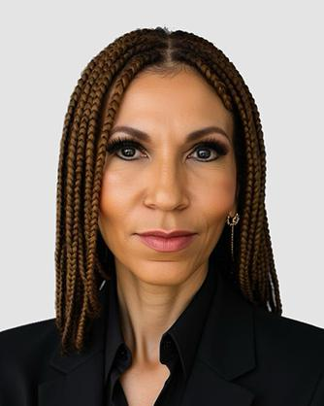

Committees:

- Audit

- Finance

- N&G, Chair

Other Public Company Directorships:

- Veris Residential, Inc. (NYSE: VRE) ("Veris")

- Monogram Residential Trust, Inc. (NYSE: MORE) (acquired by Greystar Growth and Income Fund, LP in 2017) ("Monogram") (2016 – 2017)

Other Memberships:

- Chair, Real Estate Executive Council

Education:

- B.A., Cornell University

- M.B.A., J. Mack Robinson College of Business at Georgia State University

Age: 60 Director Since: 2020

Experience:

- Basis Investment Group, LLC, multi-strategy commercial real estate private equity investment platform

  - Founder and CEO (since 2009)

- CWCapital LLC, U.S. debt investment platform previously owned by Caisse de dépôt et placement du Québec

  - Senior Managing Director, Head of Capital Markets Lending Division (2004 – 2009)

- Commercial Capital Initiatives, Inc. (a subsidiary of GMAC Commercial Mortgage Corporation), a commercial real estate company

  - Senior Vice President ("SVP") (1997 – 2004)

- Equitable Real Estate Investment Management, pension fund advisor and investment manager
  - Director (1990-1997)

Skills and Qualifications:

- REIT Industry and Corporate Sustainability – Demonstrated track record of delivering strong returns for individual and institutional stakeholders through extensive investment experience in commercial real estate transactions and leadership roles on public REIT boards. As a member of the Strategic Review Committee of the board of Monogram, Ms. Jones oversaw the take-private sale of the company, which resulted in a 22% premium to the share price. As Chair of the board of Veris and formerly Lead Independent Director, she led the board in the company's successful transformation from a capital-intensive office owner to a pure play multifamily REIT, as well as its CEO transition, the sale of $2.5 billion of non-strategic assets and the pay down of $1 billion in debt, improving the operating platform and outperforming peers. In addition, Ms. Jones has been a driving force and leader in the implementation of sustainability strategies at Veris and Crown Castle.

- Financial and M&A – Gained extensive experience with strategic financial transactions and capital allocation throughout her career closing over $25 billion in commercial real estate transactions across the U.S., including with joint venture negotiation, capital markets, leasing, structuring and investment. Successfully deployed capital in real estate on behalf of some of the country's largest public pension plans and institutional investors while consistently achieving top quartile returns.

- Strategic Planning/Oversight – Developed throughout her career, over three decades of making strategic investment decisions, and most recently as founder and CEO of one of the few woman-owned diversified commercial real estate investment platforms overseeing the development and execution of the firm's investment strategy, operations, finance and technology as well as closing $9 billion in transactions and managing a portfolio, which includes more than 30,000 multifamily units.

- Ms. Jones also brings to our Board public company board and executive experience, as well as corporate governance/ethics, risk management, operations, accounting, academia/education and HR/compensation expertise.

CROWN CASTLE INC. 2026 PROXY STATEMENT

11

Kevin T. Kabat
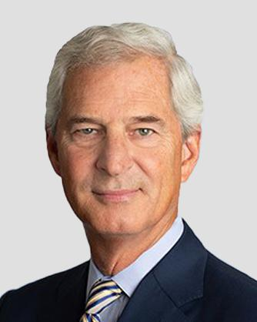

Committees:

- CHC

- N&G

Other Public Company Directorships:

- NiSource Inc. (NYSE: NI) (since 2015)

- Unum Group (NYSE: UNM) (since 2008)

- AlTi Global Inc. (NASDAQ: ALTI) (January 2023 – August 2023)

- E*TRADE Financial Corporation (NASDAQ: ETFC) ("E*TRADE") (2016 – 2020)

Education:

- B.S., John Hopkins University

- M.S., Purdue University

Age: 69 Director Since: 2023

Experience:

- Fifth Third Bancorp (NASDAQ: FITB), diversified financial services company

  - CEO and Vice Chairman of the Board (2012 – 2016)

  - CEO (2007 – 2012)

  - CEO and Chairman (2008 – 2010)

  - EVP (2003 – 2006)

  - President and CEO, Fifth Third Bank Michigan (2001 – 2003)

- Old Kent Financial Corporation, bank holding company acquired by Fifth Third Bank in 2021

  - Held a number of management and executive positions including as Vice Chairman and President (1982 – 2001)

Skills and Qualifications:

- Financial and M&A – Obtained financial acumen through his more than a three-decade career in the financial services sector, leading one of the largest U.S. diversified financial services companies, which contributed to his deep understanding of financial markets. During his tenure at Fifth Third Bancorp, Mr. Kabat oversaw a successful spin-off of the company's processing division, which was pivotal to the successful execution of its recapitalization strategy. He also served as Lead Independent Director of E*TRADE, overseeing the acquisition of the company by Morgan Stanley in an all-stock transaction valued at approximately $13 billion.

- Risk Management – Developed valuable risk management skills through his operational and executive leadership roles with an increasing amount of complexity in the financial services industry, as demonstrated by his CEO tenure at Fifth Third Bancorp, which he successfully navigated through a volatile market environment during the 2008 financial crisis and subsequent economic recovery. His extensive experience serving on public company boards contributes to the Board's risk oversight.

- Strategic Planning/Oversight and Operations – Gained a deep understanding of operating in a highly regulated operational environment and balancing the interests of many stakeholders while serving as CEO of Fifth Third Bancorp, where he was responsible for overseeing the strategic direction of the company, leading a shift toward a customer-centric culture and introduction of robust digital service offerings in response to customer demand for efficient digital payment options.

- Mr. Kabat also brings to our Board knowledge of accounting, HR/compensation, academia/education and corporate governance/ethics, as well as executive and public company board experience.

CROWN CASTLE INC. 2026 PROXY STATEMENT

12

Anthony J. Melone


Committees:

- Audit, Chair

- Fiber Review

- N&G

Other Public Company Directorships:

- ADTRAN, Inc. (NASDAQ: ADTN) (2016 – 2020)

Education:

- B.S., Villanova University

- M.S.E., University of Pennsylvania

Age: 65 Director Since: 2015

Experience:

- Crown Castle Inc.

  - Special Advisor (April 2024 – May 2024)

  - Interim President and CEO (January 2024 – April 2024)

- Verizon Communications Inc. (NYSE, NASDAQ: VZ), leading communications technology company and network provider

  - EVP and CTO (2010 – 2015)

  - Served in a variety of positions with Verizon Wireless, a subsidiary of Verizon (2000 – 2010), including as SVP and CTO (2007 – 2010)

Skills and Qualifications:

- Wireless/Telecom Industry – Gained understanding of our business and the communications infrastructure industry, along with extensive knowledge of our customers and their evolving expectations over his more than 35 years in the telecommunications industry, including responsibility for managing infrastructure assets and over 20,000 communications towers and over 50,000 wireless cell sites.

- Technology – Acquired an advanced understanding of telecommunications technologies, regulatory compliance requirements and related emerging technological trends while serving in leadership positions at Verizon, including his role as CTO for Verizon, and its subsidiary Verizon Wireless, where he successfully oversaw the transition of the wireless network from 3G to 4G standard and the launch of the nation's first wireless broadband wide-area network. He played a pivotal role in overseeing multiple platform integrations in support of Verizon's M&A strategy, facilitating interoperability to support reliable network service.

- Strategic Planning/Oversight – Developed through his direct responsibility as CTO at Verizon, where he oversaw a large-scale capital investment program designed to enhance and expand the company's nationwide wireless network, including his leadership role in planning and implementing network quality and coverage performance initiatives.

- Mr. Melone also brings to our Board knowledge of finance, operations, risk management, HR/compensation and corporate governance/ethics, in addition to public company board and executive experience.

CROWN CASTLE INC. 2026 PROXY STATEMENT

13

Katherine Motlagh


Committees:

- Audit

- CHC

- Finance, Chair

Other Public Company Directorships:

- EVgo, Inc. (NASDAQ: EVGO) (since 2022)

- Aeva Technologies, Inc. (NASDAQ: AEVA) (since 2025)

Age: 52 Director Since: 2025

Experience:

- CyrusOne LLC (NASDAQ: CONE) ("CyrusOne"), a global data center developer and operator delivering digital infrastructure solutions

  - EVP and Chief Financial Officer ("CFO") (2020 – 2023)

- American Tower Corporation (NYSE: AMT) ("AMT"), global provider of wireless infrastructure

  - CFO, Europe, Middle East and Africa and Latin America (2015 – 2020)

- Ericsson AB (NASDAQ: ERIC) ("Ericsson"), a multinational networking and telecommunications company

  - Customer Unit and Delivery Unit CFO (2011 – 2015)

Skills and Qualifications:

- Wireless/Telecom Industry – Gained an understanding of our business and the wireless communications infrastructure industry over her more than 20 year career in the telecommunications industry, where she held various finance and accounting leadership roles at CyrusOne, AMT, Ericsson, Nokia Corporation and Nextel Communications, Inc. (acquired by Sprint Corporation in 2013).

- Finance and Accounting – Served as a member of the executive management team of CyrusOne and was responsible for its accounting, finance, capital markets, tax, procurement and investor relations. She is also a licensed Certified Public Accountant.

- Strategic Planning/Oversight – Gained extensive expertise during her tenure as CFO at CyrusOne and as a divisional CFO at AMT in strategic leadership and oversight of financial activities and financial reporting, management of international tax policy and planning and internal control compliance. While at AMT, she oversaw international businesses in 18 countries and led a global finance organization of over 300 employees.

Other Memberships:

- Director, Institute of Management Accountants - National and European Board (2007 – 2009; 2016 – 2018)

Certifications:

• NACD Directorship Certification

Education:

- B.S., Financial University (Moscow, Russia)

- M.S., Financial University (Moscow, Russia)

- Ms. Motlagh also brings to our Board knowledge of risk management, corporate governance, cyber/information security, HR/compensation, operations and M&A and also brings executive and public company board experience.

CROWN CASTLE INC. 2026 PROXY STATEMENT

14

Kevin A. Stephens
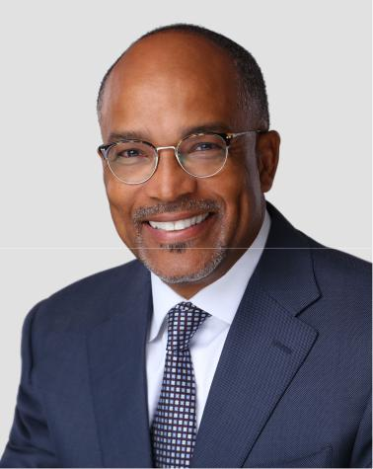

Committees:

- Audit

- CHC

- Fiber Review

Other Public Company Directorships:

- Keysight Technologies, Inc. (NYSE: KEYS) (since 2022)

Other Memberships:

- Director, Consumer Cellular Inc., a private company

- Member, The Executive Leadership Council

Education:

- B.B.A., University of Michigan

- M.B.A., University of Southern California

Age: 64 Director Since: 2020

Experience:

- Altice USA, Inc. (NYSE: ATUS) ("Altice"), provider of broadband communications and video services

  - EVP and President, Business Services Division (2015 – 2019)

- Suddenlink Communications, Inc. ("Suddenlink") (acquired by Altice in 2015), internet and cable provider

  - Served in multiple senior leadership positions, including as President, Commercial and Advertising Operations (2006 – 2015)

- Served in various senior leadership positions at Cox Communications, Inc., Choice One Communications and Xerox Corporation

Skills and Qualifications:

- Telecom Industry – Gained extensive experience in the fiber and telecommunications industry while serving in leadership positions at a number of companies in the sector, developing deep knowledge of customer preferences, distribution channels and industry segments, including in his most recent position at Altice, where he held responsibility for full P&L and operations, as well as oversight of all functional areas.

- M&A – Acquired significant expertise by playing a key role throughout his career in all phases of the M&A process, including executing 10 corporate acquisitions across three companies. Following the $20 billion acquisition of Cablevision by Altice, Mr. Stephens led the integration of three business-to-business organizations into one business, creating operational efficiencies by redefining the strategy for the combined company and reinvigorating the product pipeline, which delivered accelerated revenue growth. Mr. Stephens also served as advisor in 2020 to Morgan Stanley Infrastructure Partners in connection with a $3.2 billion acquisition of a fiber infrastructure company.

- Strategic Planning/Oversight – Developed a strong track record of designing and executing profitable enterprise expansion strategies in both start-up and Fortune 500 companies, including creating a new wholesale line of business at Suddenlink, which developed into a significant revenue contributor for the company.

- Mr. Stephens brings to our Board operations, financial, corporate governance/ethics, HR/compensation and technology expertise and executive and public company board experience.

CROWN CASTLE INC. 2026 PROXY STATEMENT

15

Matthew Thornton, III
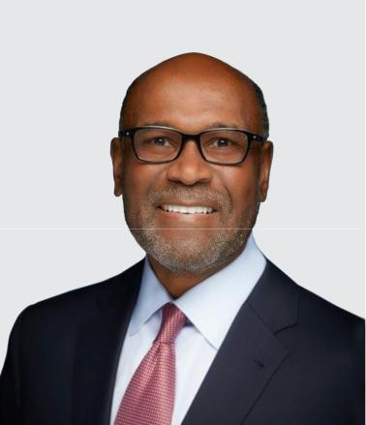

Committees:

- Audit

- CHC, Chair

- N&G

Other Public Company Directorships:

- Sherwin Williams Company (NYSE: SHW) (since 2014)

- Trustee of registered investment companies in the Nuveen funds complex (since 2020)

Other Memberships:

- Member, The Executive Leadership Council

Education:

- B.A., University of Memphis

- M.B.A., University of Tennessee, Knoxville

Age: 67 Director Since: 2020

Experience:

- FedEx Corporation (NYSE: FDX), leading transportation, ecommerce and services company (1978 – 2019)

  - EVP and COO, FedEx Freight Corporation (2018 – 2019)

  - SVP, U.S. Operations, Federal Express Corporation ("FedEx Express"), a subsidiary (2006 – 2018)

  - SVP, Air, Ground and Freight Services, FedEx Express (2004 – 2006)

  - VP, Regional Operations (Central Region), FedEx Express (1998 – 2004)

Skills and Qualifications:

- Operations – Gained significant strategic operations and logistics management experience through his broad range of positions over a more than four-decade career at FedEx, where he was responsible for domestic and international P&L and improved the operational performance of multiple business segments. In his most recent role as COO of FedEx Freight, he managed nearly 380 service centers, which included international efforts, transportation, field operations and customer service among other crucial business areas, with an annual revenue of nearly $8 billion.

- Strategic Planning/Oversight – Obtained extensive strategic planning experience leading transformational growth initiatives at FedEx, including the development and implementation of an E-commerce platform to facilitate growth, improve service reliability and operational efficiency. This experience was further expanded through his service on the board of Sherwin Williams Company, where he oversaw multiple strategic acquisitions and divestitures to drive value creation opportunities.

- HR/Compensation – Acquired over his career, including in his most recent positions, where he oversaw more than 45,000 employees and initiated company-wide efforts to improve network health, on time performance and operational improvements. He was able to achieve record level employee engagement ratings and productivity under his tenure, while maintaining industry-leading practices in driver and workplace safety.

- Mr. Thornton also brings to our Board knowledge of risk management, technology and corporate governance/ethics, as well as financial, executive and public company board experience.

CROWN CASTLE INC. 2026 PROXY STATEMENT

16

Board Matrix

The following matrix provides information regarding the nominees for director, including certain types of knowledge, skills, experiences and attributes possessed by one or more of our directors which the Board believes are relevant to our business, industry or REIT structure. The matrix does not encompass all of the knowledge, skills, experiences or attributes of our directors, and the fact that a particular knowledge, skill, experience or attribute is not listed does not mean that a director does not possess it. In addition, the absence of a particular knowledge, skill, experience or attribute with respect to any of our directors does not mean that the director in question lacks such knowledge, skill or expertise or is unable to contribute to the decision-making process in that area and indicates instead that such director does not satisfy the Company's definition associated with such designated skill or expertise. The type and degree of knowledge, skill and experience listed below may vary among the members of the Board.
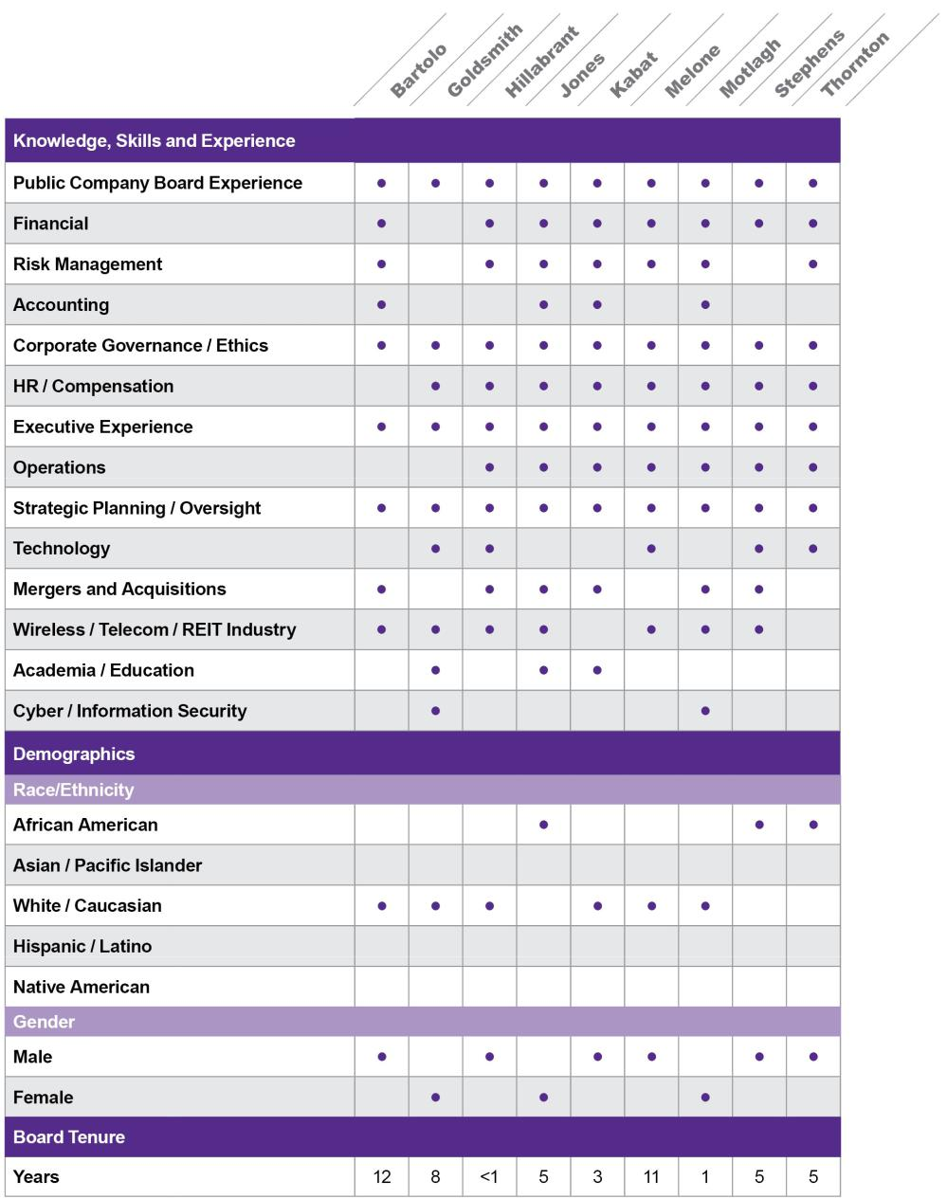

CROWN CASTLE INC. 2026 PROXY STATEMENT

17

Board Leadership Structure

For over 20 years, the roles of our Board Chair and CEO have been filled by two different persons. Notwithstanding the foregoing, our Corporate Governance Guidelines provide that the Board does not maintain a firm policy with respect to the separation of the offices of Board Chair and CEO. The Board believes that it is in the best interests of our stockholders for the Board to make a determination regarding the separation or combination of these roles each time it elects a new Board Chair or CEO based on the relevant facts and circumstances applicable at such time.

Meetings

During 2025, the Board held 12 meetings (four regularly scheduled and eight special). In 2025, each incumbent director attended at least 75% of the aggregate of (1) the total number of meetings of the Board during the period in which he or she was a director and (2) the total number of meetings of all Board committees ("Committees") on which he or she served during the period in which he or she was a director.

Our Corporate Governance Guidelines provide that, while the Board understands that scheduling conflicts may arise resulting in absences, the Board strongly encourages each director to attend our annual meeting of stockholders. Each of the directors serving on the Board at the time of our 2025 Annual Meeting attended the 2025 Annual Meeting.

The non-management directors generally meet in executive session at each regularly scheduled meeting of the Board (typically four times per year). In addition, the Board meets at least once a year in executive session with only independent directors present. The independent Board Chair, Mr. Bartolo, presides at the executive sessions of non-management directors and of independent directors.

Director Time Commitments

As further described under "—Board Committees—Standing Committees—Nominating and Governance Committee—Consideration of Director Nominees" below, as part of its annual review of director nominees for election, the N&G Committee reviews, among other factors, the attendance and other commitments of individual directors. Under our Corporate Governance Guidelines, directors are expected to notify the Chair of the N&G Committee, the Company's General Counsel and the Company's Corporate Secretary in advance of accepting (1) an invitation to serve on the board of directors of any other company and (2) if a director serves on the audit committee of three or more public companies (including our Audit Committee of the Board ("Audit Committee")), an appointment to serve on an additional audit committee of another public company's board of directors. Our Corporate Governance Guidelines further provide that, without the approval and consent of the N&G Committee or the Board, a director will not serve (1) on the boards of more than four public companies (including the Company) or (2) if the director serves as a sitting CEO (or equivalent) or executive officer of a public company (including the Company), on the board of more than one public company in addition to the board of the public company for which such director serves as CEO (or equivalent) or executive officer. The N&G Committee and the Board may take into account the nature of and time involved in a director's service on other boards (and committees thereof) in evaluating the suitability of individual directors and making its recommendations to the Company's stockholders. Service on boards of other companies (or committees thereof) should be consistent with the Company's conflict of interest policies.

The N&G Committee conducts an annual review of director commitment levels and affirms that each director complies with the levels set forth in our Corporate Governance Guidelines at such time. All directors and director nominees currently comply with the director commitment levels set forth in our Corporate Governance Guidelines.

Risk Oversight

Management is primarily responsible for assessing and managing our various exposures to risk on a day-to-day basis. Our Internal Audit department serves as the primary monitoring and testing function for company-wide policies and procedures, including policies and procedures regarding our risk management strategy. Such strategy includes identifying, evaluating and addressing potential risks that may exist at the enterprise, strategic, financial, operational, compliance and reporting levels. The Board is responsible for overseeing and assessing our risk management strategy. In addition, at least annually, the Board, through its Committees, and management engage in an interactive review and evaluation of the risks that are essential and mission critical to our business

CROWN CASTLE INC. 2026 PROXY STATEMENT

18

and operations ("Mission Critical Risks"). The Board exercises these responsibilities periodically as part of its meetings and also through its Committees, each of which examines various components of risk in connection with its responsibilities.

Our Vice President—Audit and Security reports to the Audit Committee and provides periodic updates (generally quarterly) to the Audit Committee with respect to the Internal Audit department's activities, including with respect to risk management matters and the audit agenda. In addition, an overall review of risk is inherent in the Board's consideration of our long-term strategies and in the transactions and other matters presented to the Board, including capital expenditures, acquisitions and divestitures and financial matters. The Board's role in risk oversight is consistent with the Board's current leadership structure, with the CEO and other members of senior management having responsibility for assessing, managing and mitigating, when appropriate, risk exposure, and the Board and its Committees providing oversight and review in connection with those efforts.

Oversight of Cybersecurity Risk

Our Chief Information Security Officer reports on a periodic basis (generally semi-annually, or more frequently, as needed) to the Audit Committee regarding cybersecurity risk exposure and cybersecurity risk management strategy. The Board also may review and assess cybersecurity risks as part of its oversight of the Company's enterprise risk management, including in connection with its review of the Company's Mission Critical Risks. For more information regarding cybersecurity matters, please refer to "Item 1C. Cybersecurity" in our 2025 Form 10-K.

CROWN CASTLE INC. 2026 PROXY STATEMENT

19

Board Committees

The Board has four standing Committees: Audit Committee, CHC Committee, N&G Committee and Finance Committee. In December of 2023, we entered into a Cooperation Agreement, as amended, with Elliott Investment Management L.P., pursuant to which (among other things) we agreed to establish a Fiber Review Committee and a CEO Search Committee, which were each formed in January 2024. At its meeting in May of 2024, and following the appointment of Steven J. Moskowitz as the Company's President and CEO effective April 11, 2024, the Board took action to dissolve the CEO Search Committee. In connection with the departure of Mr. Moskowitz as the Company's President and CEO effective March 23, 2025, the Board reinstated the CEO Search Committee. Following the announcement by the Company in August of 2025 of the appointment of Mr. Hillabrant as the Company's President and CEO effective September 15, 2025, the Board dissolved the CEO Search Committee. The following pages summarize the responsibilities and function of each of the standing Committees and ad-hoc Committees, including the dissolved CEO Search Committee and the Fiber Review Committee, in 2025.

The following table shows the current chairs and members of each of the current Committees and the independence status of each Board member:
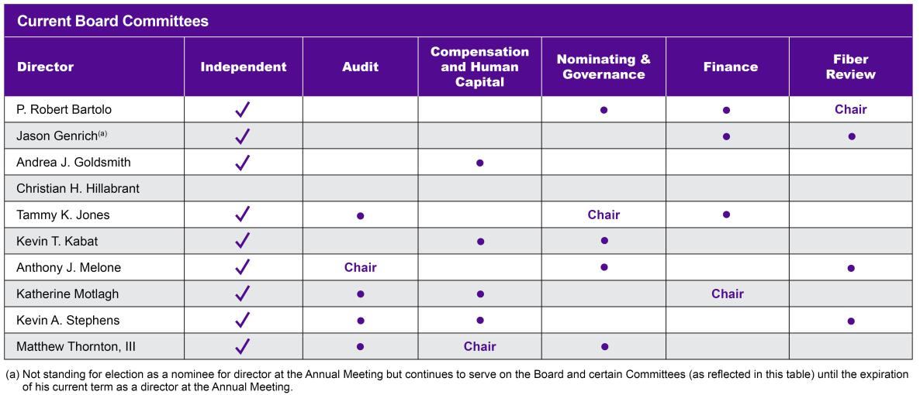

Copies of the Committee charters of each of the Audit Committee, CHC Committee, N&G Committee, Finance Committee and Fiber Review Committee can be found on our website at https://investor.crowncastle.com, and such information is also available in print to any stockholder who requests it through our Corporate Secretary. The information on our website, including such Committee charters, is not, and shall not be deemed to be, incorporated by reference into this Proxy Statement or any other filings with the SEC unless expressly noted in any such other filings.

Standing Committees

- Audit Committee

Number of Meetings in 2025: 8

Functions and Authority:

- providing oversight of:

  - our financial statements and accounting practices;

  - the quality and integrity of the financial statements and other financial information we provide to any governmental body or the public;

  - our compliance with legal and regulatory requirements;

  - the qualifications and independence of our independent registered public accountants ("Auditors");

CROWN CASTLE INC. 2026 PROXY STATEMENT

20

  - the performance of our internal audit function and the Auditors; and

  - our systems of internal controls regarding finance, accounting, cybersecurity, legal compliance and ethics;

- assisting the Board in overseeing and assessing our risk management strategy by examining risks within the Audit Committee's purview;

- reviewing with management the Company's significant cybersecurity and other information technology risks, controls and procedures, including internal policies, plans and processes to monitor, mitigate and remediate such risks;

- selecting and appointing the Auditors; and

- reviewing and approving audit and non-audit services to be performed by the Auditors.

Audit Committee Financial Expert: The Board has determined that (1) Mses. Jones and Motlagh meet the requirements of an audit committee financial expert pursuant to applicable SEC rules, (2) each of the current members of the Audit Committee meets the requirements of an independent director pursuant to the New York Stock Exchange ("NYSE") listing standards and (3) each of the current members of the Audit Committee is also financially literate. For information regarding each Audit Committee member's business experience, see "II. Election of Directors—Nominees for Director."

For additional information regarding the Audit Committee, see "III. Ratification of Appointment of Independent Registered Public Accountants— Audit Committee Matters."

- Compensation and Human Capital Committee

Number of Meetings in 2025: 7

Functions and Authority:

- assisting the Board with its responsibilities relating to compensation of our executives;

- developing an overall executive compensation philosophy, strategy and framework consistent with corporate objectives and stockholder interests;

- designing, recommending to the Board, administering and evaluating our executive compensation plans, policies and programs;

- overseeing the administration of our incentive compensation and equity-based compensation plans;

- approving and recommending to the independent directors of the Board the CEO's goals and objectives, including conducting an annual evaluation of the CEO's performance considering those goals and objectives, and the compensation of the CEO;

- reviewing and approving actions relating to the compensation of the executive officers reporting to the CEO;

- reviewing whether our compensation plans, policies and programs are competitive and consistent with our long-term strategy, corporate values and accepted legal practices;

- reviewing, approving and making recommendations to the Board with respect to incentive compensation, equity-based plans and other compensation arrangements that require approval by the Company's stockholders;

- retaining, terminating and approving the fees of any compensation consultants to assist the CHC Committee with its duties;

- assisting the Board in overseeing the Company's strategies and policies for human capital development and training, talent retention and recruitment, Company culture and engagement and management (other than CEO) succession planning; and

- assisting the Board in overseeing and assessing our risk management strategy by examining risks within the CHC Committee's purview.

CROWN CASTLE INC. 2026 PROXY STATEMENT

21

In carrying out the above functions, the CHC Committee has the authority to form and delegate any of its authorities and responsibilities to subcommittees composed of one or more of its members as it deems appropriate and to delegate responsibility for the day-to-day management of executive compensation to the senior officers of the Company.

Executive Compensation Process and Procedures: Over the course of several meetings throughout the year, the CHC Committee annually reviews executive compensation, including base salary, STI compensation, LTI compensation and other benefits. In performing its duties, the CHC Committee obtains advice, as it deems necessary, from an independent compensation consultant engaged directly by the CHC Committee ("Compensation Consultant"). While the Compensation Consultant is engaged by the CHC Committee, it works with management, including members of our Human Resources department and our CEO, in developing compensation studies as directed by the CHC Committee. For 2025, FW Cook served as the Compensation Consultant. In addition, in the case of compensation decisions relating to executives other than the CEO, the CHC Committee seeks and obtains input from the CEO. The CHC Committee regularly holds executive sessions at its meetings during which management, including the CEO, is not in attendance. Additional information regarding the CHC Committee's processes and procedures for consideration and determination of executive compensation is provided below at "IV. Executive Compensation—Compensation Discussion and Analysis."

Compensation Committee Interlocks and Insider Participation: None of the members of the CHC Committee during 2025, or as of the date of this Proxy Statement, is or has been one of our officers or employees. In addition, during 2025, none of our executive officers served on the compensation committee (or board, in the absence of a compensation committee) of any company that employed any member of our CHC Committee or Board.

- Nominating and Governance Committee

Number of Meetings in 2025: 5

Functions and Authority:

- assisting the Board by identifying individuals qualified to become Board members and recommending director nominees for election by the stockholders or for appointment to fill vacancies;

- recommending to the Board director nominees for each Committee of the Board;

- advising the Board about the compensation of the non-employee directors of the Board, including the philosophy related thereto, and making recommendations with respect thereto;

- assisting the Board in overseeing the Company's sustainability strategy, goals and initiatives;

- advising the Board about appropriate composition of the Board and its Committees;

- advising the Board about and recommending to the Board appropriate corporate governance practices and assisting the Board in implementing those practices;

- developing and periodically reviewing and assessing the CEO succession plan and assisting the Board in evaluating potential successors to the CEO position;

- leading the annual evaluation of the Board and its Committees; and

- assisting the Board in overseeing and assessing our risk management strategy by examining risks within the N&G Committee's purview.

Consideration of Director Nominees: The N&G Committee has the authority to recommend nominees for election as directors to the Board. In considering candidates for the Board, the N&G Committee takes into account the entirety of each candidate's credentials and, subject to the discussion below, currently does not maintain any specific minimum qualifications that must be met by an N&G Committee recommended nominee.

While the N&G Committee does not maintain a formal list of minimum qualifications in making its evaluation and recommendation of candidates, the N&G Committee will generally consider, among other factors, whether prospective nominees are able to read and understand basic financial statements, have relevant business experience, have industry or other specialized expertise and have high moral character. In addition, the N&G Committee considers issues of diversity, including with respect to experience, expertise, viewpoints and skills, in

CROWN CASTLE INC. 2026 PROXY STATEMENT

22

connection with the director selection process. Further, the N&G Committee reviews the director time commitments of director nominees and may take into account the nature of and time involved in a nominee's service on other boards (and committees thereof) in evaluating the suitability of individual directors and making its recommendations to the Company's stockholders, as further described above at "—Director Time Commitments." The N&G Committee may attribute greater or lesser significance to different factors at particular times depending upon the needs of the Board, its composition or the N&G Committee's perception about future issues and needs.

The N&G Committee may consider candidates for the Board from any reasonable source, including from a third party search firm engaged by the N&G Committee or through stockholder recommendations (provided the procedures set forth below in "V. Other Matters—Stockholder Recommendation of Director Candidates" are followed). The N&G Committee does not intend to alter the manner in which it evaluates candidates based on whether the candidate is recommended by a stockholder. However, in evaluating a candidate's relevant experience, the N&G Committee may consider previous experience as a member of the Board.

The N&G Committee has structured the Board such that there are directors of varying tenures, with new directors and perspectives joining the Board as circumstances warrant, while retaining the institutional memory of longer-tenured directors. The N&G Committee believes that longer-tenured directors, balanced with less-tenured directors, enhance the Board's oversight capabilities and its collective business acumen. The Company maintains a mandatory Board retirement policy, pursuant to which the Board will not nominate any non-employee director for election or re-election who has reached 72 years of age.

- Finance Committee

Number of Meetings in 2025: 3

Functions and Authority:

- assisting the Board with oversight of the Company's investments, acquisitions and divestitures, capital and financing plans and activities, including dividends, share repurchases, debt financings and other borrowings and balance sheet and other related financial matters;

- periodically reviewing and reassessing implementation of, and compliance with, the investment strategies, guidelines and policies of the Company;

- authorizing borrowing and debt repurchases, refinancings and retirement by the Company in furtherance of the financial and capital plans and activities of the Company; and

- reviewing and discussing the credit and financial strength ratings of the Company and its subsidiaries, ratings strategy and the nature of dialogue with rating agencies.

Additional Committees

- Fiber Review Committee

Number of Meetings in 2025: 7

Functions and Authority:

- assisting the Board by overseeing and directing the Board and management's review of the strategic and operational alternatives available to the Company with respect to the Company's fiber and small cells businesses, including but not limited to potential sale, merger, spin-off, joint-venture and financing transactions, as well as a range of operational opportunities for improved value creation ("Alternatives"); and

- providing to the Board recommendations based on the conclusions of its review of the Alternatives.

Following a comprehensive strategic and operational review of the Company's small cells and fiber solutions businesses (collectively, "Fiber Business") by the Fiber Review Committee in March of 2025, the Company entered into an agreement to sell the Company's Fiber Business for $8.5 billion, subject to customary closing conditions and certain purchase price adjustments ("Strategic Fiber Transaction"). The Fiber Review Committee meets periodically to evaluate the status and developments relating to, and the progress of, the pending Strategic Fiber Transaction.

CROWN CASTLE INC. 2026 PROXY STATEMENT

23

- CEO Search Committee (Dissolved August 2025)

Number of Meetings in 2025: 7

Functions and Authority:

- conduct a search to identify candidates for the Company's next President and CEO and recommend such candidates to the Board for consideration by the Board for appointment to the position of President and CEO of the Company.

The Board reinstated the CEO Search Committee in March of 2025 as a result of the departure of Mr. Moskowitz as our President and CEO effective March 23, 2025. Subsequent to the announcement by the Company in August of 2025 of the appointment of Mr. Hillabrant as our President and CEO effective September 15, 2025, the Board dissolved the CEO Search Committee in August of 2025.

Board Independence

The Board has affirmatively determined that each member of the Board standing for election at the Annual Meeting, except Mr. Hillabrant (our current President and CEO), has no material relationship with us and is an independent director, as defined under NYSE listing standards.

To assist in its determination of director independence, the Board has adopted certain categorical standards, as set forth on Appendix A hereto.

The Board determined the independence of the Company's directors and director nominees taking into account such standards.

Board Compensation

The Board maintains a compensation arrangement for the Board's non-executive directors, subject to the N&G Committee's review (a director who is also an employee of ours receives no additional compensation for services as a director). Our N&G Committee reviews the competitiveness of the compensation paid to our non-executive directors at least annually. In the fourth quarter of 2024, the N&G Committee, with the assistance of the Compensation Consultant, reviewed the Board's non-employee director compensation arrangement. The N&G Committee reviewed a competitive market analysis prepared by such Compensation Consultant, comparing the Board's compensation arrangement to those of the companies comprising our peer group for 2024 (see "IV. Executive Compensation—Compensation Discussion and Analysis—Executive Compensation Setting—Competitive Market Analysis—Peer Group Data" for further discussion regarding our peer group). Based on its review, the N&G Committee determined, and the Board ratified, that no changes be made to the compensation program for non-employee directors at such time.

For 2025, the Board compensation arrangement was composed of the following types and levels of compensation:

- Initial Equity Grant. Each newly appointed non-employee director typically receives a grant, pursuant to our LTI plan, of a number of unrestricted shares of our common stock, par value $0.01 per share ("Common Stock"), having a valuation equal to approximately $90,000, priced at the per share closing price of the Common Stock as of the effective date of the director's appointment or election ("Initial Equity Grant"); provided, that if a director is appointed or elected on or about the date of an Annual Equity Grant (defined below), the director generally receives the Annual Equity Grant in lieu of an Initial Equity Grant.

- Annual Equity Grant. Each year, following the Board's first regularly scheduled meeting, each non-employee director typically receives a grant of unrestricted shares of Common Stock ("Annual Equity Grant"), which is pro-rated for any director not expected to serve past that year's annual meeting of stockholders. For 2025, the valuation of the Common Stock grant was equal to approximately $230,000 ($380,000 in the case of the non-executive Board Chair), based upon the per share closing price of the Common Stock as of the date of such Board meeting.

- Retainers. Each non-employee director typically receives an annual cash retainer, paid quarterly, for serving on the Board ("Board Retainer"), which for 2025 was $85,000. In addition, non-employee directors are eligible

CROWN CASTLE INC. 2026 PROXY STATEMENT

24

to receive annual cash retainers, paid quarterly, for service on the Committees ("Committee Retainers") for 2025 as detailed below.

2025 Committee Retainers^{(a)}

Board Committee |  | Committee Chair |  |  | Committee Member^{(b)}
Audit Committee |  | $30,000 |  |  | $15,000
CEO Search Committee |  | $20,000 |  |  | $10,000
CHC Committee |  | $25,000 |  |  | $12,500
Fiber Review Committee |  | $25,000 |  |  | $12,500
Finance Committee |  | $20,000 |  |  | $10,000
N&G Committee |  | $20,000 |  |  | $10,000

- The Committee Retainer for the CEO Search Committee was paid to members serving for the two quarters in 2025 prior to its dissolution, with Mr. Kabat serving as Chair of the CEO Search Committee for the two quarters in 2025 prior to its dissolution.
- Represents Committee Retainers paid to members (other than chair) of the respective Committees.

For non-employee directors who serve on the Board or its Committees for less than the full fiscal year, the Board Retainer and any applicable Committee Retainer are typically paid only with respect to the quarters in which they served.

- Other Compensation. Each non-employee director is eligible to participate, at such director's election, in our medical (including vision) and dental plans.

- Expense Reimbursement and Continuing Education. In addition to the foregoing, non-employee directors are reimbursed for reasonable expenses (1) incidental to service on the Board and (2) related to continuing education activities regarding corporate governance, director roles and responsibilities and other matters relating to director duties.

Director Compensation Table for 2025

The following table sets forth the compensation earned by our non-employee directors in 2025.

 |  |  | Fees Earned or |  |  |  | All Other |  | Total Director
 |  |  | Paid in Cash |  | Stock Awards |  | Compensation |  | Compensation
 |  |  | ($)(a) |  | ($)(b) |  | ($)(c) |  | ($)(d)
P. Robert Bartolo |  |  | 135,000 |  | 379,990 |  | 26,445 |  | 541,435
Cindy Christy^{(e)} |  |  | 53,750 |  | 88,789 |  | — |  | 142,539
Ari Q. Fitzgerald^{(e)} |  |  | 53,750 |  | 88,789 |  | — |  | 142,539
Jason Genrich |  |  | 112,500 |  | 229,991 |  | — |  | 342,491
Andrea J. Goldsmith |  |  | 97,500 |  | 229,991 |  | — |  | 327,491
Tammy K. Jones |  |  | 135,000 |  | 229,991 |  | — |  | 364,991
Kevin T. Kabat |  |  | 117,500 |  | 229,991 |  | — |  | 347,491
Anthony J. Melone |  |  | 132,500 |  | 229,991 |  | 16,802 |  | 379,293
Katherine Motlagh |  |  | 93,750 |  | 258,304 |  | 21,188 |  | 373,242
Sunit S. Patel^{(f)} |  |  | — |  | — |  | — |  | —
Bradley E. Singer^{(e)} |  |  | 60,000 |  | 229,991 |  | — |  | 289,991
Kevin A. Stephens |  |  | 125,000 |  | 229,991 |  | 16,802 |  | 371,793
Matthew Thornton, III |  |  | 122,500 |  | 229,991 |  | — |  | 352,491

- Equals the sum of the Board Retainer, Committee Chair Retainer and Committee Member Retainers, each paid quarterly, earned by the non-employee directors in 2025 as follows:

CROWN CASTLE INC. 2026 PROXY STATEMENT

25

 |  |  |  | Committee |  | Committee
Name |  | Board Retainer ($) |  | Chair Retainer ($) |  | Member Retainers ($)
P. Robert Bartolo |  | 85,000 |  | 25,000 |  | 25,000
Cindy Christy | 42,500 |  |  | — | 11,250
Ari Q. Fitzgerald |  | 42,500 |  | — |  | 11,250
Jason Genrich | 85,000 |  |  | — | 27,500
Andrea J. Goldsmith |  | 85,000 |  | — |  | 12,500
Tammy K. Jones | 85,000 |  | 20,000 |  | 30,000
Kevin T. Kabat |  | 85,000 |  | 10,000 |  | 22,500
Anthony J. Melone | 85,000 |  | 30,000 |  | 17,500
Katherine Motlagh* |  | 63,750 |  | 10,000 |  | 20,000
Sunit S. Patel |  | — |  | — |  | —
Bradley E. Singer* |  | 42,500 |  | 10,000 |  | 7,500
Kevin A. Stephens | 85,000 |  |  | — | 40,000
Matthew Thornton, III |  | 85,000 |  | 25,000 |  | 12,500

  - Reflects the Committee Chair Retainer earned by Mr. Singer and Ms. Motlagh for two quarters served as Chair of the Finance Committee for 2025.

- Represents shares of unrestricted Common Stock granted to eligible non-employee directors in 2025. The amounts shown are approximately equal to the number of shares granted as the 2025 Annual Equity Grant (4,147 shares for Mr. Bartolo, 969 shares for each of Ms. Christy and Mr. Fitzgerald and 2,510 shares for each other non-employee directors), multiplied by $91.63 (except for Ms. Motlagh), which was the closing price per share of Common Stock on February 26, 2025, the date such grants were approved by the Board. Ms. Motlagh received 2,510 shares in lieu of an Initial Equity Grant, since her effective appointment date (March 17, 2025) occurred near the grant date of the 2025 Annual Equity Grant. The valuation of her 2025 Annual Equity Grant reflects the closing price per share of Common Stock on March 17, 2025, which was $102.91.

- Represents the portion of the medical, dental and vision premiums paid by us for the non-employee directors in 2025. The director also pays a portion of the medical, dental and vision premiums.
- Equal to the sum of Fees Earned or Paid in Cash, Stock Awards and All Other Compensation for the non-employee directors in 2025.

- Represents compensation earned by each of Messrs. Fitzgerald and Singer and Ms. Christy for services rendered in 2025 prior to their departure from the Board, effective upon the expiration of their terms as directors at the 2025 Annual Meeting.

- Mr. Patel resigned from the Board effective March 17, 2025, and was appointed as our EVP & CFO effective April 1, 2025. Mr. Patel was eligible to receive compensation for his service on the Board prior to his service as EVP & CFO. Pursuant to Instruction 3 to Item 402(c) of Regulation S-K, Mr. Patel's compensation for his service as a non-employee director is set forth in the Summary Compensation Table and in the other tables under "IV. Executive Compensation." As such, no amounts are reported for Mr. Patel in this table.

Director Stock Ownership Guidelines

The Board has adopted stock ownership and retention guidelines generally providing that each of our non-employee directors should seek to establish and maintain by the fifth anniversary of the date such director is appointed to the Board beneficial ownership of a number of shares of our Common Stock, having a value sufficient to satisfy a stock ownership level of three times the Annual Equity Grant (defined below) (exclusive of the additional equity award amount for a non-employee Board Chair) for non-employee directors (currently $230,000). A non-employee director generally has until the fifth anniversary after the date of any increase in the Annual Equity Grant to meet the incremental increase to the stock ownership level as a result of such Annual Equity Grant increase.

Common Stock retention guidelines for non-employee directors are substantially similar to those applicable to our executives as described in "IV. Executive Compensation—Compensation Discussion and Analysis—Executive Compensation Governance, Policy and Practice—Stock Ownership and Retention Guidelines" below.

Certain Relationships and Related Transactions

Review of Transactions with Related Persons. From time to time we may engage in transactions with companies whose officers, directors or principals are executive officers or directors of ours or are family members of directors or executive officers of ours. The N&G Committee is primarily responsible for reviewing such transactions. In the course of its review and approval or ratification of such a transaction, the N&G Committee considers various aspects of the transaction it deems appropriate, which may include:

- the nature of the related person's interest in the transaction;

- the material terms of the transaction;

- whether such transaction might affect the independent status of a director under NYSE independence standards;

- the importance of the transaction to the related person and to us; and

CROWN CASTLE INC. 2026 PROXY STATEMENT

26

- whether the transaction could impair the judgment of a director or executive officer to act in the best interest of our Company.

Any member of the Board who is a related person with respect to a transaction under review does not participate in the vote relating to approval or ratification of the transaction.

We have various processes for identifying and reporting conflicts of interests, including related person transactions. Our Conflict of Interest and Disclosure Policy ("Conflicts Policy") provides that each director, executive officer and other employee is expected to avoid engaging in business or conduct, or entering into agreements or arrangements, which would give rise to actual or perceived conflicts of interest. The Conflicts Policy also provides procedures for reporting any actual or perceived conflict of interest. Further, under our Related Party Transactions Policy, each executive officer, director or director nominee is expected to notify the General Counsel or Corporate Secretary prior to the entry into a related person transaction. If a related person transaction is identified, such transaction is brought to the attention of the N&G Committee for its approval, ratification or disapproval in consideration of all of the material facts and circumstances that it deems appropriate. In addition, we annually distribute and review a questionnaire to each of our executive officers and directors requesting certain information regarding, among other things, certain transactions with us in which they or any member of their immediate family has an interest.

CROWN CASTLE INC. 2026 PROXY STATEMENT

27

- RATIFICATION OF APPOINTMENT OF INDEPENDENT REGISTERED PUBLIC ACCOUNTANTS Proposal 2

The Audit Committee has appointed PricewaterhouseCoopers LLP ("PwC") to continue to serve as our independent registered public accountants for fiscal year 2026. In the event the stockholders do not ratify the appointment, the appointment will be reconsidered by the Audit Committee. Approval of the resolution will in no way limit the Audit Committee's authority to terminate or otherwise change the engagement of PwC for fiscal year 2026.

We were billed for professional services provided with respect to fiscal years 2025 and 2024 by PwC in the amounts set forth in the following table:

Services Provided |  |  | 2025 |  |  | 2024
Audit Fees^{(a)} |  | $ | 5,895,000 |  | $ | 3,800,000
Audit-Related Fees^{(b)} |  |  | 2,120 |  |  | 2,120
Tax Fees^{(c)} |  |  | — |  |  | —
All Other Fees^{(d)} |  |  | 35,000 |  |  | 35,000
Total |  | $ | 5,932,120 |  | $ | 3,837,120

- Represents the aggregate fees billed for professional services rendered by PwC for the audit of our annual financial statements, review of financial statements included in our quarterly reports on Form 10-Q, services related to the audit of internal control over financial reporting and other services normally provided by our independent auditor in connection with statutory and regulatory filings or engagements. The increase in audit fees for 2025 as compared to 2024 is primarily driven by audits of the carve-out financial statements of the Company's small cells and fiber solutions businesses in connection with the Company's pending sale of its small cells and fiber solutions businesses.

- Represents the aggregate fees billed for assurance and related services by PwC that are reasonably related to the performance of the audit or review of our financial statements and not reported as "Audit Fees."
- Represents the aggregate fees billed for professional services rendered by PwC for tax compliance, tax advice and tax planning.

- Represents the aggregate fees billed for products and services provided by PwC other than those reported as audit, audit-related or tax fees in the table above, including fees related to limited assurance services pertaining to sustainability metrics with respect to our senior unsecured credit facility.

We expect a representative of PwC to attend the Annual Meeting. The representative will have an opportunity to make a statement if he or she desires and also will be available to respond to appropriate questions.


- The Board unanimously recommends a vote FOR ratification of the appointment of PwC as our independent registered public accountants for fiscal year 2026.

CROWN CASTLE INC. 2026 PROXY STATEMENT

28

Audit Committee Matters

The Board has established an Audit Committee composed entirely of independent directors, as defined in the rules and regulations of the NYSE and SEC. Upon the recommendation of the Audit Committee and in compliance with the regulations of the NYSE, the Board has adopted an Audit Committee charter setting forth the requirements for the composition of the Audit Committee, the qualifications of its members and the responsibilities of the Audit Committee. The Audit Committee charter can be found on our website at https://investor.crowncastle.com.

The Audit Committee has adopted procedures regarding the pre-approval of certain services which may be rendered by our Auditors. Such procedures provide that the Audit Committee should pre-approve audit and permitted non-audit services to be rendered by our Auditors. Such approval of services may be made with respect to audit, audit-related, tax and other services permitted under SEC rules that the Audit Committee believes would not otherwise impair the independence of the Auditors. Whenever practicable, estimated or budgeted fees should be pre-approved at the time the services are pre-approved. Such procedures also provide that between the regularly scheduled meetings of the Audit Committee, each member of the Audit Committee (with preference given to the Chair of the Audit Committee, if available) is authorized to pre-approve fees or engagements presented by an officer relating to audit and permitted non-audit related services of our Auditors; provided, however, the Audit Committee members in the aggregate may not approve fees and engagements exceeding $200,000 of fees, excluding any fees or engagements (1) approved by the Audit Committee or (2) regarding services relating to securities offerings of the Company and its subsidiaries ("Delegation Procedures"). At the regularly scheduled meetings of the Audit Committee, the Audit Committee is generally provided a schedule detailing any services which have been approved or utilized during the fiscal year and since the last regularly scheduled Audit Committee meeting, including any fees and engagements approved pursuant to the Delegation Procedures.

No services were provided by the Auditors in 2025 that were approved by the Audit Committee under SEC Regulation S-X Section 2-01(c)(7)(i)

- (which addresses certain services considered de minimus approved by the audit committee after such services have been performed). In addition, in accordance with regulations promulgated by the SEC, the Audit Committee has issued the following report.
Audit Committee 2025 Report

To our Stockholders:

Management of the Company has the primary responsibility for preparing the Company's financial statements and implementing the Company's reporting process, including the Company's system of internal controls. The Company's Auditors are responsible for expressing an opinion on

- the conformity of the Company's audited financial statements with accounting principles generally accepted in the United States and (2) the effectiveness of internal control over financial reporting. On behalf of the Board, the Audit Committee, among other functions, performs an oversight role relating to the Company's financial statements and accounting practices, systems of internal control, the independence and the performance of the Auditors and the performance of the internal audit function.

In this context, the Audit Committee hereby reports as follows:

- The Audit Committee has reviewed and discussed with the Company's management the audited financial statements as of and for the year ended December 31, 2025.

- The Audit Committee has discussed with PwC the matters required to be discussed by the applicable requirements of the Public Company Accounting Oversight Board ("PCAOB") and the SEC.

- The Audit Committee has received the written disclosures and the letter from PwC required by applicable requirements of the PCAOB regarding PwC's communications with the Audit Committee concerning independence and has discussed with PwC its independence.

CROWN CASTLE INC. 2026 PROXY STATEMENT

29

- Based on its review of the Company's audited financial statements and the discussions with management and PwC referred to above, the Audit Committee recommended to the Board that the audited consolidated financial statements be included in the 2025 Form 10-K.

Respectfully submitted by the Audit Committee of the Board.

AUDIT COMMITTEE
Anthony J. Melone
(Chair)

Tammy K. Jones

Katherine Motlagh

Kevin A. Stephens

Matthew Thornton, III

CROWN CASTLE INC. 2026 PROXY STATEMENT

30

IV. EXECUTIVE COMPENSATION

Proposal 3

In accordance with the requirements of Section 14A of the Exchange Act and the related rules, our stockholders have the opportunity to vote to approve, on a non-binding, advisory basis, the compensation of our NEOs as disclosed in this Proxy Statement in accordance with the SEC's compensation disclosure rules.

Accordingly, we are asking our stockholders to approve the following resolution at the Annual Meeting:

RESOLVED, that the stockholders of Crown Castle Inc. ("Company") approve, on an advisory basis, the compensation of the named executive officers of the Company, as disclosed in the Company's Proxy Statement for the 2026 Annual Meeting of Stockholders pursuant to Item 402 of Regulation S-K, including the Compensation Discussion and Analysis, compensation tables and narrative disclosure.

As described in "IV. Executive Compensation—Compensation Discussion and Analysis" of this Proxy Statement, we seek to align the interests of our NEOs with the interests of our stockholders. Our compensation programs are generally designed to reward our NEOs for performance against pre-established financial goals and the TSR experienced by our stockholders, with a focus on variable, "at risk" incentive-based compensation that supports our "pay-for-performance" compensation philosophy. We believe that our executive compensation program is designed to attract, retain and motivate high-performing executives to lead our Company.

The vote on this resolution is not intended to address any specific element of compensation; rather, the vote relates to the compensation of our NEOs, as described in this Proxy Statement in accordance with the compensation disclosure rules of the SEC. The vote on this proposal is advisory, which means that the vote is not binding on the Company, our Board or the CHC Committee. Nevertheless, the Board and the CHC Committee value the opinions of our stockholders and intend to consider any stockholder concerns evidenced by this vote and evaluate whether any actions are necessary to address those concerns. In connection with the non-binding, advisory vote regarding the frequency of voting on the compensation of our NEOs held at our 2021 Annual Meeting of Stockholders, our stockholders expressed a preference for an annual frequency of advisory votes on NEO compensation; as such, unless the Board modifies its policy on the frequency of future advisory votes on NEO compensation, the next advisory vote on NEO compensation will be held at our 2027 Annual Meeting of Stockholders ("2027 Annual Meeting").

- The Board unanimously recommends a vote FOR the approval of the compensation of our NEOs as disclosed in this Proxy Statement.

CROWN CASTLE INC. 2026 PROXY STATEMENT

31

Executive Officers

Set forth below is certain information relating to our current executive officers. Biographical information for Mr. Hillabrant is set forth above under "II. Elections of Directors—Nominees for Director."

Name | Biographical Information
 | Sunit S. Patel was appointed our EVP and CFO, effective April 1, 2025. Prior to joining the Company, Mr. Patel served as
 | CFO of Ibotta Inc. from February 2021 to March 2025 and as EVP, Merger and Integration at T-Mobile USA Inc. from October
Sunit S. Patel, 64 | 2018 to April 2020. Prior to joining T-Mobile US Inc., Mr. Patel served as EVP and CFO at CenturyLink, Inc. (now, Lumen
Executive Vice President and | Technologies, Inc.) from October 2017 to October 2018. Prior to that, Mr. Patel served as EVP and CFO from February 2008
Chief Financial Officer | to October 2017 and as Group VP and CFO from March 2003 to February 2008 at Level 3 Communications Inc. (which was
since April 2025 | acquired by CenturyLink, Inc. in 2016). Mr. Patel was co-founder and CFO at Looking Glass Networks Inc. (which was
 | acquired by Level 3 Communications in 2006). Mr. Patel served as a non-employee director of the Company from January
 | 2024 to March 2025.
 | Catherine Piche was appointed our EVP and Chief Operating Officer–Towers ("COO–Towers"), effective October 28, 2024.
 | Prior to her appointment, Ms. Piche served as COO–International of Phoenix Tower International LLC, a global wireless
 | communications infrastructure provider, from October 2023 to September 2024 and as our EVP and COO–Towers from
Catherine Piche, 55 | August 2021 to September 2023. Prior to that time, Ms. Piche served in various leadership positions at the Company,
Executive Vice President and | including as SVP–Project Delivery, Design and Construction from August 2021 to September 2021, as VP–Delivery, Design
Chief Operating Officer—Towers | and Construction from June 2021 to August 2021, as VP–Project Delivery from April 2020 to June 2021, and as Area
since October 2024 | President–East Area from April 2011 to April 2020. Before initially joining the Company in April 2011, Ms. Piche spent over
 | ten years at AMT, in various leadership positions in tower deployment, national carrier accounts and general management.
 | She began her career in telecommunications serving in numerous operational roles at Sprint Corporation (prior to its merger
 | with T-Mobile US, Inc.) and AT&T Inc.
 | Christopher D. Levendos was appointed our EVP and Chief Operating Officer—Fiber ("COO–Fiber") effective January 23,
 | 2024. Prior to that time, Mr. Levendos served as our EVP and COO, overseeing both historical operating segments. Mr.
Christopher D. Levendos, 58 | Levendos also served as our EVP and COO–Fiber from December 2020 to November 2023 and acted as the Interim EVP
Christopher D. Levendos, 58 | and COO–Towers from October 2023 to November 2023. Previously, Mr. Levendos served as our VP of Fiber Operations
Executive Vice President and
Executive Vice President and | from June 2018 to December 2020. Prior to joining the Company, Mr. Levendos served as an EVP of Field Operations at
Chief Operating Officer—Fiber | Frontier Communications Corporation ("Frontier") where he was responsible for the efficiency and effectiveness of
since January 2024
since January 2024 | operational field service delivery, upgrades, maintenance and repair from June 2017 to June 2018. Prior to joining Frontier,
 | Mr. Levendos served as an executive at Google Fiber Inc. from April 2015 to May 2017, heading Google Fiber Inc.'s Network
 | Deployment and Operations organization.
Edward B. Adams, Jr., 57 | Edward B. Adams, Jr. was appointed our EVP and General Counsel, effective February 21, 2023. Prior to his appointment
Edward B. Adams, Jr., 57 | as EVP and General Counsel, Mr. Adams served with us in several roles. From January 2023 to February 2023, Mr. Adams
Executive Vice President and General
Executive Vice President and General | was our SVP and Interim General Counsel. Mr. Adams served as our SVP—Legal from August 2021 to December 2022 and
Counsel | from November 2019 to August 2021, he was VP—Legal. Prior to joining us in October 2016 as VP—Litigation, Mr. Adams
since February 2023
since February 2023 | was a partner at Norton Rose Fulbright US LLP, where he represented clients in a variety of litigation matters.
Timothy P. Grace, 62 | Timothy P. Grace was appointed our EVP and Chief Human Resources Officer ("CHRO"), effective February 25, 2026. Prior
Timothy P. Grace, 62 | to joining the Company, Mr. Grace served as Global Head of People and Culture for Helen of Troy Limited, a publicly traded
Executive Vice President | consumer products company, from January 2023 to August 2025. Prior to that, he served as the Global CHRO of Laureate
and Chief Human Resources Officer | Education, Inc., a publicly traded global higher education company, from May 2018 to January 2023. Prior to his tenure at
since February 2026 | Laureate Education, Inc., Mr. Grace served as Global CHRO for Toys "R" Us, Inc. from September 2015 to May 2018 and
 | served as Group Vice President of Human Resources, Operations Americas at L'Oréal USA, Inc. from March 2014 to
 | September 2015.
 | CROWN CASTLE INC. | 2026 PROXY STATEMENT
 | 32

Compensation Discussion and Analysis

The following Compensation Discussion and Analysis ("CD&A") provides an overview of the Company's executive compensation programs and policies, material compensation decisions and the key factors we considered in making those decisions. It includes specific information about the compensation paid, earned or awarded to the persons listed in the table below who constitute our NEOs for 2025. Where this CD&A contains language indicating that the Compensation and Human Capital Committee (for purposes of this CD&A, "Committee") has approved or taken action with respect to a matter, such language is also intended to indicate that the Board (or the independent directors, as applicable) has approved or taken any action required with respect to such matter.

 | 2025 Named Executive Officers
Name | Title(s)
Christian H. Hillabrant^{(a)} | President and Chief Executive Officer
Sunit S. Patel^{(b)} | Executive Vice President and Chief Financial Officer
Daniel K. Schlanger^{(c)} | Executive Vice President and Chief Transformation Officer; Former Interim President and Chief
 | Executive Officer; Former Chief Financial Officer
Christopher D. Levendos | Executive Vice President and Chief Operating Officer—Fiber
Edward B. Adams, Jr. | Executive Vice President and General Counsel
Catherine Piche | Executive Vice President and Chief Operating Officer—Towers
Steven J. Moskowitz^{(d)} | Former President and Chief Executive Officer

- Mr. Hillabrant was appointed as President & CEO effective September 15, 2025.

- Mr. Patel was appointed as EVP & CFO effective April 1, 2025.

- Mr. Schlanger served as CFO through March 31, 2025. Mr. Schlanger was appointed as our Interim President & CEO effective March 23, 2025. Mr. Schlanger ceased serving as Interim President & CEO on September 15, 2025, and was appointed EVP & Chief Transformation Officer.

- Mr. Moskowitz served as President & CEO, from April 11, 2024, until March 23, 2025.

Executive Summary

Business and Market Environment

From 2022 through 2025, the business and communications infrastructure sector has experienced significant market disruption caused by a confluence of industry-specific and macroeconomic discrete factors. These include a decrease in tower and small cells leasing activity due to reduced network spending by the major telecommunications providers, an increase in tower, small cells and fiber churn activity primarily driven by the T-Mobile US, Inc. and Sprint network consolidation and increases in borrowing costs due to higher interest rates.

In the midst of this market disruption, the Board has taken actions to position the Company for future value creation:

- Reviewed Business Strategy: The Board, including through its Fiber Review Committee, engaged in a comprehensive strategic and operational review of the Company's Fiber Business. The Board successfully concluded this strategic review and entered into the Strategic Fiber Transaction in March of 2025, which is anticipated to close in the first half of 2026. After the anticipated close of the Strategic Fiber Transaction, as a U.S.-focused, standalone tower company, the Board believes the Company will have an opportunity to enhance stockholder value.

- Aligned Compensation Program with Business Priorities: The Board has made changes to the Company's executive pay programs over the past couple of years that are intended to reward the execution of our evolving business priorities.

- Facilitated Leadership Transitions to Support the Business: See section below for more details.

CROWN CASTLE INC. 2026 PROXY STATEMENT

33

Executive Leadership Changes and Transitions

Since 2023, the Company has experienced a number of executive leadership transitions, including three CEO transitions, two Interim CEO appointments, a CFO transition and other key leadership changes. Following these changes and transitions, we believe that the Company has the right leadership team to advance our strategy to enhance stockholder value. Relevant changes and transitions that occurred in 2025 include:

- In January 2025, the Company announced that Mr. Schlanger would cease serving as its EVP and CFO, effective March 31, 2025.

- In March 2025, the Board appointed Mr. Patel as the Company's EVP and CFO, effective April 1, 2025.

- In March 2025, Mr. Moskowitz ceased serving as the Company's President and CEO, effective March 23, 2025. In connection with the announcement of Mr. Moskowitz's departure, the Board appointed Mr. Schlanger as Interim President and CEO, effective March 23, 2025.

- In August 2025, the Board appointed Mr. Hillabrant as the Company's President and CEO, effective September 15, 2025.

- In connection with Mr. Hillabrant's appointment, Mr. Schlanger ceased serving as Interim President and CEO and was appointed as the Company's EVP and Chief Transformation Officer ("CTRO"), each effective September 15, 2025.

Certain compensation arrangements related to these leadership changes and transitions are described in more detail at "—Compensation Arrangements for Certain Executives" below.

Alignment of Compensation with Company Performance

Our executive compensation program aims to reward our CEO and all other NEOs based on achievement of the Company's strategic objectives in an effort to align their interests with those of our stockholders. Accordingly, the executive compensation program is heavily weighted to "at risk" compensation consisting of performance-based STIs and LTIs.

- 2025 Executive Management Team Annual Incentive Plan ("AIP") Payout Paid Above Target: In 2025, we achieved Adjusted EBITDA performance of $4.044 billion, which was above our target of $3.968 billion, and organic revenue growth of $285 million, which was above our target of $251 million (see Appendix B for our definitions and reconciliations of these non-GAAP financial measures). The corresponding weighted payout under the 2025 AIP was 139.16% of target.

- 2023 to 2025 Performance-based Restricted Stock Units ("RSUs") Not Earned: For the three-year period ended December 31, 2025, our TSR was meaningfully negative and trailed that of the companies in the S&P 500 Index, which was our performance peer group for purposes of TSR comparison, resulting in the forfeiture of the 2023 performance-based LTI awards for the 2023 through 2025 performance period.

The design of our executive compensation program is intended to align realizable pay for our executives with stockholder experience, as illustrated in the table below. Over the past three fiscal years, the Company’s cumulative TSR was negative 23%. Over that same period, a hypothetical CEO would have realized total compensation approximately 24% below the originally intended target direct compensation, assuming continuous service over the period. We have elected to present this analysis using a hypothetical CEO for illustrative purposes in light of the multiple CEO transitions and related compensation arrangements experienced by the Company over the past three years, which the Company believes would otherwise limit the comparability and usefulness of an individualized realizable pay analysis. The target compensation used for purposes of this table is based on the 2025 target direct compensation of Mr. Hillabrant, our current President and CEO, as outlined in "—Executive Compensation Elements—2025 Target Direct Compensation" below, and is used solely as a reference point. This table does not represent actual compensation paid or realizable by any current of former executive officer.

CROWN CASTLE INC. 2026 PROXY STATEMENT

34

Lower realizable compensation as compared to target compensation in this illustration is primarily attributable to the impact of the decline in the Company's stock price on outstanding LTIs and forfeiture of the 2023 performance-based RSUs.
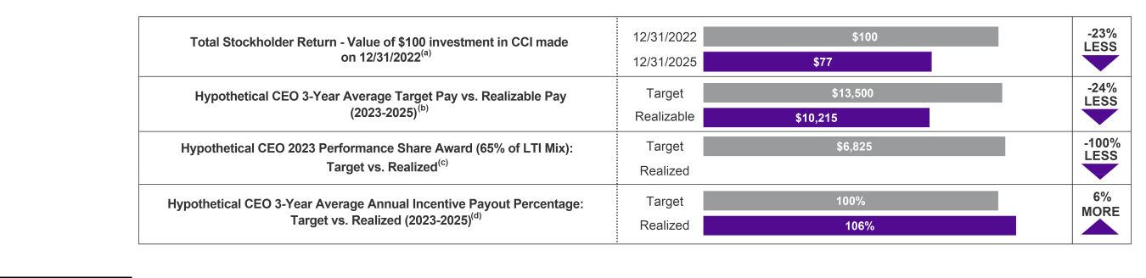

- Illustrates TSR of Common Stock during the period from December 31, 2022, through December 31, 2025, assuming $100 was invested on December 31, 2022, and including reinvestments of dividends.
- "Target Pay" is based on hypothetical CEO receiving $1 million in base salary, $2 million target annual incentive and $10.5 million in target LTI. "Realizable Pay" includes actual base salary, actual annual incentive paid and the value of outstanding Time RSUs (as defined below) and performance-based RSUs based on our December 31, 2025, share price of $88.87, with 2023 performance-based RSUs shown at actual payout and 2024 and 2025 performance-based RSUs shown at target. Excludes any dividends or dividend equivalents paid.

- For details regarding the 2023 performance-based RSUs, see our Definitive Proxy Statement on Schedule 14A, filed on April 11, 2024.

- Three-year average realized annual incentive payout percentage reflects the average of the actual incentive payout percentages for 2023, 2024 and 2025, which were 72.50%, 106.53% and 139.16%, respectively.

The table above is not intended to replace the disclosure required by Item 402(v) of Regulation S-K, which is presented in "IV. Executive Compensation—Pay Versus Performance" below.

Key Compensation Actions to Support Business Initiatives

 |  | In 2025, following the announcement of the Strategic Fiber Transaction, the Committee approved changes to the
 |  | compensation peer group, which were intended to:
 | Compensation Peer | • Reflect the anticipated scope and scale of the business following the pending Strategic Fiber Transaction by placing
 | Group | the Company closer to the median for its anticipated post-divestiture revenue and market capitalization; and
 |  | • Increase the weighting of REIT companies within the peer group to reflect the Company’s business profile post-
 |  | divestiture as U.S.-focused, standalone tower REIT.
 |  | For 2025, the Committee aligned the AIP with key business objectives by:
 | EMT Annual Incentive | • Increasing the weighting of Adjusted EBITDA⁽¹⁾ as a performance measure to 70% (previously 50%) to align with th
 | EMT Annual Incentive | Company's focus on profitability; and
 | Plan | Company's focus on profitability; and
 | Plan | • Replacing AFFO per share ("AFFO/Share")⁽¹⁾ as a performance measure with organic revenue growth (weighted at
 |  | 30%) to highlight the importance of top-line growth during a challenging business environment.
 |  | CROWN CASTLE INC. | 2026 PROXY STATEMENT
 |  | 35


Between 2024 and 2026, our LTI program has evolved to support key business objectives and align with investor prioritie

- 2024: Enhanced the focus on capital allocation and discipline by replacing absolute TSR as a performance measur and introducing average return on invested capital over a three-year performance period ("Average ROIC")⁽¹⁾ as a performance measure.

- 2025: Introduced three-year cumulative AFFO/Share⁽¹⁾ as a performance measure to enhance the focus on multi-ye profitability. Relative TSR transitioned from a discrete measure to a modifier that can adjust payouts of performance

Long-Term Incentive | based LTI awards by +/- 15% to prioritize the Company's financial performance, while aiming to hold management
Plan | accountable for stock price performance relative to competitors. Additionally, the performance comparator group
 | transitioned from the S&P 500 Index to the REIT constituents of the S&P 500 Index and the S&P 500 Index as a
 | whole to increase the emphasis on companies that are subject to similar macro factors as the Company, while also
 | continuing to highlight the importance of outperforming the broader market.

- 2026: Increased the emphasis on three-year cumulative AFFO/Share⁽¹⁾ (now 40% of total LTI mix) and reduced the emphasis on Average ROIC⁽¹⁾ (now 20% of the total LTI mix) to continue to prioritize multi-year profitability and to recognize that the business model is anticipated to be less capital intensive following the projected close of the Strategic Fiber Transaction.

 |  |  | In March 2025, while not standard to our executive compensation program, the Committee approved a one-time award o
 |  |  | RSUs to vest upon the successful closing of the Strategic Fiber Transaction ("Transformation RSUs")^{(b)}. The Committee
 |  |  | believes that these non-recurring awards were necessary to retain key leadership to help facilitate the successful closing
 | Transformation RSU |  | the Strategic Fiber Transaction and to navigate the transition period thereafter, particularly in light of the leadership
 |  |  | transitions outlined above.
 | Awards |  | transitions outlined above.
 |  |  | Transformation RSUs were granted to Messrs. Schlanger, Adams and Levendos and Ms. Piche, with a collective grant
 |  |  | value of $4.025 million, which we believe is an effective incentive to maintain continuity of leadership and facilitate the
 |  |  | closing of the $8.5 billion Strategic Fiber Transaction.
 | Target Compensation |  | Based on the competitive market, for 2025, we largely held target compensation flat and did not increase base salary or
 | Adjustments |  | annual incentive opportunities for our NEOs.

- See Appendix B for our definition of these non-GAAP financial measures.

- Mr. Schlanger's Transformation RSUs vest 50% upon the closing of the Strategic Fiber Transaction and 50% on the six-month anniversary of such closing.

Compensation Arrangements for Certain Executives

To help facilitate the leadership changes and transitions that we believe were necessary to support the business (as outlined above), we entered into the compensation arrangements outlined in the table below in 2025.

Name

Mr. Patel

Compensation Arrangement and Rationale


In connection with his appointment as EVP and CFO, Mr. Patel received the following compensation arrangement:

- Target compensation consisting of $625,000 in base salary, target annual incentive of 100% of base salary and 2025 LTI award with an approximate value of $4,450,000, delivered in the form of 40% RSUs which vest based on the passage of time over a three-year period or such other time period as specified in the agreement governing the RSUs ("Time RSUs") and 60% performance-based RSUs; and

- One-time make-whole cash bonus of $250,000 and make-whole Time RSUs of $3,000,000 vesting over three years, which were similar in value to and intended to replace his forfeited bonus and equity upon separation from his prior employer.

CROWN CASTLE INC. 2026 PROXY STATEMENT

36


In connection with his appointment as Interim President and CEO, the Board approved a:

- Monthly stipend of $100,000 in addition to his base salary as CFO that he would continue to be eligible to receive to recognize the difference in cash compensation levels between his role as CFO and that of a CEO;

- 2025 LTI award with an approximate value of $4,125,000, which represents the LTI award he would have received in

Mr. Schlanger | normal course had he continued as CFO;
- Time RSU award with an approximate value of $4,100,000 cliff vesting after one year, which amount represents approximately one third of the annual LTI award received by our former President and CEO, Mr. Moskowitz; and
- Transformation RSU award (as described above) with an approximate value of $1,000,000.

In connection with his transition to EVP and CTRO on September 15, 2025, Mr. Schlanger did not receive any additional compensation.


In connection with his appointment as President and CEO, the Board approved:

- Target cash compensation consisting of $1,000,000 in base salary and target annual incentive of 200% of base salary, each pro-rated for service;

- 2025 LTI award with an approximate value of $5,250,000 delivered in the form of 40% Time RSUs and 60% performance-

Mr. Hillabrant | based RSUs, which reflects approximately 50% of the value of his expected 2026 annual LTI target of $10,500,000; and
- One-time, make-whole cash bonus of $800,000, subject to recoupment by the Company if Mr. Hillabrant voluntarily terminates employment (other than a resignation for Good Reason (as defined in his Severance Agreement)) or experiences a Termination for Cause (as defined in his Severance Agreement) within 12 months following September 15, 2025, and make-whole Time RSUs with an approximate value of $7,000,000 vesting over three years, which were similar in value to and intended to replace his forfeited bonus and equity and are upon separating from his prior employer.
 | Mr. Moskowitz's employment was terminated without Cause (as defined in the Severance Agreement) effective March 23, 2025,
 | which met the definition of a Qualifying Termination pursuant to the terms of his Severance Agreement. As a result, Mr.
 | Moskowitz is eligible to receive the following, in accordance with his agreement:
 | • Lump sum payment equal to the sum of his base salary and target annual incentive for 2025 multiplied by two;
Mr. Moskowitz | • Prorated target cash amount of his annual incentive for 2025;
Mr. Moskowitz | • Continued coverage under specified health benefits program for two years and participation in the Company’s 401(k) Plan
 | for 2025; and
 | • Opportunity for continued vesting of his new hire Time RSUs on April 11 of 2025 and 2026, the original schedule, and
 | vesting of all other RSUs that would have vested two years following his separation.
 | See "IV. Executive Compensation—Potential Payments Upon Termination of Employment" for further details regarding
 | payments received by Mr. Moskowitz pursuant to his Severance Agreement.

Compensation Program Overview

Our executive compensation program reflects our commitment to best practices in compensation governance. Among other attributes, our program is designed to:

- align executive pay with Company performance against pre-established goals;

- provide a fair and competitive mix of compensation opportunities to attract, retain and motivate our executives to achieve important business objectives;

- reward our executive team for delivering superior financial and operating results and creating long-term stockholder value; and

- foster a culture of stewardship that aligns our executives' long-term interests, in the form of equity ownership, with those of our stockholders.

CROWN CASTLE INC. 2026 PROXY STATEMENT

37

We believe that our executive compensation program includes features that align the interests of our executive management with those of our stockholders and is designed to exclude features that may result in misalignment.

Other notable highlights of our executive compensation program include:
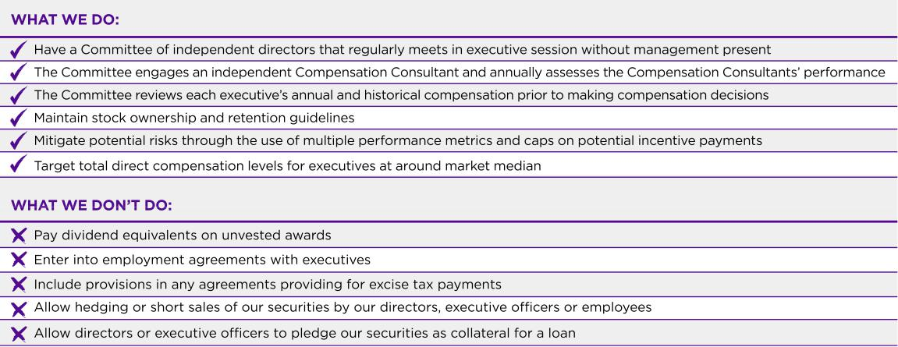

Further, at the 2025 Annual Meeting, we submitted our executive compensation program to an advisory stockholder vote, and our stockholders overwhelmingly approved our program, with approximately 93% of votes cast in favor of the proposal. The Committee has interpreted this vote to mean that our stockholders were supportive of our overall executive compensation philosophy and program.

Robust Stockholder Engagement

We frequently engage with our stockholders to solicit their input on the issues important to them. In 2025, we engaged with stockholders representing approximately half of our outstanding Common Stock (based on December 31, 2025). In these engagements, members of our management or Board met with investor portfolio managers and analysts, as well as governance and stewardship team members. Our leadership has also met with the sell-side analyst community, participated in investor conferences and held informal direct stockholder discussions throughout the year. Our stockholders previously expressed a desire for our compensation program to include a return-based performance metric to reinforce the importance of capital discipline, which led us to incorporate a ROIC metric into our LTI compensation program starting in 2024.

Compensation Philosophy, Strategy and Design

Our executive compensation program includes a range of features that are designed to align the interests of our executive management with those of our stockholders and to exclude features that may result in misalignment.

Pay for Performance Alignment

We seek to accomplish our goal of aligning pay with performance by providing our executives with a competitive compensation package that rewards performance against specific, strategic, financial and operational goals that the Committee believes are critical to the Company's long-term success and the achievement of sustainable long-term stockholder returns. We believe attracting, retaining and motivating talented management is essential to creating stockholder value throughout the business cycles of our industry.

The Committee aims to target total direct compensation ("TDC") (i.e., the sum of base salary, target STIs and LTIs) for our executives at approximately the 50th percentile of market, while continuing to provide our executives with the opportunity to earn actual TDC above the 50th percentile should our performance exceed predetermined criteria and below the 50th percentile should our performance fall short of such criteria. The

CROWN CASTLE INC. 2026 PROXY STATEMENT

38

Committee believes that targeting these levels of compensation aligns with our overall total rewards strategy, which in turn helps us achieve our executive compensation objectives and supports our long-term success.

In administering our executive compensation program, we are guided by the following principal objectives:

- Aligning annual incentive compensation with financial, operational and strategic objectives; and

- Rewarding share price appreciation, multi-year profitability and relative performance through LTI awards.

The charts below shows the approximate allocation of base salary, annual incentives and certain RSUs for 2025 (as shown in "IV. Executive Compensation—Summary Compensation Table") among fixed, short-term variable and long-term variable compensation for Mr. Hillabrant, who served as our President and CEO as of December 31, 2025, and for the following NEOs who served as executive officers of the Company as of December 31, 2025: Messrs. Patel, Schlanger, Levendos and Adams and Ms. Piche. The 2025 CEO TDC allocation refers to certain annualized compensation elements of Mr. Hillabrant's 2025 compensation and excludes his make-whole Time RSU award and make-whole cash bonus that he received in connection with his appointment as President and CEO to cover the bonus and equity forfeited upon separating from his prior employer. In addition, the LTI component of Mr. Hillabrant's annualized compensation reflects his target LTI award for 2026 to better demonstrate Mr. Hillabrant's TDC on a go forward basis. Further, the 2025 NEO TDC allocation reflects annualized base salary and STIs, where applicable, and excludes grants of new hire RSUs, promotion RSUs and Transformation RSUs. See "—Executive Summary" above and "— Executive Compensation Elements—Long-Term Incentives—Off-Cycle Awards" for further information.

2025 CEO and NEO Total Direct Compensation Allocation
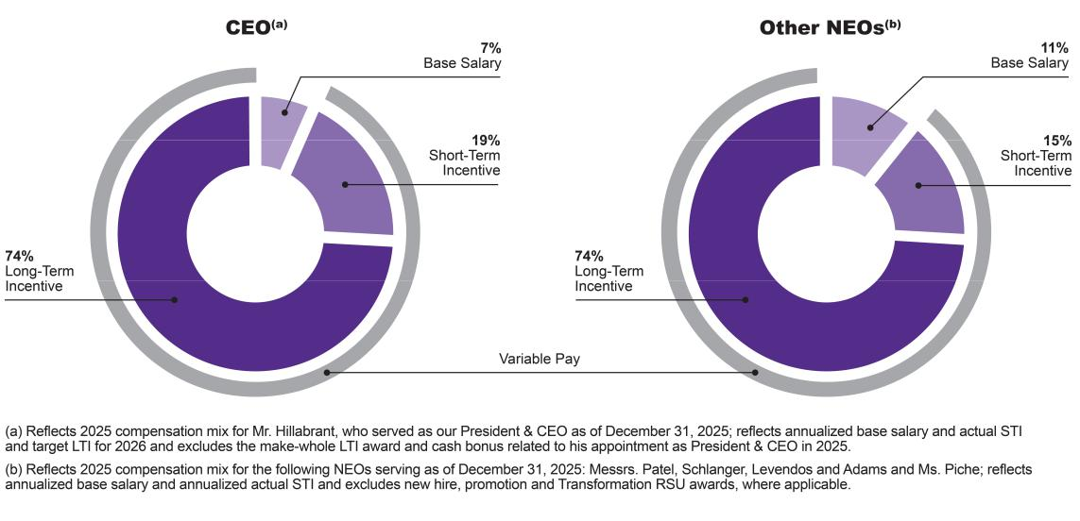

Executive Compensation Setting

We regularly review our executive compensation program to ensure that we provide the opportunity for each of our NEOs to receive competitive compensation without providing an incentive for excessive risk-taking. With the support of the Compensation Consultant, the Committee annually reviews each individual component of compensation as well as the aggregate compensation that may be paid or awarded to each of our NEOs and compares them:

- Externally against compensation awarded and paid to executive officers holding comparable positions at companies with which we compete for executive talent; and

- Internally against other members of the executive team to ensure internal equity, taking into account individual performance, skills and experience.

CROWN CASTLE INC. 2026 PROXY STATEMENT

39

We assess our compensation programs to ensure that elements of compensation are positioned at approximately the median as compared with the compensation of executives in our industry sector and among companies in other industries of comparable size, scope and organizational complexity. We also seek to provide a direct link between pay and the enhancement of stockholder value.

The Committee has established a number of processes to assist it in ensuring that our executive compensation program is achieving these objectives as detailed below.

Competitive Market Analysis

The Committee determines the levels for each element of total target compensation (i.e., base salary, STIs and LTIs) by annually engaging in a competitive market analysis with respect to each of these compensation elements for each executive position ("Competitive Market Analysis"). The Committee usually begins this Competitive Market Analysis several months before the compensation decisions are made. Compensation decisions are typically made at the first regularly scheduled Committee meeting of each year (usually held during the first quarter of the year) ("First Regular Committee Meeting"). Market data used in the Committee's Competitive Market Analysis includes peer group data and published and custom survey data.

Peer Group Data

Each year the Committee reviews publicly disclosed compensation data from companies comprising our "Peer Group," as discussed further below, when establishing executive pay levels and program design.

Generally, in the second half of each year, the Committee reviews the Peer Group composition in advance of the Competitive Market Analysis. This Peer Group review is conducted in collaboration with the Compensation Consultant and also considers management's perspective on current or prospective peer companies. While the Committee typically conducts this Peer Group review annually, it has strived to keep the Peer Group composition fairly constant year-to-year to provide consistency in market data results and allow the Committee to spot trends in pay levels and program design over time.

2025 Compensation Peer Group. In 2024, the Committee elected to delay its review of the compensation peer group for 2025 primarily as a result of the Company's Fiber Business strategic review, as its outcome could impact the scope and scale of our business. In March 2025, the Company announced that it entered into a definitive agreement to sell its Fiber Business, concluding the strategic review. Following this announcement, at its next regularly scheduled meeting in May 2025, the Committee conducted a review of the Peer Group with the assistance of the Compensation Consultant to determine whether the Peer Group continues to reflect the size, scope and other characteristics of the Company, resulting in the Committee's approval of changes to the Peer Group that were intended to reflect the anticipated scope and scale of the business following the close of the Strategic Fiber Transaction by placing the Company closer to the median for its projected post-divestiture revenue and market capitalization. In addition, the changes to the Peer Group contemplated an increased weighting of REIT companies aimed at representing the Company's anticipated business portfolio post divestiture as a U.S.-focused, standalone towers REIT.

Based on its review, the Committee elected to:

- Remove ten companies: Applied Materials, Inc., Booking Holdings Inc., BXP, Inc., Charter Communications, Inc., Intuit Inc., KLA Corporation, LAM Research Corporation, Lumen Technologies, Inc., NetApp, Inc. and ServiceNow, Inc.; and

- Add eight companies: Alexandria Real Estate Equities, Inc., AvalonBay Communities Inc., Equity Residential, Extra Space Storage Inc., Invitation Homes Inc., Iron Mountain Inc., Mid-America Apartment Communities, Inc. and Weyerhaeuser Company.

CROWN CASTLE INC. 2026 PROXY STATEMENT

40

These changes resulted in the following "2025 Peer Group":
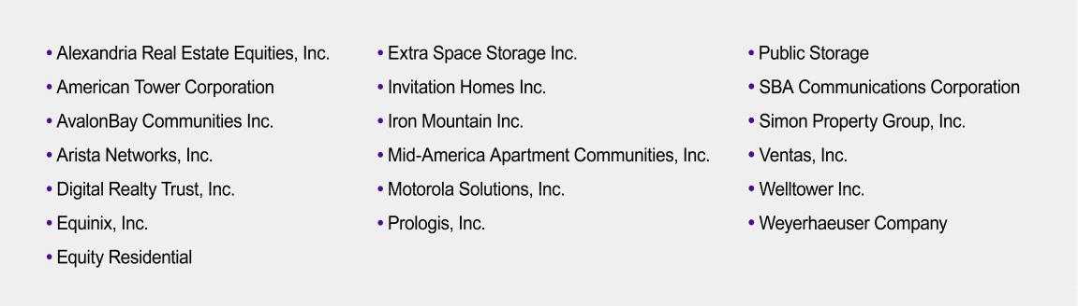

The 2025 Peer Group was used in 2025 as a benchmarking tool to establish pay levels and program design for the 2025 fiscal year.

Published and Custom Survey Data

For certain executive positions, the Committee analyzes market data reported in proprietary compensation surveys published by third parties. This analysis provides information regarding levels of executive compensation for positions for which publicly disclosed data are not widely available. Survey participants include companies in the S&P 500 Index, as well as companies in industries similar to ours. The Committee reviews and may utilize this data since we do not recruit executives exclusively from the communications infrastructure, telecommunications and REIT industries.

In addition to the foregoing data, the Compensation Consultant may analyze and provide additional market data regarding best practices and compensation plan design from the Peer Group and other sources as requested by the Committee. The market data described above is used by the Committee in the Competitive Market Analysis to make decisions regarding executive compensation. No single group, survey or set of market data is used by the Committee as the sole gauge for determining executive compensation; rather, the information is used collectively, and no formulaic quantitative methodology is used by the Committee when using such data to determine executive compensation.

Assessment of Individual and Company Performance

In addition to market data, the Committee considers other factors in connection with its evaluation and determination of the components of compensation. These other factors may include our financial and operating performance, the applicable executive's individual performance, the executive's level of experience, the size of year-over-year changes in compensation and the duties and level of responsibility of a particular executive position. These factors are discussed in more detail below.

Total Compensation Review

Through the Competitive Market Analysis and in its deliberations regarding executive compensation decisions, the Committee reviews and compares the individual components of compensation and the total compensation for each NEO against the market data. In addition, the Committee reviews year-over-year changes in compensation for each NEO against the market data. These analyses are an important aspect of the Committee's regular executive compensation decision-making process.

CROWN CASTLE INC. 2026 PROXY STATEMENT

41

Executive Compensation Elements

Our executive compensation program is designed to meet the objectives of our "pay for performance" philosophy by linking a significant portion of each executive's compensation to Company performance.

The following table summarizes the purpose and key characteristics of each of the primary components of our executive compensation program.

COMPENSATION ELEMENT |  | PURPOSE
 |  | Provide a base level of income, targeting the market
BASE SALARY |  | Provide a base level of income, targeting the market
 |  | median for executive talent.
 |  | Motivate executives to achieve our short-term financial
SHORT-TERM INCENTIVES |  | Motivate executives to achieve our short-term financial
(Annual cash incentive) |  | and operational objectives.

KEY CHARACTERISTICS

Fixed compensation. Reviewed annually and adjusted as appropriate.

Variable, cash-based compensation. Award potential ranges from 0% to 175% of target based on corporate performance measured against pre-established performance goals.

PERFORMANCE-BASED LTIs |  | Align the interests of our executives with those of our
(Cumulative AFFO/Share) |  | stockholders by enhancing the focus on multi-year
 |  | profitability.

Variable, stock-based compensation. The number of earned units can range from 0% to 200% based on our cumulative AFFO/Share over a three-year period. "Cliff" vesting following the end of the three-year performance period.

PERFORMANCE-BASED LTIs |  | Position the interests of our executives in line with those
(Average ROIC) |  | of our stockholders by creating a direct correlation
 |  | between realizable pay and our Average ROIC over a
 |  | three-year performance period and reinforcing the
 |  | importance of capital discipline.

PERFORMANCE-BASED LTIs MODIFIER Prioritize the Company's financial performance, while

(Relative TSR) also aligning the interests of our executives with those of our stockholders by creating a correlation between realizable pay and stockholder return performance on a relative basis.

SERVICE-BASED LTIs |  | Motivate executives to contribute to long-term increases
(Time RSUs) |  | in stockholder value, build executive ownership and
 |  | retain executives through ratable, multi-year vesting.

Variable, stock-based compensation. The number of earned units can range from 0% to 200% based on our Average ROIC over a three-year performance period. "Cliff" vesting following the end of the three-year performance period.

Performance modifier to AFFO/Share and Average ROIC LTI awards by +/- 15% based on our TSR relative to the REIT constituents of the S&P 500 Index and the S&P 500 Index as a whole, with above-median target at the 55th percentile.

Variable, stock-based compensation. Long-term award with ratable vesting over three years that provides a direct correlation of realizable pay to stockholder value.

The Committee takes several objectives into consideration when assessing the reasonableness of the TDC of the NEOs, particularly the compensation of our CEO. These objectives include ensuring alignment with our vision and business strategy, creating sustainable long-term stockholder value through the amount and mix of compensation provided and advancing the core principles of our compensation philosophy and objectives while remaining within our risk tolerance.

2025 Target Direct Compensation

As explained above, the Committee reviewed target pay and determined 2025 total target compensation for the NEOs to align with market data of our peers. As a result of a challenging market environment, for 2025, the Committee made no changes to target TDC for the NEOs, except for Ms. Piche, who was not eligible to receive an LTI award for 2024 due to the timing of her appointment as EVP and COO–Towers in the fourth quarter of 2024.

CROWN CASTLE INC. 2026 PROXY STATEMENT

42

The following table illustrates the TDC for each NEO for 2025:

Name |  | Title |  | Base Salary |  | Target STI |  | Target LTI |  | Target TDC |  | Increase in
Name |  | Title | ($) |  | ($) |  | ($) |  | ($) |  |  | TDC
Christian H. Hillabrant^{(a)} |  | President & CEO |  | 1,000,000 |  | 2,000,000 |  | 10,500,000 |  | 13,500,000 |  | N/A
Sunit S. Patel^{(b)} |  | EVP & CFO |  | 625,000 |  | 625,000 |  | 4,450,000 |  | 5,700,000 |  | N/A
Daniel K. Schlanger |  | EVP & CTRO; Former Interim President |  | 640,000 |  | 640,000 |  | 4,125,000 |  | 5,405,000 |  | —%
Daniel K. Schlanger |  | & CEO; Former CFO |  | 640,000 |  | 640,000 |  | 4,125,000 |  | 5,405,000 |  | —%
Christopher D. Levendos |  | EVP & COO—Fiber |  | 600,000 |  | 600,000 |  | 4,350,000 |  | 5,550,000 |  | —%
Edward B. Adams, Jr. |  | EVP & General Counsel |  | 515,000 |  | 515,000 |  | 2,900,000 |  | 3,930,000 |  | —%
Catherine Piche |  | EVP & COO—Towers |  | 550,000 |  | 550,000 |  | 3,700,000 |  | 4,800,000 |  | —%
Steven J. Moskowitz^{(c)} |  | Former President & CEO |  | 900,000 |  | 1,575,000 |  | 12,300,000 |  | 14,775,000 |  | —%

- Reflects Mr. Hillabrant's annualized compensation effective September 15, 2025, which was the effective date of his appointment to the position of President & CEO.

- Reflects Mr. Patel's annualized compensation effective April 1, 2025, which was the effective date of his appointment to the position of EVP & CFO.

- Mr. Moskowitz ceased serving as our President & CEO, effective March 23, 2025.

Base Salary

Base salary is one of the main components of cash compensation for our executives. This element of pay provides a foundation for attracting and retaining executives and establishing a minimum level of compensation upon which our executives may rely.

The Committee bases its decisions regarding base salary on multiple factors, including the level of responsibility and performance of the executive, considering such executive's contribution, accountability and experience, as well as the executive's base salary as compared to the Competitive Market Analysis. The Committee reviews recommendations made by the CEO with regard to base salary for executives other than himself and then either approves or revises such recommendations. The Committee and Board independently review the performance of the CEO when determining and approving the base salary for the CEO.

For 2025, the Committee did not approve any adjustments to the base salaries of the NEOs:

 |  |  |  |  |  | Base Salary
Name |  | Title
Name |  | Title | 2025 |  | 2024 |  |  | % Increase
Christian H. Hillabrant^{(a)} |  | President & CEO |  | $1,000,000 |  | N/A |  | N/A
Sunit S. Patel^{(b)} |  | EVP & CFO |  | $625,000 |  | N/A |  | N/A
Daniel K. Schlanger^{(c)} |  | EVP & CTRO; Former Interim President & CEO; |  | $640,000 |  | $640,000 |  | —%
 |  | Former CFO
Christopher D. Levendos |  | EVP & COO—Fiber |  | $600,000 |  | $600,000 |  | —%
Edward B. Adams, Jr. |  | EVP & General Counsel |  | $515,000 |  | $515,000 |  | —%
Catherine Piche |  | EVP & COO—Towers |  | $550,000 |  | $550,000 |  | —%
Steven J. Moskowitz^{(d)} |  | Former President & CEO |  | $900,000 |  | $900,000 |  | —%

- Mr. Hillabrant was appointed as our President & CEO, effective September 15, 2025, and, therefore, received a pro-rated portion of the 2025 base salary noted in the table.

- Mr. Patel was appointed as our EVP & CFO, effective April 1, 2025, and, therefore, received a pro-rated portion of the 2025 base salary noted in the table.

- Mr. Schlanger's base salary for 2025 is reflective of all executive officer positions that he held with the Company for 2025. He did not receive any adjustments to his base salary as a result of his appointment to Interim President & CEO on March 23, 2025, and did not receive any further adjustments to his base salary when he transitioned from Interim President & CEO to EVP & CTRO on September 15, 2025. Mr. Schlanger received a $100,000 monthly stipend in addition to his base salary as CFO for his service as our Interim President & CEO from March 23, 2025, to September 15, 2025, to recognize the difference in cash compensation levels between his role as CFO and that of a CEO.

- Mr. Moskowitz ceased serving as our President & CEO, effective March 23, 2025.

CROWN CASTLE INC. 2026 PROXY STATEMENT

43

Short-Term Incentives

The STI component of compensation represents a significant portion of the overall cash compensation opportunity for our executives. STIs are a variable element of compensation that are linked to the achievement of specific short-term financial objectives each year.

Our NEO's STIs are earned based upon meeting certain performance goals and may be earned at above-target or below-target levels based on the degree of achievement of those goals. In order to accomplish its overall executive compensation objectives, the Committee has identified the following principles for developing the overall framework of the STI program. The program should:

- be performance-based and market competitive;

- link the financial measures with stockholder expectations; and

- motivate executives to achieve short-term financial objectives, while avoiding excessive risk.

Annual Incentives

To achieve the program objectives, our STIs for executives are generally composed of performance-based annual incentives paid in accordance with an annually approved AIP. The AIP is a cash-based, STI program that provides executives with the opportunity to earn an annual cash incentive based on the achievement of annual performance goals. Such performance goals are pre-established based on the annual expectations for our business and are meant to be challenging, yet achievable. The Compensation Consultant has reviewed the performance goals and has noted that the performance goals represent meaningful targets that are challenging and indicative of value creation. The performance period covered by the AIP is from January 1 to December 31 of the applicable calendar year.

For 2025, each NEO was eligible to earn between 0% and 175% of such executive's target opportunity under the AIP. To mitigate excessive risk, annual incentives are capped at the maximum payout opportunity even if actual performance exceeds the maximum performance goal. The following table illustrates the 2025 annual incentive target opportunity and the potential range of payouts as a percentage of target for each NEO:

Name |  | Title |  | Target Opportunity |  | Potential Payout Range
Name |  | Title |  | (as % of Base Salary) |  | (as % of Target Opportunity)
Christian Hillabrant |  | President & CEO |  | 200% |  | 0% - 175%
Sunit S. Patel |  | EVP & CFO |  | 100% |  | 0% - 175%
Daniel K. Schlanger |  | EVP & CTRO; Former Interim President & |  | 100% |  | 0% - 175%
Daniel K. Schlanger |  | CEO; Former CFO |  | 100% |  | 0% - 175%
Christopher D. Levendos |  | EVP & COO—Fiber |  | 100% |  | 0% - 175%
Edward B. Adams, Jr. |  | EVP & General Counsel |  | 100% |  | 0% - 175%
Catherine Piche |  | EVP & COO—Towers |  | 100% |  | 0% - 175%
Steven J. Moskowitz^{(a)} |  | Former President & CEO |  | 175% |  | 0% - 175%

- Mr. Moskowitz ceased serving as our President & CEO, effective March 23, 2025.

2025 Annual Incentive Performance Structure and Achievement.

The annual incentive structure is designed to recognize and motivate strong financial performance. The performance measures, relative weightings and threshold-target-maximum payout ranges were designed based on our 2025 financial budget, as approved by the Board in the first quarter of 2025. For 2025, the Committee modified the annual incentive structure to (1) remove AFFO/Share as a performance measure,

- introduce organic revenue growth as a new financial performance measure and (3) increase the weighting of Adjusted EBITDA from 50% to 70%.

CROWN CASTLE INC. 2026 PROXY STATEMENT

44

The components of the total annual incentive payout under the AIP for 2025 were as follows:

Performance Measure | 2025 Weighting | 2025 Actual | 2025 Weighted Achievement
Adjusted EBITDA^{(a)} | 70% | 124% | 86.70%
Organic Revenue Growth^{(a)} | 30% | 175% | 52.50%
2025 Annual Incentive Achievement |  |  | 139.16%

- See Appendix B for definition and reconciliation of this non-GAAP financial measure.

For 2025, the level at which corporate financial performance goals were established was based on the Board-approved financial budget and the guidance provided to investors for the applicable calendar year, with "target" goals representing the Board-approved budget amounts. The target levels established below were rigorous. For Adjusted EBITDA, the target level for 2025 was established below 2024 actual results in light of the headwinds facing the Company and the industry as a whole, including: a decrease in tower and small cells leasing activity due to reduced network spending by the major telecommunications providers, an increase in tower, small cells and fiber solutions churn activity primarily driven by the T-Mobile US, Inc. and Sprint network consolidation and increases in borrowing costs due to higher interest rates.

The following table presents the 2025 corporate financial performance goals and actual results considered by the Committee in determining the NEOs' 2025 annual incentives. For each NEO, the annual incentive is financially driven, based on an objective formula that weighs the performance measures of Adjusted EBITDA at 70% and organic revenue growth at 30%. Based on actual performance and weighting of these metrics, each NEO received a payout of 139.16% of target as set forth in the table above.

Annual Incentive Performance Metrics, Weighting, Payout Range and Achievement

70% Weighting 30% Weighting

Performance Level |  |  | Adjusted EBITDA^{(a)} |  | Percent
 |  |  | ($ in millions) |  | Payout
Maximum |  |  | $4,207 |  | 175%
Target |  |  | $3,968 |  | 100%
Threshold |  |  | $3,809 |  | 50%
Below Threshold |  |  | <$3,809 |  | 0%
Actual |  |  | $4,004 |  | 124%

Performance Level |  | Organic Revenue |  | Percent
Performance Level |  | Growth^{(a)} |  | Percent
 |  | ($ in millions) |  | Payout
Maximum |  | $266 |  | 175%
Target |  | $251 |  | 100%
Threshold |  | $241 |  | 50%
Below Threshold |  | <$241 |  | 0%
Actual |  | $285 |  | 175%

- See Appendix B for definition and reconciliation of this non-GAAP financial measure.

There is the following additional performance requirement for annual incentives for 2025:

- The business units or departments for which the executives are responsible must receive an acceptable assessment of applicable internal control over financial reporting for the previously completed fiscal year, pursuant to Section 404 of the Sarbanes-Oxley Act of 2002 ("404 Assessment"). Receipt of a 404 Assessment with a material weakness may result in a reduction or elimination of the potential annual incentives for the responsible executives and potentially all of the executives.

CROWN CASTLE INC. 2026 PROXY STATEMENT

45

The following table illustrates the 2025 annual incentive payout for each eligible NEO based on the payout factors above:

Name |  | Title |  | Target Annual Incentive |  | Annual Incentive |  | Actual Annual Incentive
Name |  | Title |  | Target Annual Incentive |  | Achievement |  | Actual Annual Incentive
Christian H. Hillabrant^{(a)} |  | President & CEO |  | $591,780 |  | 139.16% |  | $823,522
Sunit S. Patel^{(b)} |  | EVP & CFO |  | $470,890 |  | 139.16% |  | $655,291
Daniel K. Schlanger |  | EVP & CTRO; Former Interim President & |  | $640,000 |  | 139.16% |  | $890,624
Daniel K. Schlanger |  | CEO; Former CFO |  | $640,000 |  | 139.16% |  | $890,624
Christopher D. Levendos |  | EVP & COO—Fiber |  | $600,000 |  | 139.16% |  | $834,960
Catherine Piche |  | EVP & COO—Towers |  | $550,000 |  | 139.16% |  | $765,380
Edward B. Adams, Jr. |  | EVP & General Counsel |  | $515,000 |  | 139.16% |  | $716,674
Steven J. Moskowitz^{(c)} |  | Former President & CEO |  | $353,835 |  | 139.16% |  | $492,397

- Mr. Hillabrant was appointed as our President & CEO, effective September 15, 2025, and, therefore, his target and actual annual incentive reflected in the table has been prorated for 2025.
- Mr. Patel was appointed as our EVP & CFO, effective April 1, 2025, and, therefore, his target and actual annual incentive reflected in the table has been prorated for 2025.

- Mr. Moskowitz ceased serving as our President & CEO effective March 23, 2025, and his target and actual annual incentive reflected in the table has been prorated for 2025 in accordance with the terms of his Severance Agreement.

Further details regarding annual incentives paid to the NEOs are provided below in the tables and related footnotes at "IV. Executive Compensation—Summary Compensation Table" and "IV. Executive Compensation—Grants of Plan-Based Awards in 2025."

Long-Term Incentives

The LTI component represents the largest portion of the overall value of the total compensation program for our executives. In its assessment of LTIs, the Committee, with the assistance of the Compensation Consultant, considers market data, our business needs and the economic climate. In doing so, the Committee has determined that a mix of performance-based and time-based equity continues to appropriately achieve our executive LTI program objectives.

The objectives of our LTI program are to:

- align a significant portion of our executives' compensation with the return experienced by our stockholders;

- provide a means for our executives to accumulate shares of Common Stock to foster a culture of stewardship; and

- serve as a retention vehicle for our executives.

2025 LTI Design Overview.

For 2025, to provide an appropriate balance of incentives tied to performance, the annual LTI element of our executive compensation program was delivered in the form of the following RSUs, which may vest based on: (1) three-year cumulative AFFO per share ("Cumulative AFFO/Share Performance RSUs"), weighted at 30%, (2) our average ROIC over a three-year performance period ("Average ROIC Performance RSUs," and together with AFFO/Share Performance RSUs "Performance RSUs"), weighted at 30%, and (3) the passage of time over a three-year period in the form of Time RSUs. Performance RSUs are subject to a relative TSR modifier with a target goal set at above median performance (as described further below at "—Relative TSR Modifier to 2025 LTI Awards").

CROWN CASTLE INC. 2026 PROXY STATEMENT

46

The table below illustrates the framework of the 2025 LTI design.
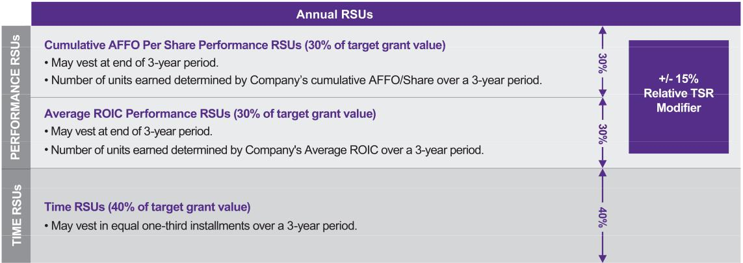

2025 LTI Awards.

The Performance RSUs granted in 2025 were issued pursuant to our 2022 Long-Term Incentive Plan, as amended ("2022 LTIP") and represent a contingent right to receive Common Stock equal to 0% to 200% of the target number of Performance RSUs. Vesting of the Performance RSUs is subject to (1) the level of achievement against the relevant performance criteria over a three-year performance period (beginning January 1, 2025, and ending December 31, 2027) and (2) the executive remaining an employee or director of ours (including our affiliates) until February 19, 2028. In addition, the Performance RSUs are subject to relative TSR modifier with a target goal set at above median performance.

In connection with the award of the Performance RSUs for 2025, the Committee established a threshold, target and maximum performance level and determined the percentage of the RSUs that would vest at each performance level as set forth below:

Cumulative AFFO/Share Performance RSUs^{(a)}

Performance Level Vesting

Average ROIC Performance RSUs^{(a)}

Performance Level Vesting

 | Maximum |  |  | 200% |  | Maximum |  | 200%
 |  | Target |  | 100% |  | Target |  | 100%
 | Threshold |  |  | 50% |  | Threshold |  | 50%
 | Below Threshold |  |  | 0% |  | Below Threshold |  | 0%

- See Appendix B for definition and reconciliation of this non-GAAP financial measure.

Information with respect to performance levels for our cumulative AFFO/Share and Average ROIC measures during the pendency of their three-year performance periods are not considered material to an understanding of the compensation arrangements of our executive officers and is not disclosed in this discussion, as it represents confidential financial information that we do not otherwise disclose to the public. Disclosing this information could cause significant competitive harm to the Company. We believe our performance targets for cumulative AFFO/Share and Average ROIC were set at an appropriate level at the beginning of the performance period to be aspirational, but sufficiently achievable to motivate the performance of our executive officers. We disclose information with respect to the threshold, target and maximum payout opportunities for cumulative AFFO/Share and Average ROIC and the actual number of units awarded in our executive compensation disclosures with the SEC in the fiscal year following the conclusion of the three-year performance period.

The levels at which the cumulative AFFO/Share and Average ROIC vesting targets are established are generally reviewed and approved at the First Regular Committee Meeting of the grant year. Additional information regarding the Performance RSUs described above is provided below in the tables and related

CROWN CASTLE INC. 2026 PROXY STATEMENT

47

footnotes at "IV. Executive Compensation—Summary Compensation Table" and "IV. Executive Compensation—Grants of Plan-Based Awards in 2025."

Relative TSR Modifier to 2025 LTI Awards.

While our Performance RSUs granted in 2025 are based on specific financial performance measures, actual payouts of LTI compensation are also directly tied to TSR. Accordingly, payout percentages with respect to cumulative AFFO/Share and Average ROIC are adjusted by a cumulative three-year relative TSR modifier of up to plus or minus (+/-) 15% based on relative performance as ranked against the REIT constituents of the S&P 500 Index and the S&P 500 Index as a whole ("TSR Peer Group"), with the target payout if the Company's TSR performance ranking ("TSR Rank") equals the 55th percentile of the TSR Peer Group.

Relative TSR Modifier^{(a)}

Performance Level |  | TSR Rank |  | Relative TSR Modifier
Maximum |  | 80th percentile |  | 115%
Target |  | 55th percentile |  | 100%
Threshold |  | 30th percentile |  | 85%

- For TSR Rank outcomes (i) between the 30th and 55th percentiles of the TSR Peer Group or (ii) between the 55th and 80th percentiles of the TSR Peer Group, the relative TSR modifier will be calculated via linear interpolation.

The Committee has the authority to interpret and determine the application and calculation of matters relating to the determination of TSR, the Company's TSR Rank, the relative TSR modifier, Average ROIC and cumulative AFFO/Share and to make adjustments it deems appropriate to reflect changes in the Common Stock, including as a result of any stock split or consolidation, stock dividend, recapitalization, merger, reorganization or other relevant distribution or change in capitalization.

Off-Cycle Awards.

In 2025, the Committee approved certain off-cycle LTI awards that consisted of the following:

- Make-whole RSUs (also referred to as new hire RSUs) are Time RSUs awarded to certain newly hired executives based on the position and role into which they are hired and vest in accordance with the terms of the respective RSU agreement ("Make-Whole RSUs" or "New Hire RSUs"). The following Make-Whole RSUs were granted to NEOs in 2025 to primarily offset the equity forfeited from a prior employer or as inducement to join the Company:

  - On April 1, 2025, in connection with his appointment as EVP and CFO, Mr. Patel was awarded Make-Whole RSUs with an approximate value of $3,000,000, which are scheduled to vest a third on April 10th of each of 2026, 2027 and 2028, subject to Mr. Patel's continued employment with the Company through each applicable vesting date.

  - On September 15, 2025, in connection with his appointment as President and CEO, Mr. Hillabrant was awarded Make-Whole RSUs with an approximate value of $7,000,000, which are scheduled to vest a third on September 15th of each of 2026, 2027 and 2028, subject to Mr. Hillabrant's continued employment with the Company through each applicable vesting date.

- Promotion RSUs are Time RSUs awarded to certain executives in recognition of a promotion to a new position or role and vest in accordance with the terms of the respective RSU agreement ("Promotion RSUs"). On March 23, 2025, Mr. Schlanger received an RSU grant in connection with his promotion to Interim President and CEO with an approximate value of $4,100,000 to vest in full on March 23, 2026, subject to Mr. Schlanger's continued employment through the vesting date; provided that such Promotion RSUs will accelerate and vest in full if Mr. Schlanger is terminated by the Company without cause prior to the vesting date.

CROWN CASTLE INC. 2026 PROXY STATEMENT

48

- Transformation RSUs are a one-time award of RSUs scheduled to vest upon the successful closing of the Strategic Fiber Transaction, except with respect to Mr. Schlanger (as detailed below). The following non-recurring Transformation RSUs were granted to NEOs in 2025 predominantly to retain key leadership during a time of transformation within the Company as a result of the anticipated divestiture of its Fiber Business and to help facilitate the closing of the Strategic Fiber Transaction, which is anticipated to close in the first half of 2026. The collective grant value of these awards is $4.025 million, which we believe is an effective incentive to facilitate the closing of the $8.5 billion Strategic Fiber Transaction.

  - On March 23, 2025, Mr. Schlanger was awarded a Transformation RSU grant with an approximate value of $1,000,000, which is scheduled to vest 50% upon the closing of the Strategic Fiber Transaction and 50% on the six-month anniversary of such closing, subject to Mr. Schlanger's continued employment through each applicable vesting date; provided that these RSUs will accelerate and vest in full if Mr. Schlanger is terminated by the Company without cause prior to the award becoming fully vested.

  - On March 28, 2025, Messrs. Adams and Levendos were each awarded a Transformation RSU grant with an approximate value of $1,500,000 and $1,000,000, respectively.

  - On April 22, 2025, Ms. Piche was awarded a Transformation RSU grant with an approximate value of $525,000.

Payout for 2023 Performance RSUs.

For the three-year period ending on December 31, 2025, our TSR was meaningfully negative and trailed that of our performance relative to companies in the S&P 500 Index, which companies consist of our performance peer group for purposes of the 2023 Performance RSUs, resulting in the forfeiture of the 2023 performance-based LTI awards for the 2023 through 2025 performance period.

Other Elements of Executive Compensation

In addition to base salary, STIs and LTIs, we provide other benefits as outlined below. We believe these other elements of our executive compensation program support our overall talent attraction and retention objectives.

Severance Agreements

The Committee believes establishing competitive severance arrangements with our executives is a key part of a total rewards package to effectively recruit and retain high-performing executives. We have entered into severance agreements containing severance benefits and non-compete and non-solicitation provisions with each of our NEOs and certain other executive officers (as amended, "Severance Agreements"). We do not currently have employment-related agreements with any of our NEOs other than the Severance Agreements (as defined in and further discussed in "IV. Executive Compensation—Potential Payments Upon Termination of Employment").

Pursuant to each Severance Agreement, we are generally required to provide severance benefits to the officer if such officer is terminated without Cause (as defined in the Severance Agreement) or such officer terminates employment with Good Reason (as defined in the Severance Agreement) (collectively a "Qualifying Termination"). The Severance Agreements provide for enhanced severance benefits if the officer incurs a Qualifying Termination within two years following a Change in Control (as defined in the Severance Agreements).

The Committee has adopted a policy not to enter into any agreement providing for an excise tax "gross up" payment relating to an "excess parachute payment" (pursuant to Section 280G of the Internal Revenue Code of 1986, as amended ("Code")) ("Excise Tax Payment"), and no existing Severance Agreements contain Excise Tax Payment provisions.

We periodically review the level of executive severance benefits by analyzing our severance benefits as compared to competitive market practices as provided in surveys and information from third parties. Subsequent Severance Agreements may be different as a result of such reviews.

CROWN CASTLE INC. 2026 PROXY STATEMENT

49

Mr. Moskowitz's employment was terminated without Cause effective March 23, 2025, which met the definition of a Qualifying Termination pursuant to the terms of his Severance Agreement with the Company. As a result, Mr. Moskowitz is eligible to receive certain payments and benefits following his separation, in accordance with such agreement.

Amended and Restated Extended Service Separation Program

The Board has approved a program designed to make available certain retirement-type benefits to all employees, including the NEOs, that meet certain age and service requirements. Generally, to be eligible, (1) the sum of an employee's age and years of service as an employee must be equal to or greater than 70, (2) the employee must be credited with at least 10 years' service, (3) the employee must be at least 50 years old and (4) the employee must provide at least six months' prior notice (or, for certain non-executive positions, three months' prior notice) of his or her intention to terminate employment. Assuming these conditions are satisfied, RSUs held by such employees that were granted at least six months prior to termination will continue to have the opportunity to vest pursuant to their terms (other than the employment requirement), subject to certain additional conditions, including the execution of a full release and an agreement to be available for post-termination consultation with us. As to an employee not holding RSUs, the program generally provides that, in connection with employment termination, an employee who meets the above eligibility requirements will receive a fully-vested, discretionary, profit-sharing contribution pursuant to the Crown Castle Inc. 401(k) Plan ("401(k) Plan") equal to 25% of the employee's base salary. The program is subject to interpretation, modification or termination by the Committee or Board in the sole discretion of each at any time.

Retirement Benefits

In 2025, our executives were eligible to participate in our 401(k) Plan under generally the same parameters applicable to all other employees, including a matching contribution ("Base Match"), dollar for dollar on up to 5% of the executive's cash compensation contributed. The Base Match is treated as subject to Internal Revenue Service limitations. The value of the 2025 Base Match for each NEO is provided below in the table at "IV. Executive Compensation—Summary Compensation Table" and "IV. Executive Compensation—All Other Compensation Table."

Health and Welfare Benefits

Our executives are eligible to participate in the same health and welfare benefits that are available to our other eligible employees, such as medical, dental, vision and life insurance. The value of the health and welfare benefits paid by us for each NEO in applicable years is provided below in the tables at "IV. Executive Compensation—Summary Compensation Table" and "IV. Executive Compensation—All Other Compensation Table."

Relocation Benefits

In general, we do not offer our executives significant perquisites, other than relocation assistance. We generally offer relocation assistance to all of our employees (including our executives) who we ask to relocate in connection with their employment with us, with the level of benefits generally corresponding to the level of the employee's position. We have found that relocation assistance can play an important role in attracting qualified candidates or transferring existing employees to our various office locations. The primary benefits provided under our relocation assistance program to our NEOs and other senior management are generally: reasonable moving and related expenses, closing costs related to selling and buying a house and temporary living expenses, if needed, for up to 120 days. We provided relocation assistance benefits to Ms. Piche, our EVP and COO—Towers, and Mr. Hillabrant, our President and CEO, in 2023 and 2025, respectively. The value of the relocation assistance provided to each of Ms. Piche and Mr. Hillabrant is set forth in "VI. Executive Compensation—All Other Compensation Table."

Executive Compensation Governance, Policy and Practice

The Committee is responsible for the executive compensation program design and decision-making process. The Committee solicits input from independent members of the Board, the CEO, other members of

CROWN CASTLE INC. 2026 PROXY STATEMENT

50

management and the independent Compensation Consultant to assist with its responsibilities. The following summarizes the roles of each of the participants in the executive compensation decision-making process.

Compensation and Human Capital Committee

The Committee is composed solely of members of the Board who (1) are not employees of the Company and (2) meet the independence requirements of the NYSE listing standards.

The Committee is responsible for overseeing our executive compensation and LTI programs. Specifically, the Committee is responsible for:

- designing, recommending, administering and evaluating the executive compensation plans, policies and programs of the Company; and

- overseeing the administration of the Company's equity-based compensation plans.

For additional information regarding the Committee, see "II. Election of Directors—Board Committees—Compensation and Human Capital Committee."

Independent Compensation Consultant

In performing its duties, the Committee obtains advice from the Compensation Consultant, FW Cook, which is engaged directly by the Committee (while the Compensation Consultant is engaged by the Committee, it works with management, including members of our HR department and our CEO, as directed by the Committee). In addition, in the case of compensation decisions relating to executives other than the CEO, the Committee seeks and obtains input from the CEO. The Committee regularly holds executive sessions at its meetings during which management, including the CEO, is not in attendance. Management, including members of our HR department and our CEO, assists with the coordination, preparation and review of Committee meeting materials.

Management

The CEO annually reviews the competitive pay position and the performance of each executive officer other than himself. The CEO's conclusions and recommendations, including base salary adjustments and award amounts for the current year and target annual award amounts for the next year under the AIP (other than for himself) are presented to the Committee. The Committee makes all compensation decisions and approves all share-based awards for the NEOs and other executive officers. The Committee may exercise its discretion in modifying any compensation element to any executive officer, including reducing or increasing the payment amount for one or more components of such awards.

Stock Ownership and Retention Guidelines

To further align the interests of our executive management with those of our stockholders, we have adopted certain stock ownership and retention guidelines ("Ownership Guidelines") designed to support a culture of stewardship among the NEOs and certain other executive officers. The Committee believes the maintenance of the Ownership Guidelines motivates executives to perform in accordance with the interests of our stockholders. The ownership levels in the Ownership Guidelines are designed to ensure that executives have a meaningful economic stake in our Common Stock, while satisfying the executives' need for portfolio diversification.

The Ownership Guidelines provide that each of the NEOs should maintain beneficial ownership of a number of shares of Common Stock having a value sufficient to satisfy the applicable stock ownership level specified below:

 | Position |  | Stock Ownership Multiple^{(a)}
 | Chief Executive Officer |  | 6X Base Salary
 | Other Executive Officers |  | 3X Base Salary

- Represents the dollar value of Common Stock to be held, as determined pursuant to NYSE quotations. Eligible shares under the Ownership Guidelines for purposes of satisfying the applicable stock ownership levels include all shares of Common Stock deemed beneficially owned

CROWN CASTLE INC. 2026 PROXY STATEMENT

51

by an executive officer, which includes stock held in the Company's 401(k) plan, unvested Time RSUs and performance-based RSUs that remain only subject to time vesting. Unearned performance-based RSUs are not considered eligible for purposes of determining the applicable stock ownership levels.

The NEOs have until the fifth anniversary of the date such NEO was appointed to meet the applicable Common Stock ownership level. In addition, an NEO has until the fifth anniversary after the date of an increase in base salary to meet the incremental increase to the applicable Common Stock ownership level as a result of such base salary increase.

The Ownership Guidelines provide that if an NEO's Common Stock ownership is below (or subsequently falls below) the applicable stock ownership level, such NEO should hold and retain all shares of Common Stock received by the NEO resulting from equity awards granted to the NEO by the Company as a component of compensation until the NEO's applicable stock ownership level is met. The Ownership Guidelines apply with respect to "after-tax shares" (e.g., the sale of shares to cover taxes relating to Company granted equity awards is not subject to the Ownership Guidelines).

As of the Record Date, all of our NEOs who have served in their covered position for at least five years and continue to serve as an executive officer on the Record Date were in compliance with the Ownership Guidelines.

Compensation Recovery and Recoupment (Clawback) Policies

Recovery Policy.

In October 2023, the Board adopted the Incentive Compensation Recovery Policy ("Recovery Policy") to comply with the requirements of Exchange Act Rule 10D-1 and the NYSE listing standards thereunder to provide for the mandatory recoupment of excess incentive compensation (as that term is defined in the Recovery Policy) that was received by certain current and former executive officers in the event the Company is required to prepare an accounting restatement due to material noncompliance with any financial reporting requirement under the federal securities laws.

Recoupment Policy.

In addition, we maintain a separate legacy recoupment policy ("Recoupment Policy"), which provides that in the event of a restatement of the Company's financial statement or a determination by the Board that misconduct by an NEO or certain other employees caused financial or reputational harm to the Company, the Committee will review the circumstances and make recommendations to the Board as to whether recoupment should be pursued. Under the Recoupment Policy, "misconduct" includes any intentional or reckless violation of our guidelines and policies or any grossly negligent act or failure to act causing the above described result. In such circumstances, the Committee will review all compensation that has been awarded to a responsible party and determine how such compensation may have been affected by the financial restatements or misconduct.

Should the Board determine that recoupment is appropriate, we may recoup from an NEO or other responsible employee any cash incentives and equity awarded in reliance on the financial statements that were restated, or for the year in which the financial or reputational harm occurred, to the extent the Committee determines that the cash incentives and equity awarded were based on such restated financial statements or resulted from such misconduct. The NEO and other responsible employees may also be subject to other disciplinary actions, up to and including termination of employment.

Insider Trading, Anti-Hedging and Anti-Pledging Policies

We have adopted an Insider Trading Policy and procedures governing the purchase, sale or other disposition of our securities by directors, officers, employees, contingent workers, contractors and consultants, which we believe are reasonably designed to promote compliance with insider trading laws, rules and regulations and applicable NYSE listing standards.

Further, our Insider Trading Policy prohibits our directors and employees, including our executive officers, from, among other things, short sales and trading in options, puts, calls or other derivative instruments relating to our securities, including for hedging purposes. All directors and executive officers are also

CROWN CASTLE INC. 2026 PROXY STATEMENT

52

prohibited from pledging our securities as collateral for a loan, including borrowing against our securities held in a margin account.

A copy of our Insider Trading Policy is filed as Exhibit 19 to our 2025 Form 10-K.

Policies and Practices Related to the Grant of Stock Options and Similar Awards

Although the 2022 LTIP allows for the grant of stock options, stock appreciation rights, or similar option-like awards, we do not currently grant such equity awards as part of our compensation program. Accordingly, we have no formal policies or practices to disclose under Item 402(x) of Regulation S-K. In addition, the Company does not schedule equity award grants in anticipation of the release of material nonpublic information, nor does the Company time the disclosure of material nonpublic information for purposing of affecting the value of executive compensation.

Accounting and Tax Impacts upon Executive Compensation

For a discussion of the accounting impacts on various elements of LTI compensation, see notes 2 and 12 to our consolidated financial statements in our 2025 Form 10-K.

In determining executive compensation, the Committee considers, among other factors, the possible tax consequences. Tax consequences, including tax deductibility, are subject to factors that are beyond our control. In addition, the Committee believes that it is important to retain flexibility in designing compensation programs that meet its stated objectives. For these reasons, the Committee, while considering tax deductibility as one of the factors in determining compensation, has historically not limited compensation to those levels or types of compensation that will be deductible by us.

Generally, Section 162(m) of the Code precludes a public corporation from taking a deduction for annual compensation in excess of $ 1,000,000 paid to its covered employees (as defined in Section 162(m)). Our Section 162(m) covered employees include our principal executive officer ("PEO"), our principal financial officer, our three next highest-paid officers and any employee who has been classified previously as a covered employee for purposes of Section 162(m). Because we intend to continue to qualify as a REIT under the Code, we generally distribute a sufficient level of net taxable income to our stockholders on an annual basis and as a result, do not incur U.S. federal income tax. Based on our REIT status, we do not expect the tax deduction limitations under Section 162(m) of the Code to have a material impact on us.

CROWN CASTLE INC. 2026 PROXY STATEMENT

53

Compensation and Human Capital Committee 2025 Report

The Compensation and Human Capital Committee has reviewed and discussed the disclosure set forth above under the heading "Compensation Discussion and Analysis" with management and, based on such review and discussions, it has recommended to the Board that the "Compensation Discussion and Analysis" be included in this Proxy Statement.

Respectfully submitted by the Compensation and Human Capital Committee of the Board.

COMPENSATION AND
HUMAN CAPITAL

COMMITTEE

Matthew Thornton, III
(Chair)

Andrea J. Goldsmith

Kevin T. Kabat

Katherine Motlagh

Kevin A. Stephens

CROWN CASTLE INC. 2026 PROXY STATEMENT

54

Summary Compensation Table

The following Summary Compensation Table sets forth the compensation of the NEOs for 2025, 2024 and 2023 (where applicable). Additional details regarding the applicable elements of compensation in the Summary Compensation Table are provided in the footnotes following the table.

 |  |  |  |  |  |  |  | Stock |  | Non-Equity |  | All Other
 |  |  |  | Salary |  | Bonus |  |  |  | Incentive Plan |  |  |  | Total
Name and Principal Position |  | Year |  |  |  |  |  | Awards |  | Compensation |  | Compensation |  | Total
 |  |  |  | ($)(a) |  | ($)(b) |  | ($)(c) |  | ($)(d) |  | ($)(e) |  | ($)

Christian H. Hillabrant^{(f)} |  | 2025 |  | 269,231 |  | 800,000
President & CEO
Sunit S. Patel^{(g)} |  | 2025 |  | 456,731 |  | 250,000
EVP & CFO
Daniel K. Schlanger^{(h)} |  |  | 2025 |  | 640,000 |  | 572,473
EVP & CTRO |  |  | 2024 |  | 636,154 |  | 0
 |  |  | 2023 |  | 620,000 |  | 0
Christopher D. Levendos |  | 2025 |  | 600,000 |  | 0
EVP & COO—Fiber |  | 2024 |  | 585,577 |  | 0
 |  | 2023 |  | 525,000 |  | 0
Edward B. Adams, Jr. |  |  | 2025 |  | 515,000 |  | 0
EVP & General Counsel |  |  | 2024 |  | 512,115 |  | 0
 |  |  | 2023 |  | 462,272 |  | 0
Catherine Piche^{(i)} |  | 2025 |  | 550,000 |  | 0
EVP & COO—Towers |  | 2024 |  | 84,615 |  | 0
 |  | 2023 |  | 403,846 |  | 0
Steven J. Moskowitz^{(j)} |  |  | 2025 |  | 225,000 |  | 0
Former President & CEO |  |  | 2024 |  | 630,000 |  | 0

12,147,036 | 823,522 |  | 115,012 |  | 14,154,801
7,695,957 | 655,291 |  | 45,295 |  | 9,103,274
9,885,430 |  | 890,624 |  | 46,573 |  | 12,035,100
6,541,679 |  | 681,792 |  | 61,337 |  | 7,920,962
3,814,076 |  | 449,748 |  | 59,194 |  | 4,943,018
5,423,183 | 834,960 |  | 46,666 |  | 6,904,809
4,498,170 | 639,180 |  | 62,076 |  | 5,785,003
4,160,858 | 380,835 |  | 59,194 |  | 5,125,887
4,449,373 |  | 716,674 |  | 18,425 |  | 5,699,472
2,998,892 |  | 548,629 |  | 35,425 |  | 4,095,061
3,588,861 |  | 362,700 |  | 33,858 |  | 4,447,691
4,286,658 | 765,380 |  | 44,870 |  | 5,646,908
1,171,415 | 104,341 |  | 8,682 |  | 1,369,053
4,160,858 | 0 |  | 183,370 |  | 4,748,074
12,504,484 |  | 492,397 |  | 4,996,573 |  | 18,218,454
14,566,409 |  | 1,210,251 |  | 35,115 |  | 16,441,775

- Represents the dollar value of base salary earned by the NEO during the applicable fiscal year.

- For Mr. Hillabrant and Mr. Patel, represents one-time make-whole cash bonuses paid shortly following their commencement of employment in 2025. Such bonuses are subject to recoupment by the Company in certain circumstances, including but not limited to their voluntary termination of employment (other than for Good Reason (as defined in the applicable Severance Agreement)) within twelve months following commencement of employment. For Mr. Schlanger, represents payments made in 2025 in the form of a monthly stipend of $100,000 per month for each month during which he served as Interim President & CEO.

- Represents the aggregate grant date fair value of stock awards granted to each NEO in the applicable fiscal year, calculated in accordance with ASC 718. The grant date fair values have been determined based on the assumptions and methodologies set forth in notes 2 and 12 to the consolidated financial statements in our 2025 Form 10-K. The grant date fair value of the Average ROIC Performance RSUs and the AFFO/Share Performance RSUs granted in 2025 is reported based on the Company's determination of the probable outcome of the achievement of the applicable performance conditions at the target level on the grant date. The combined value of the 2025 Average ROIC Performance RSUs and 2025 AFFO/Share Performance RSUs, assuming achievement of the maximum performance level of 200%, is: Mr. Hillabrant, $6,437,547; Mr. Patel, $5,740,595; Mr. Schlanger, $5,590,988; Mr. Levendos, $5,329,520; Mr. Adams, $3,552,890; Ms. Piche, $4,533,074; and Mr. Moskowitz, $15,069,129.

- Represents the value of the annual incentives earned by and paid to the NEOs for the applicable fiscal year under the applicable AIP. These annual incentives are paid in cash. For Mr. Hillabrant and Mr. Patel, in accordance with their compensation arrangements, the amounts are prorated to reflect their respective dates of hire. For Mr. Moskowitz, such prorated amount is payable pursuant to his Severance Agreement by reason of his Qualifying Termination (as defined in his Severance Agreement), which occurred on March 23, 2025. Additional details regarding the range of the NEOs' 2025 annual incentive award opportunities are disclosed above at "IV. Executive Compensation—Compensation Discussion

CROWN CASTLE INC. 2026 PROXY STATEMENT

55

and Analysis—Executive Compensation Elements—Short-Term Incentives" and below in the table and related footnotes at "IV. Executive Compensation—Grants of Plan-Based Awards in 2025."

- Represents the aggregate value of all other compensation for the applicable fiscal year not otherwise reported in any other column of the Summary Compensation Table. This amount generally includes matching contributions made by the Company under the 401(k) Plan and the dollar value of the portion of health and welfare insurance premiums paid by the Company in the applicable fiscal year. In addition, this column includes certain amounts as reported in the table below at "IV. Executive Compensation—All Other Compensation Table" and the footnotes thereto.

- Mr. Hillabrant was appointed President & CEO effective September 15, 2025. Mr. Hillabrant first qualified as an NEO for 2025, and, therefore, compensation information is provided for him with respect to 2025 only.

- Mr. Patel was appointed EVP & CFO effective April 1, 2025. Mr. Patel first qualified as an NEO for 2025, and, therefore, compensation information is provided for him with respect to 2025 only. Mr. Patel's compensation for his service as a non-employee director prior to his appointment as EVP & CFO is set forth in Summary Compensation Table pursuant to Instruction 3 to Item 402(c) of Regulation S-K.

- Mr. Schlanger served as EVP & CFO until April 1, 2025, at which time Mr. Patel was appointed to such position. Further, Mr. Schlanger was appointed Interim President & CEO effective March 23, 2025. Mr. Schlanger served in such capacity until Mr. Hillabrant was appointed President & CEO on September 15, 2025, at which time Mr. Schlanger assumed the role of EVP & CTRO.

- Ms. Piche previously served as EVP & COO–Towers from September 1, 2021, through September 30, 2023, at which time she separated from the Company. Ms. Piche rejoined the Company on September 23, 2024, as our EVP & COO–Towers.

- Mr. Moskowitz served as President & CEO from April 11, 2024, until March 23, 2025. Mr. Moskowitz first qualified as an NEO for 2024, and, therefore, compensation information is provided for him with respect to 2025 and 2024 only.

CROWN CASTLE INC. 2026 PROXY STATEMENT

56

All Other Compensation Table

The following table and the footnotes thereto describe the components of the "All Other Compensation" column in the Summary Compensation Table above.

 |  |  |  |  | Registrant
 |  |  |  |  | Contributions
 |  |  |  |  | to Defined |  | Insurance |  |  |  | All Other
 |  |  |  |  | Contribution |  | Insurance |  | Other |  | All Other
Name |  |  | Year |  | Plans |  | Premiums |  | Other |  | Compensation
 |  |  | Year |  | ($)(a) |  | ($)(b) |  | ($)(c) |  | ($)(d)
Christian H. Hillabrant |  |  | 2025 |  | 13,462 |  | 8,059 |  | 93,491 |  | 115,012
Sunit S. Patel |  | 2025 |  | 0 |  | 14,670 |  | 30,625 |  | 45,295
Daniel K. Schlanger |  |  | 2025 |  | 17,500 |  | 29,073 |  | 0 |  | 46,573
 |  |  | 2024 |  | 34,500 |  | 26,837 |  | 0 |  | 61,337
 |  |  | 2023 |  | 33,000 |  | 26,194 |  | 0 |  | 59,194
Christopher D. Levendos |  | 2025 |  | 17,500 |  | 29,166 |  | 0 |  | 46,666
 |  | 2024 |  | 34,500 |  | 27,576 |  | 0 |  | 62,076
 |  | 2023 |  | 33,000 |  | 26,194 |  | 0 |  | 59,194
Edward B. Adams, Jr. |  |  | 2025 |  | 17,500 |  | 925 |  | 0 |  | 18,425
 |  |  | 2024 |  | 34,500 |  | 925 |  | 0 |  | 35,425
 |  |  | 2023 |  | 33,000 |  | 858 |  | 0 |  | 33,858
Catherine Piche |  | 2025 |  | 17,500 |  | 27,370 |  | 0 |  | 44,870
 |  | 2024 |  | 4,231 |  | 4,451 |  | 0 |  | 8,682
 |  | 2023 |  | 16,500 |  | 19,253 |  | 147,617 |  | 183,370
Steven J. Moskowitz |  |  | 2025 |  | 17,500 |  | 29,073 |  | 4,950,000 |  | 4,996,573
 |  |  | 2024 |  | 17,250 |  | 17,865 |  | 0 |  | 35,115

- For 2025, represents the Base Match, as applicable, made to the NEOs under the 401(k) Plan, as discussed in "IV. Executive Compensation—Compensation Discussion and Analysis— Other Elements of Executive Compensation—Retirement Benefits." For 2023 and 2024, represents our matching contribution (dollar for dollar on up to 5% of the executive's cash compensation contributed) and an additional profit sharing contribution equal to 5% of the executive's cash compensation made to the NEOs, as applicable, under the 401(k) Plan relating to the applicable fiscal year.

- Represents the portion of the NEO's health and welfare insurance premiums paid by us for the applicable fiscal year. The health and welfare benefits for which a portion of these premiums were paid included the following:
  - Medical, dental and vision insurance

  - Basic life insurance

  - Short-term disability insurance

  - Long-term disability insurance

- For Mr. Hillabrant, includes (i) $73,161 in reimbursable relocation, temporary lodging and legal expenses that were incurred in 2025 in connection with his commencement of employment and relocation to the Houston, Texas area; and (ii) tax assistance in the form of a tax gross-up of $20,330 related to relocation and temporary lodging reimbursements. For Mr. Patel, represents amounts earned in 2025 for his service as a non-employee director prior to his appointment as EVP & CFO effective April 1, 2025. For Ms. Piche, represents (i) $131,250 paid in 2023 pursuant to an October

CROWN CASTLE INC. 2026 PROXY STATEMENT

57

6, 2023, separation and release agreement; and (ii) $16,367 provided in 2023 in connection with reimbursable relocation assistance expenses. For Mr. Moskowitz, represents a lump sum severance payment of $4.950 million paid to him following the occurrence of a Qualifying Termination, as defined in his Severance Agreement.
- Represents the aggregate value of all other compensation elements for the applicable fiscal year, which is included above in the "All Other Compensation" column of the table under "IV. Executive Compensation—Summary Compensation Table."

CROWN CASTLE INC. 2026 PROXY STATEMENT

58

Grants of Plan-Based Awards in 2025

The following table and the footnotes thereto provide information regarding grants of plan-based equity and non-equity awards made to the

NEOs during 2025:

 |  |  |  |  |  | Estimated Future Payouts |  |  |  |  |  |  |  | Estimated Future Payouts
 |  |  |  |  |  |  | Under Non-Equity |  |  |  |  |  |  |  | Under Equity
 |  |  |  |  |  | Incentive Plan Awards(a) |  |  |  |  |  |  |  | Incentive Plan Awards(b) |  |  |  |  |  | All Other |  | Grant Date Fair
 |  |  |  |  |  |  |  |  |  |  |  |  |  |  |  |  |  |  |  | Stock |  | Value of Stock
 |  |  | Grant |  |  | Threshold |  |  | Target |  |  | Maximum |  | Threshold |  | Target |  | Maximum |  | Stock |  | Value of Stock
Name |  |  | Grant |  |  | Threshold |  |  |  |  |  | Maximum |  | Threshold |  | Target |  | Maximum |  | Awards |  | Awards
 |  |  | Date |  | ($) |  | ($) |  |  |  |  | ($) | (#) |  | (#) |  | (#) |  |  | (#)(c) |  | ($)(d)
Christian H. Hillabrant |  |  | — | (e) |  | 295,890 |  |  | 591,781 |  |  | 1,035,616 |  | — |  | — |  | — |  | — |  | —
 |  |  | 9/15/25 | (e) |  | — |  |  | — |  |  | — |  | — |  | — |  | — |  | 73,398 |  | 6,867,851
 |  |  | 9/15/25 | (f) |  | — |  |  | — |  |  | — |  | — |  | — |  | — |  | 22,020 |  | 2,060,411
 |  |  | 9/15/25 | (f) |  | — |  |  | — |  |  | — |  | 8,257 |  | 16,515 |  | 33,030 |  | — |  | 1,609,387
 |  |  | 9/15/25 | (g) |  | — |  |  | — |  |  | — |  | 8,257 |  | 16,515 |  | 33,030 |  | — |  | 1,609,387
 |  |  | 9/15/25 | (g) |  | — |  |  | — |  |  | — |  | 8,257 |  | 16,515 |  | 33,030 |  | — |  | 1,609,387
Sunit S. Patel |  |  | — | (h) | 235,445 |  | 470,890 |  |  |  |  | 824,058 |  | — |  | — |  | — |  | — |  | —
 |  |  | 4/1/25 | (h) |  | — |  |  | — |  |  | — |  | — |  | — |  | — | 28,952 |  | 3,028,669
 |  |  | 4/1/25 | (f) |  | — |  |  | — |  |  | — |  | — |  | — |  | — | 17,178 |  | 1,796,991
 |  |  | 4/1/25 | (f) |  | — |  |  | — |  |  | — | 6,442 |  | 12,884 |  | 25,768 |  |  | — | 1,435,149
 |  |  | 4/1/25 | (g) |  | — |  |  |  |  |  |  |  |  |  |  |  |  |  | —
 |  |  | 4/1/25 | (g) |  | — |  |  | — |  |  | — | 6,442 |  | 12,884 |  | 25,768 |  |  | — | 1,435,149
Daniel K. Schlanger |  |  | — | (i) |  | 320,000 |  |  | 640,000 |  |  | 1,120,000 |  | — |  | — |  | — |  | — |  | —
 |  |  | 3/23/25 | (i) |  | — |  |  | — |  |  | — |  | — |  | — |  | — |  | 40,478 |  | 4,306,454
 |  |  | 3/23/25 | (j) |  | — |  |  | — |  |  | — |  | — |  | — |  | — |  | 40,478 |  | 4,306,454
 |  |  | 3/23/25 | (j) |  | — |  |  | — |  |  | — |  | — |  | 9,873 |  | 9,873 |  | — |  | 1,050,388
 |  |  | 3/23/25 | (f) |  | — |  |  | — |  |  | — |  | — |  | — |  | — |  | 16,290 |  | 1,733,093
 |  |  | 3/23/25 | (f) |  | — |  |  | — |  |  | — |  | 6,108 |  | 12,217 |  | 24,434 |  | — |  | 1,397,747
 |  |  | 3/23/25 | (g) |  | — |  |  | — |  |  | — |  | 6,108 |  | 12,217 |  | 24,434 |  | — |  | 1,397,747
 |  |  | 3/23/25 | (g) |  | — |  |  | — |  |  | — |  | 6,108 |  | 12,217 |  | 24,434 |  | — |  | 1,397,747
Christopher D. Levendos |  |  | — |  | 300,000 |  | 600,000 |  |  |  |  | 1,050,000 |  | — |  | — |  | — |  | — |  | —
 |  |  | 2/26/25 | (f) |  | — |  |  | — |  |  | — |  | — |  | — |  | — | 19,182 |  | 1,757,647
 |  |  | 2/26/25 | (f) |  | — |  |  | — |  |  | — | 7,193 |  | 14,387 |  | 28,774 |  |  | — | 1,332,380
 |  |  | 2/26/25 | (g) |  | — |  |  |  |  |  |  |  |  |  |  |  |  |  | —
 |  |  | 2/26/25 | (g) |  | — |  |  | — |  |  | — | 7,193 |  | 14,387 |  | 28,774 |  |  | — | 1,332,380
 |  |  | 2/26/25 | (j) |  | — |  |  |  |  |  |  |  |  |  |  |  |  |  | —
 |  |  | 3/28/25 | (j) |  | — |  |  | — |  |  | — |  | — | 9,660 |  | 9,660 |  |  | — | 1,000,776
Edward B. Adams, Jr. |  |  | — |  |  | 257,500 |  |  | 515,000 |  |  | 901,250 |  | — |  | — |  | — |  | — |  | —
 |  |  | 2/26/25 | (f) |  | — |  |  | — |  |  | — |  | — |  | — |  | — |  | 12,788 |  | 1,171,764
 |  |  | 2/26/25 | (f) |  | — |  |  | — |  |  | — |  | 4,795 |  | 9,591 |  | 19,182 |  | — |  | 888,223
 |  |  | 2/26/25 | (g) |  | — |  |  | — |  |  | — |  | 4,795 |  | 9,591 |  | 19,182 |  | — |  | 888,223
 |  |  | 2/26/25 | (g) |  | — |  |  | — |  |  | — |  | 4,795 |  | 9,591 |  | 19,182 |  | — |  | 888,223
 |  |  | 2/26/25 | (j) |  | — |  |  | — |  |  | — |  | 4,795 |  | 9,591 |  | 19,182 |  | — |  | 888,223
 |  |  | 3/28/25 | (j) |  | — |  |  | — |  |  | — |  | — |  | 14,490 |  | 14,490 |  | — |  | 1,501,164
Catherine Piche |  |  | — |  | 275,000 |  | 550,000 |  |  |  |  | 962,500 |  | — |  | — |  | — |  | — |  | —
 |  |  | 2/26/25 | (f) |  | — |  |  | — |  |  | — |  | — |  | — |  | — | 16,316 |  | 1,495,035
 |  |  | 2/26/25 | (f) |  | — |  |  | — |  |  | — | 6,118 |  | 12,237 |  | 24,474 |  |  | — | 1,133,269
 |  |  | 2/26/25 | (g) |  | — |  |  |  |  |  |  |  |  |  |  |  |  |  | —
 |  |  | 2/26/25 | (g) |  | — |  |  | — |  |  | — | 6,118 |  | 12,237 |  | 24,474 |  |  | — | 1,133,269
 |  |  | 2/26/25 | (j) |  | — |  |  |  |  |  |  |  |  |  |  |  |  |  | —
 |  |  | 4/22/25 | (j) |  | — |  |  | — |  |  | — |  | — | 5,031 |  | 5,031 |  |  | — | 525,085
Steven J. Moskowitz |  |  | — |  |  | 176,918 |  |  | 353,836 |  |  | 619,212 |  | — |  | — |  | — |  | — |  | —
 |  |  | 2/26/25 | (f) |  | — |  |  | — |  |  | — |  | — |  | — |  | — |  | 54,239 |  | 4,969,920
 |  |  | 2/26/25 | (f) |  | — |  |  | — |  |  | — |  | 20,339 |  | 40,679 |  | 81,358 |  | — |  | 3,767,282
 |  |  | 2/26/25 | (g) |  | — |  |  | — |  |  | — |  | 20,339 |  | 40,679 |  | 81,358 |  | — |  | 3,767,282
 |  |  | 2/26/25 | (g) |  | — |  |  | — |  |  | — |  | 20,339 |  | 40,679 |  | 81,358 |  | — |  | 3,767,282

- Represents the estimated payouts that the NEOs could earn under the AIP as described in the CD&A above. The annual incentive opportunities for each NEO, calculated as a percentage of the NEO's base salary, are provided above in "IV. Executive Compensation—Compensation Discussion and Analysis—Executive Compensation Elements—Short-Term Incentives— Annual Incentives." For Mr. Hillabrant and Mr. Patel, such amounts are shown on a prorated basis, reflective of their partial year participation in the 2025 AIP. The actual annual incentives paid to each NEO under the AIP are disclosed above in the "Non-Equity Incentive Plan Compensation" column of the table at "IV. Executive Compensation—Summary Compensation Table."

- The grant listed for each NEO represents the Performance RSU component of the 2025 LTIs, as well as Transformation RSUs granted to certain NEOs in 2025. All such grants were made pursuant to the 2022 LTIP. Details regarding vesting parameters generally applicable to these RSUs are provided above in "IV. Executive Compensation—Compensation Discussion and Analysis—Executive Compensation Elements—Long-Term Incentives."

CROWN CASTLE INC. 2026 PROXY STATEMENT

59

- The grant listed for each NEO represents the Time RSU component of the 2025 LTIs. All such grants were made pursuant to the 2022 LTIP. Details regarding vesting parameters generally applicable to these RSUs are provided above in "IV. Executive Compensation—Compensation Discussion and Analysis—Executive Compensation Elements—Long-Term Incentives."
- Represents the grant date fair value of the RSUs granted to the NEOs in 2025 calculated in accordance with ASC 718, the aggregate of which is included above in the "Stock Awards" column of the table at "IV. Executive Compensation—Summary Compensation Table." Generally, the grant date fair value is the amount we would expense in our financial statements over the award's vesting schedule. For information on the valuation assumptions utilized for accounting purposes, see notes 2 and 12 to the consolidated financial statements in our 2025 Form 10-K.

- Represents Make-Whole RSUs granted to Mr. Hillabrant in connection with his commencement of employment on September 15, 2025. Such RSUs vest annually, in one-third increments on each of the first, second and third anniversaries of the date of grant, subject to Mr. Hillabrant's continued employment through each applicable vesting date.

- The grant listed for each NEO represents the Average ROIC Performance RSUs.

- The grant listed for each NEO represents the Cumulative AFFO Performance RSUs.

- Represents Make-Whole RSUs granted to Mr. Patel in connection with his commencement of employment on April 1, 2025. Such RSUs vest annually, in one-third increments on April 10 of each of 2026, 2027 and 2028, subject to Mr. Patel's continued employment through each applicable vesting date.

- Represents Promotion RSUs granted to Mr. Schlanger in connection with his appointment as Interim President & CEO. Such RSUs vest in full on March 23, 2026, subject to Mr. Schlanger's continued employment through such vesting date.
- Represents Transformation RSUs, the vesting of which is contingent on the closing of the Strategic Fiber Transaction. For Mr. Schlanger, 50% of such Transformation RSUs vest upon closing of the Strategic Fiber Transaction and the remaining 50% vest on the six-month anniversary of such closing, subject to Mr. Schlanger's continued employment through each applicable vesting date. Transformation RSUs granted to other NEOs vest in full upon the closing of the Strategic Fiber Transaction.

CROWN CASTLE INC. 2026 PROXY STATEMENT

60

Outstanding Equity Awards at 2025 Fiscal Year-End

The following table and footnotes related thereto provide information regarding equity-based awards outstanding as of December 31, 2025, for each NEO. As of December 31, 2025, and the Record Date, none of the NEOs had any outstanding stock options.

Name


 |  |  |  |  | Stock Awards
 |  |  |  |  |  |  |  |  | Equity Incentive
 |  |  |  |  |  |  | Equity Incentive Plan |  | Awards:
 |  |  |  |  |  |  | Equity Incentive Plan |  | Market or Payout Plan
 |  |  |  | Market Value of |  |  | Awards: Number of |  | Market or Payout Plan
 |  | Number of Shares or |  | Market Value of |  |  | Unearned |  | Value of Unearned
 |  | Number of Shares or |  | Shares or Units |  |  | Shares, Units or Other |  | Shares, Units or Other
 |  | Units of Stock That Have |  | of Stock That |  |  | Rights that |  | Rights that Have Not
Grant Date |  | Not Vested |  | Have Not Vested |  |  | Have Not Vested |  | Vested
 |  | (#)(a) |  | ($)(b) |  |  | (#)(c) |  | ($)(b)


Christian H. Hillabrant

Sunit S. Patel


Daniel K. Schlanger

Christopher D. Levendos

9/15/2025 73,398

9/15/2025 22,020

9/15/2025 —

9/15/2025 —

4/1/2025 28,952

4/1/2025 17,178

4/1/2025 —

4/1/2025 —


2/22/2023 3,586

2/22/2023 0

2/22/2023 0

2/21/2024 10,235

2/21/2024 —

2/21/2024 —

3/23/2025 40,478

3/23/2025 —

3/23/2025 16,290

3/23/2025 —

3/23/2025 —

2/22/2023 3,912

2/22/2023 0

2/22/2023 0

2/21/2024 10,793

2/21/2024 —

2/21/2024 —

2/26/2025 19,182

2/26/2025 —

2/26/2025 —

3/28/2025 —

(d) |  | 6,522,880 |  |  | — |  |  |  | —
(e) |  | 6,522,880 |  |  | — |  |  |  | —
(e) |  | 1,956,917 |  |  | — |  | (m) |  | —
 |  | — |  |  | 16,515 |  | (m) |  | 1,467,688
 |  | — |  |  | 16,515 |  | (n) |  | 1,467,688
 |  | — |  |  | 16,515 |  | (n) |  | 1,467,688
(e) | 2,572,964 |  |  |  | — |  |  |  | —
(f) |  |  |  |  | — |  |  |  | —
(f) | 1,526,609 |  |  |  | — |  |  |  | —
 |  |  |  |  | — |  | (m) |  | —
 |  | — | 12,884 |  |  |  | (m) | 1,145,001
 |  | — |  |  |  |  | (n)
 |  | — | 12,884 |  |  |  | (n) | 1,145,001
(e) |  | 318,688 |  |  | — |  |  |  | —
(g) |  | 318,688 |  |  | — |  |  |  | —
(g) |  | 0 |  |  | — |  |  |  | —
(h) |  | 0 |  |  | — |  |  |  | —
(h) |  | 0 |  |  | — |  |  |  | —
(e) |  | 0 |  |  | — |  |  |  | —
(e) |  | 909,584 |  |  | — |  |  |  | —
 |  | 909,584 |  |  | — |  | (m) |  | —
 |  | — |  |  | 11,514 |  | (m) |  | 1,023,249
 |  | — |  |  | 11,514 |  | (o) |  | 1,023,249
 |  | — |  |  | 11,514 |  | (o) |  | 1,023,249
(i) |  | — |  |  | 11,514 |  |  |  | 1,023,249
(i) |  | 3,597,280 |  |  | — |  |  |  | —
 |  | 3,597,280 |  |  | — |  | (p) |  | —
 |  | — |  |  | 9,873 |  | (p) |  | 877,414
(e) |  | — |  |  | 9,873 |  |  |  | 877,414
(e) |  | 1,447,692 |  |  | — |  |  |  | —
 |  | 1,447,692 |  |  | — |  | (m) |  | —
 |  | — |  |  | 12,217 |  | (m) |  | 1,085,725
 |  | — |  |  | 12,217 |  | (n) |  | 1,085,725
 |  | — |  |  | 12,217 |  | (n) |  | 1,085,725
(e) | 347,659 |  |  |  | — |  |  |  | —
(g) |  |  |  |  | — |  |  |  | —
(g) | 0 |  |  |  | — |  |  |  | —
(h) |  |  |  |  | — |  |  |  | —
(h) | 0 |  |  |  | — |  |  |  | —
(e) |  |  |  |  | — |  |  |  | —
(e) | 959,174 |  |  |  | — |  |  |  | —
 |  |  |  |  | — |  | (m) |  | —
 |  | — | 12,142 |  |  |  | (m) | 1,079,060
 |  | — |  |  |  |  | (o)
 |  | — | 12,142 |  |  |  | (o) | 1,079,060
(e) |  | —
(e) | 1,704,704 |  |  |  | — |  |  |  | —
 |  |  |  |  | — |  | (m) |  | —
 |  | — | 14,387 |  |  |  | (m) | 1,278,573
 |  | — |  |  |  |  | (n)
 |  | — | 14,387 |  |  |  | (n) | 1,278,573
 |  | — |  |  |  |  | (p)
 |  | — |  |  | 9,660 |  | (p) |  | 858,484

CROWN CASTLE INC. 2026 PROXY STATEMENT

61

Name


Edward B. Adams, Jr.

Catherine Piche


Steven J. Moskowitz ^{(q)}

 |  |  |  |  |  | Stock Awards
 |  |  |  |  |  |  |  |  |  |  |  | Equity Incentive
 |  |  |  |  |  |  |  | Equity Incentive Plan |  |  |  | Awards:
 |  |  |  |  |  |  |  |  |  |  |  | Market or Payout Plan
 |  |  |  |  | Market Value of |  |  | Awards: Number of |  |  |  | Market or Payout Plan
 |  | Number of Shares or |  |  | Market Value of |  |  | Unearned |  |  |  | Value of Unearned
 |  |  |  |  | Shares or Units |  |  | Shares, Units or Other |  |  |  | Shares, Units or Other
 |  | Units of Stock That Have |  |  | of Stock That |  |  | Rights that |  |  |  | Rights that Have Not
Grant Date |  | Not Vested |  |  | Have Not Vested |  |  | Have Not Vested |  |  |  | Vested
 |  | (#)(a) |  |  | ($)(b) |  |  | (#)(c) |  |  |  | ($)(b)
2/21/2023 |  | 2,440 | (j) |  | 216,843 |  |  | — |  |  |  | —
2/21/2023 |  | 2,440 | (e) |  | 216,843 |  |  | — |  |  |  | —
2/22/2023 |  | 2,434 | (e) |  | 216,310 |  |  | — |  |  |  | —
2/22/2023 |  | 2,434 | (g) |  | 216,310 |  |  | — |  |  |  | —
2/22/2023 |  | 0 | (g) |  | 0 |  |  | — |  |  |  | —
2/22/2023 |  | 0 | (h) |  | 0 |  |  | — |  |  |  | —
2/22/2023 |  | 0 | (h) |  | 0 |  |  | — |  |  |  | —
2/22/2023 |  | 0 | (e) |  | 0 |  |  | — |  |  |  | —
2/21/2024 |  | 7,196 | (e) |  | 639,509 |  |  | — |  |  |  | —
2/21/2024 |  | 7,196 |  |  | 639,509 |  |  | — |  | (m) |  | —
2/21/2024 |  | — |  |  | — |  |  | 8,095 |  | (m) |  | 719,403
2/21/2024 |  | — |  |  | — |  |  | 8,095 |  | (o) |  | 719,403
2/21/2024 |  | — |  |  | — |  |  | 8,095 |  | (o) |  | 719,403
2/21/2024 |  | — | (e) |  | — |  |  | 8,095 |  |  |  | 719,403
2/26/2025 |  | 12,788 | (e) |  | 1,136,470 |  |  | — |  |  |  | —
2/26/2025 |  | 12,788 |  |  | 1,136,470 |  |  | — |  | (m) |  | —
2/26/2025 |  | — |  |  | — |  |  | 9,591 |  | (m) |  | 852,352
2/26/2025 |  | — |  |  | — |  |  | 9,591 |  | (n) |  | 852,352
2/26/2025 |  | — |  |  | — |  |  | 9,591 |  | (n) |  | 852,352
2/26/2025 |  | — |  |  | — |  |  | 9,591 |  | (p) |  | 852,352
3/28/2025 |  | — |  |  | — |  |  | 14,490 |  | (p) |  | 1,287,726
10/28/2024 |  | 5,371 | (k) | 477,321 |  |  |  | — |  |  |  | —
10/28/2024 |  | 5,371 | (e) |  |  |  |  |  |  |  |  | —
2/26/2025 |  | 16,316 | (e) | 1,450,003 |  |  |  | — |  |  |  | —
2/26/2025 |  | 16,316 |  |  |  |  |  |  |  | (m) |  | —
2/26/2025 |  | — |  |  | — | 12,237 |  |  |  | (m) | 1,087,502
2/26/2025 |  | — |  |  | — |  |  |  |  | (n)
2/26/2025 |  | — |  |  | — | 12,237 |  |  |  | (n) | 1,087,502
2/26/2025 |  | — |  |  | — |  |  |  |  | (p)
4/22/2025 |  | — |  |  | — | 5,031 |  |  |  | (p) | 447,105
4/11/2024 |  | 11,832 | (l) |  | 1,051,510 |  |  | — |  |  |  | —
4/11/2024 |  | 11,832 | (e) |  | 1,051,510 |  |  | — |  |  |  | —
4/11/2024 |  | 32,341 | (e) |  | 2,874,145 |  |  | — |  | (m) |  | —
4/11/2024 |  | — |  |  | — |  |  | 36,383 |  | (m) |  | 3,233,357
4/11/2024 |  | — |  |  | — |  |  | 36,383 |  | (n) |  | 3,233,357
4/11/2024 |  | — |  |  | — |  |  | 36,383 |  | (n) |  | 3,233,357
4/11/2024 |  | — | (e) |  | — |  |  | 36,383 |  |  |  | 3,233,357
2/26/2025 |  | 36,159 | (e) |  | 3,213,450 |  |  | — |  |  |  | —

- Represents the number of units of the outstanding and unvested portion of RSUs subject solely to service-based vesting conditions, including the number of shares underlying 2023 Performance RSUs, if any, that were earned at the end of the applicable performance period but remained outstanding as of the fiscal year ended December 31, 2025.
- Represents the market value of the outstanding and unvested RSUs, based on the closing market price of our Common Stock ($88.87) as of December 31, 2025 (the last trading day prior to our fiscal year end).

- Represents outstanding, unvested and unearned Performance RSUs and Transformation RSUs, based on the target number of units granted.

- Represents the outstanding and unvested portion of Make-Whole RSUs granted to Mr. Hillabrant in connection with his appointment as President & CEO. Such Make-Whole RSUs vest in three approximately equal installments on each anniversary of the grant date, subject to Mr. Hillabrant's continued employment through each applicable vesting date.
- Represents the outstanding and unvested Time RSU portion of the annual LTIs granted to each of the NEOs. These Time RSUs generally vest in three approximately equal annual installments beginning on February 19 of each year following the year of grant, except that Mr. Hillabrant's 2025 Time RSUs and Mr. Moskowitz's 2024 Time RSUs each vest in three approximately equal annual installments on the anniversary of the applicable grant date.

- Represents the outstanding and unvested portion of Make-Whole RSUs granted to Mr. Patel in connection with his appointment as EVP & CFO. Such Make-Whole RSUs vest in three approximately equal installments on April 10 of each of 2026, 2027 and 2028, subject to Mr. Patel's continued employment through each applicable vesting date.

- Represents shares underlying the absolute TSR Performance RSUs granted to certain of the NEOs in 2023 that were earned at the end of the three-year performance period. Since the performance level for such units was below the threshold, all absolute TSR Performance RSUs granted in 2023 were forfeited on February 19, 2026.
- Represents shares underlying the relative TSR Performance RSUs granted to certain of the NEOs in 2023 that were earned at the end of the three-year performance period. Since the performance level for such units was below the threshold, all relative TSR Performance RSUs granted in 2023 were forfeited on February 19, 2026.

- Represents the outstanding and unvested portion of Promotion RSUs granted to Mr. Schlanger in connection with his appointment as Interim President & CEO. Such Promotion RSUs vest on the first anniversary of the grant date, subject to Mr. Schlanger's continued employment through the vesting date.

- Represents the outstanding and unvested portion of Time RSUs granted to Mr. Adams in 2023 in connection with his promotion to EVP & General Counsel. Such Time RSUs vest in three approximately equal annual installments beginning on February 10 of each year following the year of grant.

CROWN CASTLE INC. 2026 PROXY STATEMENT

62

- Represents the outstanding and unvested portion of Time RSUs granted to Ms. Piche in connection with her appointment as EVP & COO–Towers. Such Time RSUs vested 50% each on November 10, 2025, and will vest as to the remaining 50% on November 10, 2026, subject to Ms. Piche's continued employment through the vesting date.
- Represents the outstanding and unvested portion of New Hire RSUs granted to Mr. Moskowitz in connection with his commencement of employment. Such New Hire RSUs vest 50% on April 11 of each of 2025 and 2026, subject to Mr. Moskowitz's continued employment through each applicable vesting date.

- Represents the outstanding and unvested portion of the Average ROIC Performance RSUs granted to certain NEOs in 2025 and 2024.

- Represents the outstanding and unvested portion of the Cumulative AFFO Performance RSUs granted to certain NEOs in 2025.

- Represents the outstanding and unvested portion of the relative TSR Performance RSUs granted to certain NEOs in 2024.

- Represents Transformation RSUs, the vesting of which is contingent on the successful closing of the Strategic Fiber Transactions. For Mr. Schlanger, 50% of such Transformation RSUs vest upon closing of the Strategic Fiber Transaction and the remaining 50% vest on the six-month anniversary of such closing, subject to Mr. Schlanger’s continued employment through each applicable vesting date. Transformation RSUs granted to other NEOs vest in full upon closing of the Strategic Fiber Transaction.

- Mr. Moskowitz's employment was terminated without Cause effective March 23, 2025, which constituted a Qualifying Termination as defined in his severance agreement. As such, the New Hire RSUs granted to him on April 11, 2024, will continue to vest through the vesting term, while all other RSUs have the opportunity for continued vesting for two years after termination, with the continued vesting of Performance RSUs to remain subject to the satisfaction of the applicable performance criteria.

CROWN CASTLE INC. 2026 PROXY STATEMENT

63

Option Exercises and Stock Vested in 2025

The following table provides the amount realized during 2025 by each NEO upon the vesting of RSUs. No options were exercised by any of the NEOs in 2025, and as of December 31, 2025, and the Record Date, none of the NEOs held any outstanding stock options.

 |  |  | Stock Awards
 |  |  | Number of Shares Acquired |  | Value Realized
Name |  |  | on Vesting |  | on Vesting
 |  |  | (#)(a) |  | ($)(b)
Christian H. Hillabrant |  |  | 0 |  | 0
Sunit S. Patel |  |  | 0 |  | 0
Daniel K. Schlanger |  |  | 11,130 |  | 994,020
Christopher D. Levendos |  |  | 11,985 |  | 1,070,380
Edward B. Adams, Jr. |  |  | 8,961 |  | 800,795
Catherine Piche |  |  | 5,371 |  | 480,919
Steven J. Moskowitz |  |  | 28,002 |  | 2,664,670

- The amounts shown generally include, as applicable, the value of approximately one-third of the Time RSUs granted in 2022, 2023 and 2024. In addition, the amounts for Mr. Adams, Ms. Piche and Mr. Moskowitz include the vesting of RSUs granted outside the annual LTI award cycle in prior years.

- The value realized on vesting is calculated using the closing market price of our Common Stock from the trading day immediately preceding the date of vesting.

CROWN CASTLE INC. 2026 PROXY STATEMENT

64

Potential Payments Upon Termination of Employment

Severance Agreements

We have entered into Severance Agreements with each of our NEOs, which provide certain benefits to and impose certain obligations on our NEOs upon termination of their employment with us. Details regarding the benefits provided under the NEOs' Severance Agreements and the potential value thereof are set forth below. Pursuant to each Severance Agreement, we are required to provide severance benefits to the NEO if such NEO's employment is terminated pursuant to a Qualifying Termination (as defined in footnote (a) to the table below). The Severance Agreements provide for enhanced severance benefits if the NEO's employment is terminated in connection with a Qualifying Termination Upon Change in Control (as defined in footnote (a) to the table below).

Upon a Qualifying Termination occurring on December 31, 2025, not during a Change in Control Period (as defined in the Severance Agreements), the NEOs would have been entitled to the following benefits:

- a lump sum severance payment equal to the sum of the NEO's base salary and Annual Bonus multiplied by two (for Messrs. Moskowitz and Hillabrant) or one (for all other NEOs covered by a Severance Agreement). "Annual Bonus" is defined for purposes of each NEO's Severance Agreement as the target annual bonus for the calendar year in which the date of termination occurs;

- a prorated cash amount equal to the NEO's Annual Bonus for the year in which termination occurs when and if annual incentives for the year of termination are paid to other executive officers;

- to the extent the annual incentive for the year prior to the year in which termination occurs has not been paid, a cash amount equal to the NEO's prior year actual annual incentive when and if any annual incentives for the year prior to the date of termination are paid to our other executive officers;

- continued coverage under specified health and welfare benefit programs for either two years (for Messrs. Moskowitz and Hillabrant) or for one year (for all other NEOs covered by a Severance Agreement);

- continued participation in the 401(k) Plan for the calendar year in which termination occurs, including eligible contributions based upon participation or matching (with payment of the after-tax economic equivalent if and to the extent such is not permitted under the 401(k) Plan or by applicable law); and

- the opportunity for continued vesting of all RSUs for two years after termination, with the continued vesting of Performance Awards (as defined in the Severance Agreements) to remain subject to the satisfaction of the applicable performance criteria.

In connection with a Qualifying Termination Upon Change in Control occurring on December 31, 2025, the NEOs would have been entitled to the following benefits:

- a lump sum severance payment equal to the sum of the NEO's base salary and Annual Bonus multiplied by two;

- a prorated cash amount equal to the NEO's Annual Bonus for the year in which termination occurs when and if annual incentives for the year of termination are paid to other executive officers;

- to the extent the annual incentive for the year prior to the year in which termination occurs has not been paid, a cash amount equal to the NEO's prior year actual annual incentive when and if any annual incentives for the year prior to the date of termination are paid to our other executive officers;

- continued coverage under specified health and welfare benefit programs for two years;

- continued participation in the 401(k) Plan for the calendar year in which termination occurs, including eligible contributions based upon participation or matching (with payment of the after-tax economic equivalent if and to the extent such is not permitted under the 401(k) Plan or by applicable law); and

- immediate vesting of any outstanding RSUs, provided that such immediate vesting only applies to Performance Awards with respect to the target level of performance, and the NEO has the opportunity, subject to and contingent upon actual performance, to continue vesting as to any Performance Awards in excess of such target level of performance following the date of termination.

CROWN CASTLE INC. 2026 PROXY STATEMENT

65

Each of the Severance Agreements also has provisions that generally prohibit the NEOs, for a period of 12 months following the termination of such officer's employment with us, from (1) engaging in certain competitive activities in designated geographic areas and (2) soliciting our employees and our affiliates.

In addition, the Severance Agreement with Mr. Hillabrant contains a provision that, in the event Mr. Hillabrant's employment is terminated by the Company either (1) without Cause (as defined in his Severance Agreement) or due to Mr. Hillabrant's resignation for Good Reason (as defined in his Severance Agreement), in each case, not in connection with a Change in Control (as defined in his Severance Agreement) or (2) due to his death or Disability (as defined in his Severance Agreement), Mr. Hillabrant's Make-Whole RSUs will continue to vest as if he was an employee of the Company for the remainder of the vesting period until the Make-Whole RSUs are fully vested. In addition, his Severance Agreement contains a provision that, in the event of a Non-Qualifying Termination (as defined in the Severance Agreement), other than a termination by the Company without Cause, following at least five years of service as an employee of the Company and provided that Mr. Hillabrant delivers at least 180 days' prior notice of termination: (1) the service condition for Mr. Hillabrant's RSUs will be deemed satisfied and all of his outstanding RSUs will continue to vest for the remainder of the vesting period as if he continued to be an employee of the Company;

- if any annual bonuses are paid to other executive officers of the Company, to the extent not already paid, the Company will pay his annual bonus for the immediately preceding year and (3) Mr. Hillabrant will be entitled to fully participate in the Company's 401(k) plan for the calendar year in which the termination occurred.

Mr. Moskowitz's employment was terminated without Cause effective March 23, 2025, which constituted a Qualifying Termination pursuant to the terms of his Severance Agreement with the Company. As a result, Mr. Moskowitz is eligible to receive certain payments and benefits following his separation, in accordance with such agreement.

Except with respect to Mr. Moskowitz, the following table and footnotes thereto reflect the alternative termination benefits to which each of our NEOs would be entitled in the event of termination of the individual's employment on December 31, 2025, under the different scenarios shown below. For Mr. Moskowitz, the information provided below reflects the payment and benefits provided to him under his Severance Agreement with the Company in

CROWN CASTLE INC. 2026 PROXY STATEMENT

66

connection with his departure from the Company effective March 23, 2025.

 |  |  |  |  | Severance |  | Early or Continued |  | Other |  | Total Employment
Name |  |  | Termination Type(a) |  | Amount |  | Vesting of RSUs |  | Other |  | Termination
 |  |  | Termination Type(a) |  | ($)(b) |  | ($)(c) |  | ($)(d) |  | Benefits($)
Christian H. Hillabrant |  |  | Qualifying Upon Change in Control |  | 6,000,000 |  | 11,688,126 |  | 644,671 |  | 18,332,797
 |  |  | Qualifying |  | 6,000,000 |  | 8,014,658 |  | 644,671 |  | 14,659,329
 |  |  | Non-Qualifying |  | — |  | — |  | — |  | —
Sunit S. Patel |  |  | Qualifying Upon Change in Control | 2,500,000 |  | 6,618,750 |  | 508,020 |  | 9,626,770
 |  |  | Qualifying | 1,250,000 |  | 2,831,044 |  | 489,455 |  | 4,570,499
 |  |  | Non-Qualifying |  | — |  | — |  | — |  | —
Daniel K. Schlanger |  |  | Qualifying Upon Change in Control |  | 2,560,000 |  | 14,433,860 |  | 696,296 |  | 17,690,156
 |  |  | Qualifying |  | 1,280,000 |  | 6,128,972 |  | 668,148 |  | 8,077,120
 |  |  | Non-Qualifying |  | — |  | — |  | — |  | —
Christopher D. Levendos |  |  | Qualifying Upon Change in Control | 2,400,000 |  | 11,857,895 |  | 656,483 |  | 14,914,378
 |  |  | Qualifying | 1,200,000 |  | 2,690,506 |  | 628,242 |  | 4,518,747
 |  |  | Non-Qualifying |  | — |  | — |  | — |  | —
Edward B. Adams, Jr. |  |  | Qualifying Upon Change in Control |  | 2,060,000 |  | 8,773,096 |  | 515,000 |  | 11,348,096
 |  |  | Qualifying |  | 1,030,000 |  | 2,034,225 |  | 515,000 |  | 3,579,225
 |  |  | Non-Qualifying |  | — |  | — |  | — |  | —
Catherine Piche |  |  | Qualifying Upon Change in Control | 2,200,000 |  | 4,793,255 |  | 602,891 |  | 7,596,146
 |  |  | Qualifying | 1,100,000 |  | 1,529,584 |  | 576,445 |  | 3,206,029
 |  |  | Non-Qualifying |  | — |  | — |  | — |  | —
Steven J. Moskowitz^{(e)} |  |  | Other |  | 4,950,000 |  | 10,568,238 |  | 548,693 |  | 16,066,931

- Except as provided in (e) below, represents the various employment termination scenarios as defined in the NEO's Severance Agreements. Each of such scenarios can be described as follows:

  - A "Qualifying Termination" occurs upon (1) our termination of the executive's employment with us for any reason other than for Cause (as defined in the Severance Agreements) or disability or death or (2) the executive's termination of employment with us within 60 days of the occurrence of an event that constitutes Good Reason (as defined in the Severance Agreements).

  - A "Non-Qualifying Termination" occurs upon any termination of the executive's employment with us other than a Qualifying Termination.

  - A "Qualifying Termination Upon Change in Control" occurs upon a Qualifying Termination of the executive within two years following a Change in Control (as defined in the Severance Agreements).

- Represents the severance amounts payable to the NEOs (as applicable) in connection with termination of employment.

- Represents the value of outstanding and unvested RSUs on December 31, 2025 (calculated as the number of RSUs multiplied by $88.87, the closing price per share of our Common Stock on December 31, 2025, which was the last trading day in calendar year 2025) for which the vesting would be accelerated or continued without future service or performance conditions (also includes accrued dividend equivalents that would be paid upon vesting of such RSUs). For Mr. Moskowitz, this amount also includes the value of RSUs that vested on April 11, 2025, which was calculated as the number of RSUs that vested multiplied by $95.16, the closing price per share of our Common Stock on April 10, 2025 (the trading day immediately preceding the date of vesting), plus accrued dividend equivalents.

- Except with respect to Mr. Moskowitz, represents the following items:

  - A prorated cash amount equal to the officer's Annual Bonus for the year of termination. The payment of a cash amount equal to the NEO's prior year annual incentive when and if any annual incentives for the year prior to the date of termination are paid to our other executive officers is permitted under the Severance Agreements but would not apply under this scenario because termination is assumed to occur on December 31, 2025, and any prior year actual annual incentives relating to 2024 would have already been paid.

  - An estimate of the premiums paid by us for continued coverage under specified health and welfare benefit programs.

- Mr. Moskowitz's employment was terminated without Cause by the Company effective March 23, 2025, which constituted a Qualifying Termination. The values shown on this row reflect the value of (1) severance received upon the Qualifying Termination, (2) outstanding Time RSUs that have vested following the Qualifying Termination or remain eligible for continued vesting, (3) the prorated annual incentive actually earned and paid with respect to 2025 and (4) continued health and welfare benefits for a period of two years.

CROWN CASTLE INC. 2026 PROXY STATEMENT

67

CEO Pay Ratio

In accordance with the Dodd-Frank Act and Item 402(u) of Regulation S-K promulgated thereunder and the related SEC guidance ("Pay Ratio Rules"), we are providing the following information about the relationship of the annual total compensation of our median employee to the annual total compensation of our CEO.

As noted above, Mr. Hillabrant was appointed our President and CEO effective September 15, 2025, and served in such capacity through December 31, 2025. As such, for purposes of the CEO pay ratio calculation, given that Mr. Hillabrant did not commence employment until September 15, 2025, we annualized certain elements of his compensation, including base salary and the value of health and welfare insurance premiums, as permitted under the Pay Ratio Rules.

We believe that the pay ratio disclosed below is a reasonable estimate calculated in a manner consistent with the Pay Ratio Rules. Due to estimates and assumptions permitted under the Pay Ratio Rules, our pay ratio disclosure may not be comparable to the pay ratio disclosure presented by other companies.

Year |  | CEO Annual Total Compensation |  | Median Employee Annual Total Compensation |  | Pay Ratio
2025 |  | $16,864,557 |  | $149,323 |  | 113:1

CEO Pay Ratio Methodology

As permitted under the Pay Ratio Rules, we selected an employee with substantially similar compensation in 2024 to the median employee identified for purposes of calculating our 2024 CEO pay ratio, as the employee previously identified experienced a job change in 2025. We determined that there had been no changes to our employee population or compensation arrangements that we believe would significantly impact our CEO pay ratio disclosure.

For purposes of identifying our median employee in 2024, we took the following steps:

- We determined that as of December 31, 2024 ("Determination Date"), our employee population, excluding our CEO, consisted of approximately 3,950 employees, including full-time and part-time employees. No employees were excluded on the basis of geography.

- For each employee, we calculated on a consistent basis (1) the base salary in effect as of the Determination Date, (2) the annual incentive paid with respect to fiscal year 2024, (3) commissions paid during fiscal year 2024 and (4) the grant date fair value of RSUs granted during fiscal year 2024 (calculated in accordance with ASC 718). For each employee, the sum of these components of compensation was then analyzed and sorted to identify the median employee.

We then calculated the substitute median employee's total compensation for 2025 shown in the chart above using the same methodology that we used to calculate the NEOs' total compensation for 2025 as reported in the Summary Compensation Table (see "IV. Executive Compensation—Summary Compensation Table"). Mr. Hillabrant's total compensation for 2025 shown in the chart above differs from the amount reported in the Summary Compensation Table due to the annualization of his compensation described above.

CROWN CASTLE INC. 2026 PROXY STATEMENT

68

Pay Versus Performance

The following Pay Versus Performance Table sets forth certain compensation information, including compensation actually paid ("CAP") as calculated in accordance with Item 402(v) of Regulation S-K, of our PEO and the average compensation of all other NEOs as a group for 2025, 2024, 2023, 2022 and 2021. CAP amounts do not reflect the actual amount of compensation earned by or paid to the executives covered by the disclosure during the years shown below. Additional details regarding the CAP calculation are provided in the CAP Reconciliation Tables below.

Pay Versus Performance Table

 | Summary |  |  |  | Summary |  |  | Summary |  | Summary |  |  | Summary
 |  |  |  |  |  |  |  | Compensation |  | Compensation |  |  | Compensation
 | Compensation |  | CAP to |  | Compensation |  | CAP to PEO | Table Total for | CAP to | Table Total for | CAP to |  | Table Total for | CAP to
 | Table Total for |  | CAP to |  | Table Total for |  | CAP to PEO | PEO | CAP to | PEO |  |  | PEO | CAP to
Year | PEO |  | PEO to |  | PEO to |  | to | to | PEO to | to | PEO to |  | to | PEO to
Year | to Brown |  | Brown |  | Melone |  | Melone | Moskowitz | Moskowitz | Schlanger | Schlanger |  | Hillabrant | Hillabrant
(a) | ($) |  | (b)($) |  | ($) |  | (b)($) | ($) | (b)($) | ($) | (b)($) |  | ($) | (b)($)
2025 | N/A |  | N/A |  | N/A |  | N/A | 18,218,454 | 8,879,235 | 12,035,100 | 10,430,174 |  | 14,154,801 | 13,866,051
2024 | 530,524 |  | (4,626,095) |  | 5,661,834 |  | 5,285,414 | 16,441,775 | 14,593,917 | N/A | N/A |  | N/A | N/A
2023 | 14,676,171 |  | 6,046,842 |  | N/A |  | N/A | N/A | N/A | N/A | N/A |  | N/A | N/A
2022 | 12,450,777 |  | (23,064,859) |  | N/A |  | N/A | N/A | N/A | N/A | N/A |  | N/A | N/A
2021 | 14,553,510 |  | 40,841,701 |  | N/A |  | N/A | N/A | N/A | N/A | N/A |  | N/A | N/A
 |  |  |  |  |  | Value of Initial Fixed $100 Investment
 | Average Summary |  |  |  | Average |  | Based On^{(c)}:
Year | Compensation Table Total |  |  |  | CAP to |  | TSR | Peer Group TSR | Net Income | AFFO Per Share
Year | for Non-PEO NEOs |  |  | Non-PEO NEOs |  |  | TSR | Peer Group TSR | (in millions)
(a) | ($) |  |  |  | (b)($) |  | ($) | (d)($) | ($) | (e)($)
2025 | 6,838,616 |  |  |  | 6,531,702 |  | 70.38 | 126.71 | 444 | 4.36
2024 | 6,018,026 |  |  |  | 3,892,408 |  | 68.35 | 123.90 | (3,903) | 6.98
2023 | 4,953,286 |  |  |  | 1,950,170 |  | 81.75 | 118.09 | 1,502 | 7.55
2022 | 4,159,022 |  |  |  | (3,640,624) |  | 91.08 | 106.05 | 1,675 | 7.38
2021 | 4,453,786 |  |  |  | 11,341,359 |  | 135.08 | 141.30 | 1,096 | 6.95

- The following table lists the PEO and non-PEO for each of the fiscal years 2025, 2024, 2023, 2022 and 2021:

Year | PEO | Non-PEO NEOs
2025 | Steven J. Moskowitz, Daniel K. Schlanger and Christian H. | Sunit S. Patel, Christopher D. Levendos, Edward B. Adams, Jr. and Catherine Piche
2025 | Hillabrant
2024 | Jay A. Brown, Anthony J. Melone and Steven J. Moskowitz | Daniel K. Schlanger, Christopher D. Levendos, Edward B. Adams, Jr., Edmond Chan and Michael J. Kavanagh
2023 | Jay A. Brown | Daniel K. Schlanger, Christopher D. Levendos, Michael J. Kavanagh, Edward B. Adams, Jr. and Catherine Piche
2022 | Jay A. Brown | Daniel K. Schlanger, Michael J. Kavanagh, Christopher D. Levendos and Catherine Piche
2021 | Jay A. Brown | Daniel K. Schlanger, Michael J. Kavanagh, Kenneth J. Simon, Christopher D. Levendos and Robert C. Ackerman

- See CAP Reconciliation Tables below for information on adjustments made to the applicable total compensation disclosed in the Summary Compensation Table.

- Assumes an initial investment of $100.00 on December 31, 2020, and dividend reinvestment.

- The peer group used for purposes of this disclosure in each covered year is the FTSE NAREIT All Equity REITs Index.

- The Company has selected "AFFO per share" as the company-selected measure for purposes of this disclosure. We define AFFO per share as AFFO divided by diluted weighted-average common shares outstanding. We define AFFO as Funds from Operations ("FFO") before straight-lined revenues, straight-lined expenses, stock-based compensation expense, net, non-cash portion of tax provision, non-real estate related depreciation, amortization and accretion, amortization of non-cash interest expense, other (income) expense, (gains) losses on retirement of long-term obligations, net (gain) loss on interest rate swaps, (gains) losses on foreign currency swaps, impairment of available-for-sale securities, acquisition and integration costs, restructuring charges (credits), cumulative effect of a change in accounting principle and adjustments for noncontrolling interests, less sustaining capital expenditures. We define FFO as net income (loss) plus real estate related depreciation, amortization and accretion, asset write-down charges, goodwill impairment charges and net (income) loss from discontinued operations, less noncontrolling interest and cash paid for preferred stock dividends (in periods where applicable), and is a measure of funds from operations attributable to the Company's common stockholders.

CROWN CASTLE INC. 2026 PROXY STATEMENT

69

CAP Reconciliation Tables

The amounts deducted and added in calculating the CAP for the PEO or PEOs, as applicable, for 2021 through 2025 are as follows:

Summary Compensation Table Total Adjustments
Deduct: Reported value of equity awards^{(a)}

Add: Year end fair value of outstanding equity awards granted in covered year
Add: Change in fair value of outstanding equity awards granted in prior years and unvested at year end

Add: Fair value at vesting date of equity awards granted and vested in covered year
Add: Change in vesting date fair value of equity awards granted in prior years that vested in covered year

Subtract: Fair value at end of prior year of equity awards that failed to meet vesting conditions in covered year

Add: Value of dividends paid during the covered year on outstanding and unvested equity awards not otherwise

reflected^{(b)}

Total Adjustments

Compensation Actually Paid

 | 2025 |  |  |  | 2024 |  | 2023 |  | 2022 |  | 2021
Moskowitz | Schlanger | Hillabrant |  | Brown | Melone | Moskowitz |  | Brown |  | Brown |  | Brown
18,218,454 | 12,035,100 | 14,154,801 |  | 530,524 | 5,661,834 | 16,441,775 |  | 14,676,171 |  | 12,450,777 |  | 14,553,510
(12,504,484) | (9,885,430) | (12,147,036) |  | — | (4,329,906) | (14,566,409) |  | (12,020,551) |  | (8,739,976) |  | (10,504,164)
3,213,450 | 8,176,911 | 11,527,476 |  | — | — | 11,968,032 | 8,126,778 |  | 5,571,608 |  | 15,297,424
(746,385) | (322,700) | — |  | (5,012,606) | — | — |  | (5,212,168) |  | (26,050,018) |  | 18,685,093
— | — | — |  | — | 3,892,345 | — |  | — |  | — |  | —
28,614 | (16,139) | — |  | (185,304) | — | — |  | 191,010 |  | (5,966,179) |  | 759,162
— | — | — |  | — | — | — |  | — |  | — |  | —
669,586 | 442,432 | 330,810 |  | 41,291 | 61,141 | 750,519 |  | 285,603 |  | (331,071) |  | 2,050,676
(9,339,219) | (1,604,926) | (288,750) | (5,156,619) |  | (376,420) | (1,847,858) | (8,629,328) |  | (35,515,636) |  | 26,288,191
8,879,235 | 10,430,174 | 13,866,051 |  | (4,626,095) | 5,285,414 | 14,593,917 |  | 6,046,843 |  | (23,064,859) |  | 40,841,701

- Represents the grant date fair value of equity awards reflected in the "Stock Awards" columns in the Summary Compensation Table for the covered year.

- Represents dividend equivalents accrued during the applicable year, as adjusted for the number of RSUs projected to be earned as of the end of each such year. The Company does not pay dividend equivalents prior to the vesting of RSUs and payment of such amounts is in all cases contingent on the vesting of the underlying RSUs.

The amounts deducted and added in calculating the average CAP for all other NEOs as a group for 2021 through 2025 are as follows:

 | 2025 |  | 2024 |  | 2023 |  | 2022 |  | 2021
Summary Compensation Table Total |  | 6,838,616 |  | 6,018,026 |  | 4,953,286 |  | 4,159,022 |  | 4,453,786
Adjustments

Deduct: Reported value of equity awards^{(a)}

Add: Year end fair value of outstanding equity awards granted in covered year

Add: Change in fair value of outstanding equity awards granted in prior years and unvested at year end

(5,463,793) |  | (4,762,218) |  | (4,008,976) |  | (2,716,863) |  | (2,919,983)
5,011,199 | 3,124,046 |  | 2,162,156 |  | 1,731,958 |  | 4,252,427
(145,807) |  | (1,176,483) |  | (1,038,953) |  | (5,537,606) |  | 4,791,205

Add: Fair value at vesting date of equity awards granted and vested in covered year |  | — | 488,222 |  |  | — |  | — |  | —
Add: Change in vesting date fair value of equity awards granted in prior years that |  | (9,109) |  | (41,733) |  | 15,856 |  | (1,249,038) |  | 227,065
vested in covered year |  | (9,109) |  | (41,733) |  | 15,856 |  | (1,249,038) |  | 227,065
Subtract: Fair value at end of prior year of equity awards that failed to meet vesting |  | — |  | — | (218,074) |  |  | — |  | —
conditions in covered year |  | — |  | — |  |  |  | — |  | —
Add: Value of dividends paid during the covered year on outstanding and unvested |  | 300,596 |  | 242,548 |  | 84,875 |  | (28,098) |  | 536,859
equity awards not otherwise reflected^{(b)} |  | 300,596 |  | 242,548 |  | 84,875 |  | (28,098) |  | 536,859
Total Adjustments | (306,914) |  | (2,125,618) |  | (3,003,116) |  | (7,799,647) |  | 6,887,573
Compensation Actually Paid |  | 6,531,702 |  | 3,892,408 |  | 1,950,170 |  | (3,640,624) |  | 11,341,359

- Represents the grant date fair value of equity awards reflected in the "Stock Awards" columns in the Summary Compensation Table for the covered year.

- Represents dividend equivalents accrued during the applicable year, as adjusted for the number of RSUs projected to be earned as of the end of each such year. The Company does not pay dividend equivalents prior to the vesting of RSUs, and payment of such amounts is in all cases contingent on the vesting of the underlying RSUs.

CROWN CASTLE INC. 2026 PROXY STATEMENT

70

Alignment Analysis

As discussed in "IV. Executive Compensation—Compensation Discussion and Analysis," equity awards represent the largest component of our total compensation program for executives. Fluctuations in our stock price can have a meaningful impact on CAP. This impact is magnified by the Company's selection of TSR (on a relative basis with respect to years 2021 through 2024 and, with respect to years 2021 through 2023, also on an absolute basis) as a performance criterion for a large portion of such equity awards during the applicable periods presented.

In 2025, our stock price declined more sharply than the broader U.S. equity market. This decline resulted in (1) a decrease in the overall value of all outstanding Time RSUs and performance-based RSUs; and (2) the value of performance-based RSUs held by our NEOs at the end of 2025 being significantly lower than the value of such RSUs at the beginning of 2025. The contrasting increase in overall average PEO CAP in 2025 primarily reflects one-time compensation arrangements related to leadership transitions, such as compensating an interim CEO, including with the Promotion RSU grant awarded to Mr. Schlanger, and attracting a new CEO to join our Company, including with the Make-Whole RSU grant awarded to Mr. Hillabrant. Similarly, the increase in non-PEO NEO CAP for 2025 is partially explained by the Company's efforts to attract and retain other key management and help facilitate the closing of the Strategic Fiber Transaction, including with the Make-Whole RSU grant to Mr. Patel upon his appointment as EVP and CFO and Transformation RSU grants to Messrs. Adams and Levendos and Ms. Piche. See "IV. Executive Compensation—Compensation Discussion and Analysis—Executive Summary" for further information regarding these compensation arrangements.

The graphs depicted below and related text are (1) based on historical data and are not necessarily indicative of future performance and (2) not to be incorporated by reference into the Company's filings with the SEC, whether made before or after the date hereof, except to the extent that the Company specifically incorporates such disclosure by reference.

Compensation Actually Paid vs. Company TSR. As discussed in "IV. Executive Compensation—Compensation Discussion and Analysis," the LTI component of compensation represents the largest portion of the total compensation program for our executives. The majority of LTIs for 2021 through 2023 comprise of performance-based RSUs that are tied to the Company's TSR (either absolute or relative to a comparator group) and a meaningful portion of the LTIs for 2024 are tied to the Company's TSR (relative to a comparator group). For 2025, the Company replaced relative TSR with AFFO/Share as a performance measure in its LTI program to enhance the focus on multi-year profitability, with relative TSR transitioning to a modifier that can adjust the payouts with respect to the 2025 Performance RSUs. The Company's key performance measures incentivize our executives to focus on operational objectives that are expected to drive stockholder value, which impacts the value of equity awards granted to and held by our executives.

The graph below shows the relationship between (1) Mr. Brown's CAP and the average CAP for the Company's other NEOs as a group for 2021 through 2023, (2) the CAP of each of Messrs. Brown, Melone and Moskowitz for 2024 and the average CAP for the Company's other NEOs for 2024 as a group and (3) the CAP of each of Messrs. Moskowitz, Schlanger and Hillabrant for 2025 and the average CAP for the Company's other

CROWN CASTLE INC. 2026 PROXY STATEMENT

71

NEOs for 2025 as a group as compared to the returns experienced by our stockholders over the period presented.
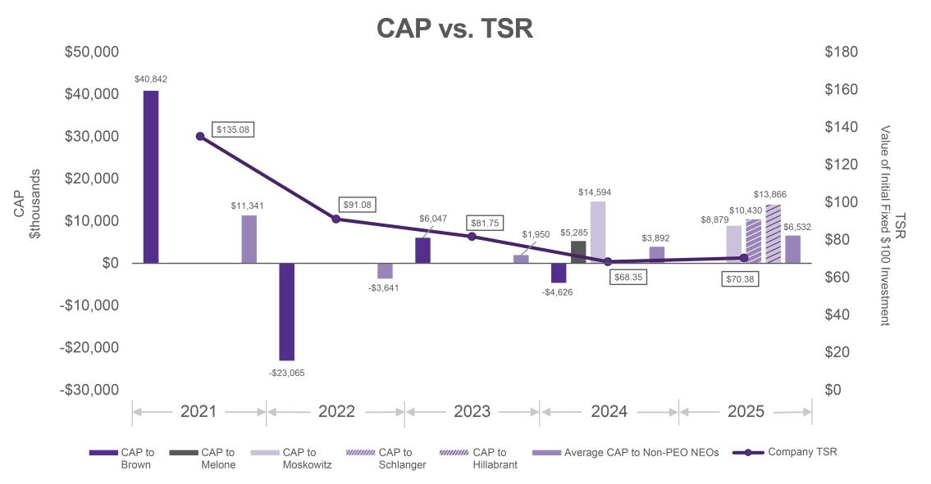

Compensation Actually Paid vs. Net Income. As shown in the graph below, there is no observed correlation between the fluctuations in the Company's net income and the executives' CAP over the period presented. This is due in large part to the fact that the Company does not use net income as a performance metric for any component of the executives' compensation.
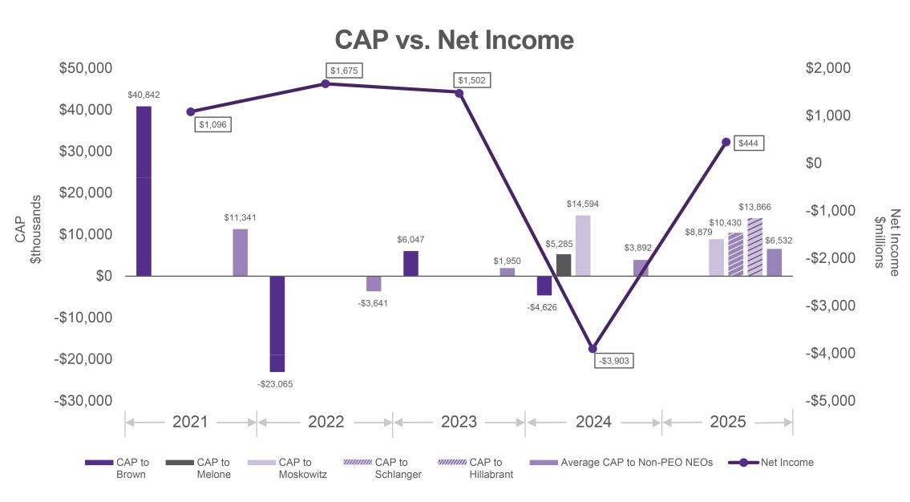

CROWN CASTLE INC. 2026 PROXY STATEMENT

72

Compensation Actually Paid vs. AFFO per Share. For 2021 through 2024, AFFO/Share was one of two financial performance measures the Company uses to determine STIs. However, due to the Company's relative emphasis on LTIs as compared to STIs, the impact of AFFO/Share improvement on executive compensation can be diminished or completely outweighed in some years. As shown below, despite AFFO/Share increases in each of 2023, 2022 and 2021, significant decreases in the value of outstanding RSUs in 2023 and 2022 caused CAP for 2023 and 2022 to be significantly lower than 2021 CAP. As shown below for 2024, although AFFO/Share decreased for 2024, the one-time RSU grants awarded to certain of the Company's PEOs and its non-PEO NEOs discussed above contributed to CAP for 2024, on average, being higher than CAP for 2023. For 2025, the Company (1) replaced AFFO/Share as a financial performance measure to determine STIs and

- introduced three-year cumulative AFFO/Share as a performance measure in its LTI program, replacing relative TSR. While the impact of AFFO/Share was more meaningful for 2025, the decrease of AFFO/Share for 2025 was primarily offset by the one-time RSU grants awarded in 2025 to certain of the Company's PEOs and its non-PEO NEOs as discussed above.
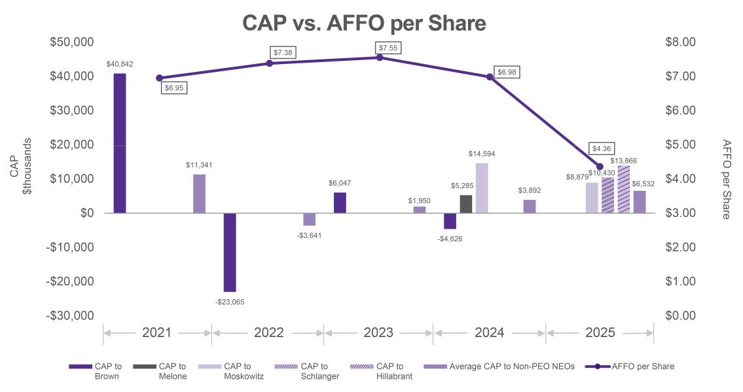

Company TSR vs. Peer Group TSR. As shown in the following graph, the Company's cumulative TSR over the period presented underperformed the FTSE NAREIT All Equity REIT Index cumulative TSR. The Company selected this index as its peer group for purposes of the Pay Versus Performance Table, in accordance with the provisions of Item 402(v) of Regulation S-K. The Company does not use the FTSE NAREIT All Equity REIT Index to gauge executive compensation elements or determine the satisfaction of vesting conditions for performance-

CROWN CASTLE INC. 2026 PROXY STATEMENT

73

based awards. For a discussion of the peer groups used by the Company for executive compensation purposes, see "IV. Executive Compensation—Compensation Discussion and Analysis."
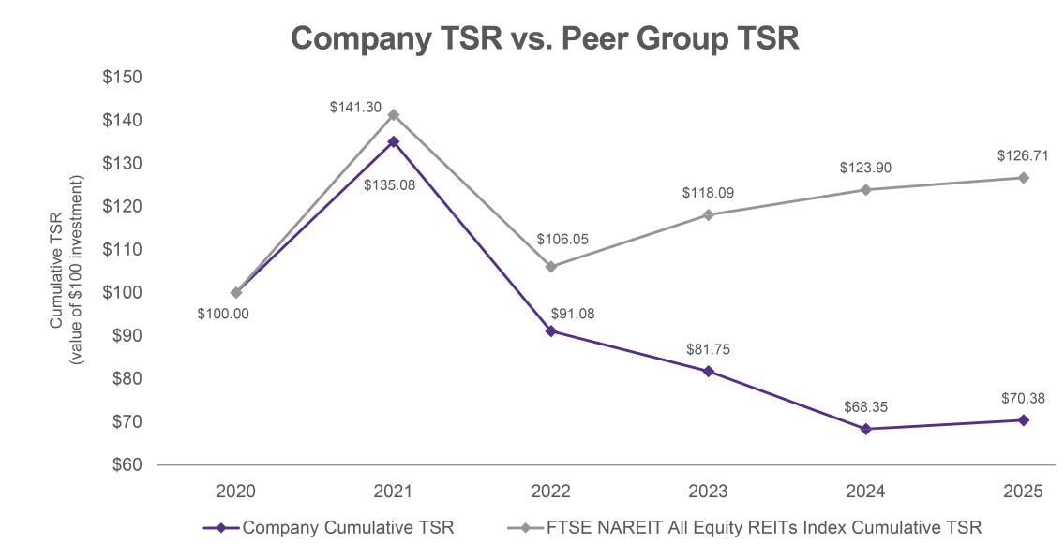

Tabular List

The list below represents the Company's most important financial performance measures (in no particular order) used to link NEOs' CAP for the most recently completed fiscal year to the Company's performance. For more information on the Company's performance measures, see "IV. Executive Compensation—Compensation Discussion and Analysis."

- Adjusted EBITDA

- AFFO per share

- Average ROIC

- Relative TSR

- Organic revenue growth

CROWN CASTLE INC. 2026 PROXY STATEMENT

74

V. OTHER MATTERS

Beneficial Ownership of Common Stock

The table below shows the beneficial ownership as of (or, as applicable, reported as of) March 23, 2026, except to the extent indicated otherwise in the footnotes, of our Common Stock held by (1) each of the directors, director nominees, the NEOs and all directors, director nominees and executive officers as a group and (2) each stockholder who beneficially owns more than 5% of our outstanding shares of Common Stock. This table also gives effect to any shares of Common Stock that may be acquired pursuant to any options, warrants, rights or other derivative securities, including RSUs, within 60 days after March 23, 2026, and includes shares held through 401(k) Plan accounts.

Common Stock Beneficially Owned

Directors, Director Nominees and NEOs^{(a)} | Number | Percent
Directors, Director Nominees and NEOs^{(a)} | (#)(b) | (%)(c)

Edward B. Adams, Jr. | 26,245
P. Robert Bartolo | 47,382
Jason Genrich | 6,576
Andrea J. Goldsmith | 15,589
Christian H. Hillabrant | 0
Tammy K. Jones | 12,077
Kevin T. Kabat | 9,149
Christopher D. Levendos | 25,657
Steven J. Moskowitz | 58,947
Anthony J. Melone | 35,473
Katherine Motlagh | 5,183
Sunit S. Patel | 16,847
Catherine Piche | 17,708
Daniel K. Schlanger | 86,508
Kevin A. Stephens | 23,114
Matthew Thornton, III | 14,792
Directors, director nominees and executive officers as a group (17 persons total) | 401,247


(d)

(e)

*

*

*


*

*

*

*

*

*

*

*

*

*

*

*

*

*

Greater than 5% Stockholders

The Vanguard Group

BlackRock, Inc.

Cohen & Steers, Inc.

State Street Corporation

* Less than 1%

68,840,472

38,829,206

36,331,844

22,241,227

(f)

(g)

(h)

(i)

15.78%

8.90%

8.33%

5.10%

- Unless otherwise indicated, each of the persons listed in this table may be deemed to have (1) sole voting and investment power with respect to the shares beneficially owned by such persons or (2) shared voting and investment power with respect to shares owned by a spouse. Unless otherwise indicated, the address of each of the persons listed in this table is c/o Crown Castle Inc., 8020 Katy Freeway, Houston, TX 77024.

- In addition to the shares shown in the table, each of the executive officers holds RSUs which have been granted pursuant to our 2013 Long-Term Incentive Plan or 2022 LTIP as a component of executive compensation, as further described in "IV. Executive Compensation—Compensation Discussion and Analysis—Long-Term Incentives."

- Pursuant to SEC rules, Common Stock percentages are based on the number of outstanding shares of Common Stock as of March 23, 2026.

- Includes an aggregate of 28,002 shares of Common Stock (net of tax withholding) that are scheduled to vest on April 11, 2026, pursuant to the RSU Award Agreement underlying the New Hire RSUs and annual Time RSUs previously granted to Mr. Moskowitz and the Severance Agreement between the Company and Mr. Moskowitz, effective April 11, 2024.

- Includes 9,649 shares of Common Stock (net of tax withholding) that are scheduled to vest on April 10, 2026, pursuant to the RSU Award Agreement underlying the Make-Whole RSUs previously granted to Mr. Patel.

- Based on a Schedule 13G/A filed with the SEC on April 30, 2025, reporting that as of March 31, 2025, The Vanguard Group had shared voting power over 712,276 shares of Common Stock, sole dispositive power over 66,637,546 shares of Common Stock and shared dispositive power over 2,202,926 shares of Common Stock. In the filing, The Vanguard Group lists its address as 100 Vanguard Blvd., Malvern, PA 19355. The Vanguard Group subsequently reported on a Schedule 13G/A filed with the SEC on March 26, 2026, that due to an internal realignment, it no longer has, or is deemed to have, beneficial ownership over the Company's securities beneficially owned by various subsidiaries or business

CROWN CASTLE INC. 2026 PROXY STATEMENT

75

divisions. The Vanguard Group also reported that certain subsidiaries or business divisions that formerly had, or were deemed to have, beneficial ownership with The Vanguard Group will report beneficial ownership separately (on a disaggregated basis).

- Based on a Schedule 13G/A filed with the SEC on April 17, 2025, reporting that as of March 31, 2025, BlackRock, Inc. has sole voting power over 35,945,106 shares of Common Stock and sole dispositive power over 38,829,206 shares of Common Stock. In the filing, BlackRock, Inc. lists its address as 50 Hudson Yards, New York, NY 10001.

- Based on a Schedule 13G/A filed with the SEC on November 14, 2025, reporting that as of September 30, 2025, Cohen & Steers, Inc. has sole voting power over 29,849,777 shares of Common Stock and sole dispositive power over 36,331,844 shares of Common Stock of which, 36,027,976 shares are beneficially owned by Cohen & Steers Capital Management, Inc., 265,656 shares are beneficially owned by Cohen & Steers UK Limited and 38,212 shares are beneficially owned by Cohen & Steers Ireland Ltd. Cohen & Steers, Inc. holds a 100% interest in Cohen & Steers Capital Management, Inc., Cohen & Steers UK Ltd. and Cohen & Steers Ireland Ltd. (a non-US institution). In the filing, Cohen & Steers, Inc. lists its address as 1166 Avenue of the Americas, 30th Floor, New York, NY 10036.

- Based on a Schedule 13G filed with the SEC on February 9, 2026, reporting that as of December 31, 2025, State Street Corporation has shared dispositive power over 22,239,559 shares of Common Stock and shared voting power over 13,829,672 shares of Common Stock. In the filing, State Street Corporation lists its address as One Congress Street, Suite 1, Boston, MA 02114.

CROWN CASTLE INC. 2026 PROXY STATEMENT

76

Delinquent Section 16(a) Reports

Section 16(a) of the Exchange Act requires our directors and executive officers, and persons who own more than 10% of a registered class of our equity securities, to file with the SEC and the NYSE reports of ownership and changes in ownership of Common Stock and our other equity securities.

Based solely on the review of such reports filed with the SEC and written representations that no other reports were required, we believe that, during the 2025 fiscal year, our executive officers, directors and greater than 10% beneficial owners timely complied with all Section 16(a) filing requirements applicable to them, except that Mr. Hillabrant did not timely file one report by one day due to delays in obtaining his Electronic Data Gathering, Analysis and Retrieval (EDGAR) Next system access.

Stockholder Recommendation of Director Candidates

Stockholders may recommend potential candidates for consideration by the N&G Committee by sending a written request to our Corporate Secretary. The written request must comply with the information and other requirements under our Second Amended and Restated By-Laws, as amended ("By-Laws") relating to the inclusion of stockholder director nominees, which requires, among other things, that the notice includes the candidate's name, contact information, biographical information and qualifications. In addition to the foregoing, the request must also include the potential candidate's written consent to being named in the proxy statement as a nominee and to serving as a director if nominated and elected. The stockholder or group of stockholders making the recommendation must also disclose, with the written request, the number of securities that the stockholder or group of stockholders beneficially owns and the period of time the stockholder or group of stockholders has beneficially owned the securities. Additional information may be requested from the nominee or the stockholder by the N&G Committee from time to time. As and if determined by the N&G Committee, potential candidates must also make themselves available to be interviewed by the N&G Committee, the Board and members of our executive management.

The N&G Committee reserves the right not to have any communications with the recommending stockholder or the candidate regarding the evaluation process of the candidate or the N&G Committee's conclusions regarding such evaluation.

Stockholder Proposals and Director Nominations for 2027 Annual Meeting

Stockholder Proposals and Director Nominations for Inclusion in our Proxy Statement

Stockholders wishing to have a proposal considered for inclusion in our 2027 proxy statement pursuant to Exchange Act Rule 14a-8 ("Rule 14a-8") must submit the proposal so that our Corporate Secretary receives it at our principal executive offices located at Crown Castle Inc., 8020 Katy Freeway, Houston, Texas 77024, Attn: Corporate Secretary no later than December 7, 2026. Any such proposal must also comply with the other requirements of Rule 14a-8.

If the date of the 2027 Annual Meeting is changed by more than 30 days from the date of the 2026 Annual Meeting, the deadline for submitting proposals to be included in our 2027 proxy statement will be a reasonable time before we begin to print and mail our proxy materials for our 2027 Annual Meeting.

Stockholders wishing to have one or more director nominations considered for inclusion in our 2027 proxy statement pursuant to the proxy access right included in Section 2.10 of our By-Laws must submit written notice of the nomination or nominations, together with other information required by Section 2.10 and otherwise comply with our By-Laws, so that our Corporate Secretary receives it at our principal executive offices no earlier than November 7, 2026, and no later than December 7, 2026.

Shareholder Proposals and Director Nominations to be Presented at the 2027 Annual Meeting

Stockholders may make nominations for directors and introduce proposals or other business to be considered at the 2027 Annual Meeting (but not included in our 2027 proxy statement). Such stockholder nominations and proposals for the 2027 Annual Meeting must be delivered between January 20, 2027, and February 19, 2027, which are 120 days and 90 days, respectively, before May 20, 2027 (the one-year anniversary of the 2026 Annual Meeting), to our Corporate Secretary at our principal executive offices located at the address referenced above.

CROWN CASTLE INC. 2026 PROXY STATEMENT

77

Nominations and proposals must be made in accordance with Section 2.07 of our By-Laws and involve proper matters for stockholder action.

In addition to satisfying the advance notice requirements under our By-Laws, including the earlier notice deadlines set forth above, to comply with the universal proxy rules, stockholders wishing to solicit proxies in support of director nominees other than the Company nominees must also provide notice that includes the additional information required by Rule 14a-19 under the Exchange Act no earlier than January 20, 2027, and no later than February 19, 2027.

If the 2027 Annual Meeting is not held, or is advanced by more than 30 days, or is delayed by more than 90 days, from May 20, 2027 (the one-year anniversary of the 2026 Annual Meeting), proper notice of a director nomination or proposal must be received by the Corporate Secretary not earlier than (1) the 120th day prior to the 2027 Annual Meeting and (2) not later than the close of business on the later of the 90th day prior to the 2027 Annual Meeting or the 10th day following the announcement of the 2027 Annual Meeting date.

If the date of the 2027 Annual Meeting is advanced or delayed by more than 30 calendar days from the first anniversary of the 2026 Annual Meeting, we will inform stockholders of such change, by including a notice, under Item 5, in our earliest possible quarterly report on Form 10-Q or current report on Form 8-K. The notice will include the new deadline for submitting proposals to be included in our 2027 proxy statement and the new date for determining whether we have received timely notice of a nomination or proposal.

Expenses Relating to this Proxy Solicitation

We will pay all Company expenses relating to this proxy solicitation. In addition to this solicitation by mail, our officers, directors and certain regular employees may solicit proxies by further mailing or personal conversations, or by telephone, facsimile or electronic means without extra compensation for that activity, but they may be reimbursed by the Company for their out-of-pocket expenses incurred in connection with the solicitation. The regular employees will be administrative personnel. We also expect to reimburse banks, brokers and other persons for reasonable out-of-pocket expenses in forwarding proxy material to, and obtaining voting instructions from, beneficial owners of our Common Stock.

Available Information

We maintain a website at https://www.crowncastle.com. Copies of the Committee charters of each of the Audit Committee, CHC Committee, N&G Committee, Finance Committee and Fiber Review Committee together with certain other corporate governance materials, including our Financial Code of Ethics, Corporate Governance Guidelines, Conflicts Policy and Proper Business and Ethics Policy, can be found under the Investors section of our website at https://investor.crowncastle.com, and such information is also available in print to any stockholder who requests it through our Corporate Secretary at the address below.

We will furnish without charge to each person whose proxy is being solicited, upon request of any such person, a copy of the 2025 Form 10-K as filed with the SEC, including the financial statements and schedules thereto, but not the exhibits. In addition, the 2025 Form 10-K is available, free of charge, on our website at https://www.crowncastle.com/investors/current10k.pdf. A request for a copy of the 2025 Form 10-K should be directed to Crown Castle Inc., 8020 Katy Freeway, Houston, Texas 77024, Attn: Corporate Secretary. A copy of any exhibit to the 2025 Form 10-K will be forwarded following receipt of a written request with respect thereto addressed to the Corporate Secretary.

Householding of Proxy Materials

In order to reduce expenses, we are taking advantage of certain SEC rules, commonly known as "householding," that permit us to deliver, in certain cases, only one Notice of Internet Availability of Proxy Materials ("Proxy Materials Notice"), our Annual Report for the year ended December 31, 2025, which includes a copy of our 2025 Form 10-K ("2025 Annual Report"), or Proxy Statement, as applicable, to multiple stockholders sharing the same address, unless we have received contrary instructions from one or more of the stockholders. If you received a householded mailing this year and would like to have additional copies of the Proxy Materials Notice, the 2025 Annual Report or other proxy materials sent to you, or if you would like to revoke your consent to the

CROWN CASTLE INC. 2026 PROXY STATEMENT

78

householding of documents in the future, please call 1-866-540-7095 or write to Broadridge, Householding Department, 51 Mercedes Way, Edgewood, New York 11717 for further instructions.

If you are eligible for householding, but you and other stockholders with whom you share an address currently receive multiple copies of the proxy materials and you wish to receive only a single copy of the proxy materials for your household, please contact Broadridge, Householding Department using one of the aforementioned methods. Proxy materials will be delivered promptly and free of charge.

Stockholder Communications

The Board welcomes communications from our stockholders and other interested parties. Stockholders and other interested parties may send communications to the Board, to any Committee, to the non-management directors or to any director in particular, to: Crown Castle Inc., 8020 Katy Freeway, Houston, Texas 77024, Attn: Corporate Secretary. Any communications addressed to the Board, to any Committee, to the non-management directors or to any director will be forwarded to the addressee without review by management.

CROWN CASTLE INC. 2026 PROXY STATEMENT

79

VI. INFORMATION ABOUT THE ANNUAL MEETING

Who Is Soliciting Proxies?

The Board is soliciting proxies for use at our Annual Meeting and any adjournments or postponements of the Annual Meeting. This Proxy Statement, the form of proxy and our 2025 Annual Report are being distributed or made available via the internet to our stockholders on or about April 6, 2026.

Why Did I Receive a "Notice of Internet Availability of Proxy Materials"?

Pursuant to SEC rules regarding the electronic distribution of proxy materials, we have elected to provide access to our proxy materials to many of our stockholders on the internet, instead of mailing the full set of printed proxy materials, which allows us to reduce costs associated with the Annual Meeting. On or about April 6, 2026, we intend to send to many of our stockholders a Proxy Materials Notice containing instructions on how to access our Proxy Statement and 2025 Annual Report and how to submit a proxy. If you receive a Proxy Materials Notice, you will not receive a printed copy of the proxy materials in the mail unless you request it. If you would like to receive a printed copy of our proxy materials, you should follow the instructions for requesting such materials included in the Proxy Materials Notice.

What are the Agenda Items for Consideration at the Annual Meeting?

The agenda for the Annual Meeting is to consider and vote upon the following matters:

- the election of nine (9) director nominees named in this Proxy Statement for a one-year term;

- the ratification of the appointment of PwC as our independent registered public accountants for fiscal year 2026;

- a non-binding, advisory vote to approve the compensation of our NEOs; and

- such other business that properly comes before the Annual Meeting or any adjournment or postponement thereof.

How Can I Attend the Annual Meeting?

The Annual Meeting will be held on May 20, 2026, at 9:00 a.m. Central Time in virtual meeting format only, via live webcast, at www.virtualshareholdermeeting.com/CCI2026. Stockholders as of the close of business on March 23, 2026, the Record Date, are entitled to participate at the Annual Meeting. To be admitted to the Annual Meeting as a stockholder, you must enter the 16-digit control number found on the Proxy Materials Notice, proxy card or the voting instruction form. Beneficial stockholders who did not receive a 16-digit control number from their bank or brokerage firm and who wish to attend the Annual Meeting should follow the instructions from their bank or brokerage firm, including any requirement to obtain a legal proxy. Most brokerage firms or banks allow a stockholder to obtain a legal proxy either online or by mail. You may also attend the Annual Meeting as a guest in the event that you do not have a 16-digit control number. You will not be able to vote your shares or submit questions during the Annual Meeting if you participate as a guest through the virtual meeting platform.

The Annual Meeting webcast will begin promptly at 9:00 a.m. Central Time, on May 20, 2026. Online access to the webcast will open approximately 15 minutes prior to the start of the Annual Meeting. We encourage you to access the webcast prior to the scheduled start time of the Annual Meeting. We will post a webcast replay on https://investor.crowncastle.com for at least one year.

Even if you plan to attend the Annual Meeting, we encourage you to vote your shares in advance of the Annual Meeting by one of the ways identified in "—How to Do I Vote?" below. If you are a participant in the 401(k) Plan, you must vote by the applicable deadline prior to the Annual Meeting. For further information on how to vote as a participant of the 401(k) Plan and the applicable deadline for voting, see "—How Do I Vote as a Participant in the Crown Castle Inc. 401(k) Plan?" below.

What if I have trouble accessing the Annual Meeting virtually?

The virtual meeting platform is supported across Google Chrome, Microsoft Edge and Mozilla Firefox web browsers running the most up-to-date version of applicable software and plugins. Please note that the Safari web

CROWN CASTLE INC. 2026 PROXY STATEMENT

80

browser may have limited compatibility with the virtual meeting platform. You should ensure that you have a strong internet connection wherever you intend to participate in the Annual Meeting. If you encounter any difficulties accessing the virtual Annual Meeting, please call the technical support number that will be posted on the virtual stockholder meeting login page.

Will There Be a Question and Answer Session at the Annual Meeting?

We are committed to ensuring that stockholders will be afforded comparable rights and opportunities to participate as they would at an in-person meeting. Our directors and certain members of our management team will join the virtual meeting and be available for questions. Stockholders as of the Record Date may submit questions related to the Company's business or governance or related to the items of business set forth on the agenda beginning 15 minutes prior to, and during, the Annual Meeting at www.virtualshareholdermeeting.com/CCI2026. You can view the agenda and the Rules of Conduct for the Annual Meeting after you log in to the virtual meeting website at www.virtualshareholdermeeting.com/CCI2026.

At the Annual Meeting, we will endeavor to address as many stockholder questions that are relevant to the purpose of the Annual Meeting or our business as time permits. To allow us to answer questions from as many stockholders as possible, we will limit each stockholder to two questions. If we receive substantially similar questions, we may group them together and provide a single response to avoid repetition.

Who Is Entitled to Vote at the Annual Meeting?

You can vote at the Annual Meeting if you are, on the Record Date, a holder of record of our Common Stock. In addition, if you are a beneficial owner of our Common Stock, you may attend and vote at the Annual Meeting by following the instructions outlined in "—How Can I Attend the Annual Meeting?" above.

Holders of Common Stock will have one vote for each share of Common Stock owned of record as of the Record Date with respect to each matter submitted for a vote. As of the close of business on the Record Date, there were 436,367,346 shares of Common Stock outstanding.

Is There a List of Stockholders Entitled to Vote at the Annual Meeting?

A complete list of the stockholders of record entitled to vote at the meeting will be available for examination, during ordinary business hours, by any stockholder of record at our offices located at 8020 Katy Freeway, Houston, Texas 77024 for a period of 10 days prior to the Annual Meeting.

How Do I Vote?

You may submit your proxy for your shares prior to the Annual Meeting in any of the following ways:

- Mail. Mark, sign, date and return the proxy card or voting instruction form (see instructions on the Proxy Materials Notice on how to request a printed proxy card or voting instruction form).

- Phone.

  - Stockholders of record: Call the toll-free number listed on your proxy card or voting instruction form.

  - Beneficial owners of our Common Stock: Follow the voting instructions provided by your bank, broker or other nominee to determine whether you may vote by telephone.

- Internet. Visit the website listed on your proxy card or voting instruction form or Proxy Materials Notice and follow the instructions provided.

Alternatively, you may vote in person at the Annual Meeting by logging on to the virtual meeting platform at

www.virtualshareholdermeeting.com/CCI2026.

Have your proxy card or voting instruction form or Proxy Materials Notice in front of you when submitting a proxy by telephone or the internet, as they contain important information that is required to access the system. The deadline to vote your proxy card or voting instruction form by telephone or the internet is 11:59 p.m. Eastern Time on May 19, 2026. As always, we encourage you to vote your shares prior to the Annual Meeting. Alternatively, to

CROWN CASTLE INC. 2026 PROXY STATEMENT

81

vote your proxy card or voting instruction form by mail, please ensure that you mail it sufficiently in advance of the Annual Meeting so that it is received before the polls open at the Annual Meeting.

How Do I Vote as a Participant in the Crown Castle Inc. 401(k) Plan?

If you are a participant in the 401(k) Plan, your proxy card, or a proxy submitted by telephone or through the internet, will also serve as voting instructions to Charles Schwab Bank, as trustee for the 401(k) Plan ("Trustee"), with respect to shares of Common Stock allocable to your 401(k) Plan account as of the Record Date.

If you provide voting instructions with respect to shares of Common Stock allocable to your 401(k) Plan account, the Trustee will vote those shares in the manner specified. If you fail to provide timely instructions, the independent fiduciary for the 401(k) Plan will instruct the Trustee to vote such shares of Common Stock in the same proportion as shares of Common Stock for which voting instructions have been timely and properly received from other 401(k) Plan participants, unless required by applicable law to exercise discretion in voting such shares.

To allow sufficient time for the Trustee to vote your shares, voting instructions from 401(k) Plan participants must be received by 11:59 p.m.

Eastern Time on May 17, 2026.

How Will My Shares Be Voted at the Annual Meeting?

All proxies that have been timely submitted and validly executed – whether by internet, telephone or mail – and not revoked will be voted at the Annual Meeting in accordance with your instructions. If you properly execute your proxy card or voting instruction form but do not give voting instructions on one or more proposals (and the proxy is not revoked), the shares represented by that proxy or voting instruction form will be voted as recommended by the Board with respect to the proposal(s) for which you have not provided voting instructions. The Board recommends the following vote for each of the proposals to be considered and voted upon at the Annual Meeting:

- FOR the election of each of the nine (9) director nominees named in this Proxy Statement (Proposal 1);

- FOR the ratification of the appointment of PwC as our independent registered public accountants for fiscal year 2026 (Proposal 2); and

- FOR the non-binding, advisory vote to approve the compensation of our NEOs (Proposal 3).

If any other matters are properly presented at the Annual Meeting for consideration and if you have submitted a proxy for your shares by internet, telephone or mail, the persons named as proxies in the proxy card will have the discretion to vote on those matters in their judgment for you. As of the date we filed this Proxy Statement with the SEC, we do not know of any other matters to be raised at the Annual Meeting.

What Are the Voting Requirements for Each Proposal?

The following chart describes the proposals to be considered at the Annual Meeting, the vote required to elect each director nominee and to adopt each other proposal and the manner in which votes will be counted:

Proposal


Election of Directors

Ratification of the Appointment of Independent Registered Public Accountants


Advisory Vote to Approve Executive Compensation

Voting Options


For, against or abstain on each nominee

For, against or abstain


For, against or abstain

Vote Required to

Adopt Proposal^{(a)}


Majority of votes cast

Majority of shares present or represented and entitled to vote thereon

Majority of shares present or represented and entitled to vote thereon


Effect of Abstentions |  | Effect of
Effect of Abstentions |  | Broker Non-Votes^{(b)}
Not applicable |  | No effect
Counted as vote |  | Brokers have discretion to
against |  | vote in certain circumstances
Counted as vote |  | No effect
against |  | No effect

- A nominee for director will be elected if the number of votes cast "for" a director nominee exceeds the number of votes cast "against" the nominee.

- Please see "—What Is the Effect of a Broker Non-Vote?" below.

CROWN CASTLE INC. 2026 PROXY STATEMENT

82

What Is a Quorum for the Annual Meeting?

A quorum of stockholders is needed to hold a valid Annual Meeting. A quorum will exist to hold a valid Annual Meeting if the holders of at least a majority in voting power of the outstanding shares of Common Stock entitled to vote at the Annual Meeting attend the Annual Meeting in person via live webcast or are represented by proxy. Abstentions are counted as present for the purpose of establishing a quorum.

What Can I Do If I Change My Mind After I Vote?

You may change your vote by revoking your proxy at any time before it is exercised. If you are a stockholder of record, you can revoke your proxy by:

- delivering a timely written notice of revocation to our Corporate Secretary, Crown Castle Inc., 8020 Katy Freeway, Houston, Texas 77024;

- properly submitting a timely, later-dated proxy by internet, telephone or mail (see instructions on your proxy card or voting instruction form or Proxy Materials Notice); or

- attending the Annual Meeting and voting. Attendance at the Annual Meeting alone will not constitute a revocation of a proxy.

If you are a beneficial owner whose shares are held in the name of a bank, broker or other nominee, you may revoke your voting instructions by submitting new voting instructions to your bank, broker or other nominee before the applicable deadline indicated in "—How Do I Vote?" above. Alternatively, you may change your vote by attending the Annual Meeting and voting using the virtual meeting platform at www.virtualshareholdermeeting.com/CCI2026. To vote at the Annual Meeting, you will need to log on to the virtual meeting platform by entering the 16-digit control number found on the Proxy Materials Notice, proxy card or the voting instruction form.

If you are a participant in the 401(k) Plan, you may revoke your voting instructions by submitting new voting instructions to the Trustee on or before the applicable deadline indicated in "—How Do I Vote as a Participant in the Crown Castle Inc. 401(k) Plan?" above.

What Is a "Broker Non-Vote"?

A "broker non-vote" occurs when a broker lacks discretionary authority to vote on a "non-routine" proposal and a beneficial owner fails to give the broker voting instructions on that matter. The rules of the NYSE determine whether matters presented at the Annual Meeting are "routine" or "non-routine" in nature. The election of directors (Proposal 1) and the proposal to approve the Company's executive compensation (on a non-binding, advisory basis) (Proposal 3) are considered "non-routine" matters. This means that beneficial owners who hold their shares in street name must provide voting instructions to their broker in order for their broker to vote their shares on these matters. In contrast, the ratification of the selection of PwC as the Company's independent registered public accounting firm for fiscal year 2026 (Proposal 2) is generally considered a "routine" matter under the rules of the NYSE and is the only proposal at the Annual Meeting with respect to which your broker could vote your shares absent your instructions.

What Is the Effect of a Broker Non-Vote?

Broker non-votes may be counted for purposes of calculating whether a quorum is present at the Annual Meeting because brokers have discretionary authority to vote on Proposal 2. A broker non-vote will not affect the outcome of the vote on Proposals 1 and 3.

How Can I Find the Voting Results of the Annual Meeting?

Preliminary voting results will be announced at the Annual Meeting. We will publicly disclose results of voting at the Annual Meeting based on the final report as certified by the independent inspector of elections on a Current Report on Form 8-K filed with the SEC within four business days following the Annual Meeting.

CROWN CASTLE INC. 2026 PROXY STATEMENT

83

Appendix A

Independence Categorical Standards

(February 22, 2023)

The board of directors ("Board") of Crown Castle Inc. ("Company") has established the following guidelines to assist it in determining whether a director of the Company ("Director") has a "material relationship" with the Company and is "independent".

The following relationships are not "material relationships" that would impair a Director's "independence" ("Safe Harbor Relationships"):

- Certain Prior Relationships. More than three years have elapsed since:

  - the Director was employed by the Company;
  - a Family Member (defined below) was employed by the Company as an executive officer;
  - the Director or a Family Member was a partner with or employed by the Company's internal or external auditor ("Auditor") and personally worked on the Company's audit; or
  - a present executive officer of the Company served on the compensation committee of a company which employed at the same time the Director or a Family Member as an executive officer.

- Current Employment. A Family Member is:
  - employed by the Company in a non-officer position; or
  - employed by, but is not a partner with, the Auditor and does not personally work on the Company's audit.

- Compensation. The Director or a Family Member has received less than $120,000 during any 12-month period in direct compensation from the Company, other than director and committee fees and pension or other forms of deferred compensation for prior service (provided such compensation is not contingent in any way on continued service).

- Business Relationships. The Director or a Family Member is or was a partner, greater than 10% shareholder, director, officer or employee of a company that has made payments to, or received payments from, the Company for property or services in an amount which, in each of the last three fiscal years, is less than the greater of:

  - $1 million, or
  - two percent (2%) of such other company's consolidated gross revenues.

- Indebtedness. The Director or a Family Member is a partner, greater than 10% shareholder, director, officer or employee of a company that is indebted to the Company or to which the Company is indebted, and the total amount of each company's indebtedness to the other is less than two percent (2%) of the total consolidated assets of such other company.

- Charitable Contributions. The Director or a Family Member is a trustee, fiduciary, director, officer or employee of a tax-exempt organization to which the Company contributes, and the Company's contributions in any single fiscal year to that organization are less than the greater of:
  - $500,000, or
  - one percent (1%) of that organization's total annual receipts.

- Stock Ownership. The Director owns, directly or indirectly, a significant amount of Company stock (including securities convertible into Company stock).

A "Family Member" is a Director's spouse, parents, children, siblings, mother- and father-in-law, sons- and daughters-in-law, brothers- and sisters-in-law, and anyone (other than domestic employees) who shares such Director's home.

If a Director has a significant relationship with the Company that does not constitute a Safe Harbor Relationship, the determination of whether such relationship constitutes a "material relationship", and therefore whether the director qualifies as independent, should be made by the Board

based on the totality of circumstances. In addition, members of the Audit Committee are subject to additional standards relating to their independence.

CROWN CASTLE INC. 2026 PROXY STATEMENT

A - 1

Appendix B

Non-GAAP Financial Measures

This Proxy Statement includes presentations of Adjusted EBITDA, Adjusted Funds from Operations ("AFFO"), including per share amounts, Funds from Operations ("FFO"), including per share amounts, and Organic Contribution to Site Rental Billings (also referred to as organic revenue growth) which are non-GAAP financial measures. These non-GAAP financial measures are not intended as alternative measures of operating results or cash flow from operations (as determined in accordance with Generally Accepted Accounting Principles ("GAAP")).

Our non-GAAP financial measures are presented as additional information because management believes these measures are useful indicators of the financial performance of our business. Among other things, management believes that:

- Adjusted EBITDA is useful to investors or other interested parties in evaluating our financial performance. Adjusted EBITDA is a financial measure frequently used by management (1) to evaluate the economic productivity of our operations and (2) for purposes of making decisions about allocating resources to, and assessing the performance of, our operations. Management believes that Adjusted EBITDA helps investors or other interested parties meaningfully evaluate and compare the results of our operations (1) from period to period and (2) to our competitors, by removing the impact of our capital structure (primarily interest charges from our outstanding debt) and asset base (primarily depreciation, amortization and accretion) from our financial results. Management also believes Adjusted EBITDA is frequently used by investors or other interested parties in the evaluation of the towers sector and other REITs to measure financial performance without regard to items such as depreciation, amortization and accretion, which can vary depending upon accounting methods and the book value of assets. Adjusted EBITDA should be considered only as a supplement to net income (loss) computed in accordance with GAAP as a measure of our performance.

- AFFO, including per share amounts, is useful to investors or other interested parties in evaluating our financial performance. Management believes that AFFO helps investors or other interested parties meaningfully evaluate our financial performance as it includes (1) the impact of our capital structure (primarily interest expense on our outstanding debt and dividends on our preferred stock (in periods where applicable)) and (2) sustaining capital expenditures, and excludes the impact of our (1) asset base (primarily depreciation, amortization and accretion) and (2) certain non-cash items, including straight-lined revenues and expenses related to fixed escalations and rent free periods. GAAP requires rental revenues and expenses related to leases that contain specified rental increases over the life of the lease to be recognized evenly over the life of the lease. In accordance with GAAP, if payment terms call for fixed escalations or rent free periods, the (1) revenues are recognized on a straight-lined basis over the fixed, non-cancelable term of the tenant contract and (2) expenses are recognized on a straight-lined basis over the estimated lease term including renewal options that are reasonably certain to be exercised. Management notes that Crown Castle uses AFFO only as a performance measure. AFFO should be considered only as a supplement to net income (loss) computed in accordance with GAAP as a measure of our performance and should not be considered as an alternative to cash flow from operations or as residual cash flow available for discretionary investment.

- FFO, including per share amounts, is useful to investors or other interested parties in evaluating our financial performance. Management believes that FFO may be used by investors or other interested parties as a basis to compare our financial performance with that of other REITs. FFO helps investors or other interested parties meaningfully evaluate financial performance by excluding the impact of our asset base (primarily real estate depreciation, amortization and accretion). FFO is not a key performance indicator used by Crown Castle. FFO should be considered only as a supplement to net income (loss) computed in accordance with GAAP as a measure of our performance and should not be considered as an alternative to cash flow from operations.

- Organic Contribution to Site Rental Billings (also referred to as organic revenue growth) is useful to investors or other interested parties in understanding the components of the year-over-year changes in our site rental revenues computed in accordance with GAAP. Management uses Organic Contribution to

CROWN CASTLE INC. 2026 PROXY STATEMENT

B - 1

Site Rental Billings to assess year-over-year growth rates for our rental activities, to evaluate current performance, to capture trends in rental rates, core leasing activities and tenant non-renewals in our core business, as well as to forecast future results. Separately, we are also disclosing Organic Contribution to Site Rental Billings as Adjusted for Impact of Sprint Cancellations, which is outside of ordinary course, to provide further insight into our results of operations and underlying trends. Management believes that identifying the impact of Sprint Cancellations provides increased transparency and comparability across periods. Organic Contribution to Site Rental Billings (including as Adjusted for Impact of Sprint Cancellations) is not meant as an alternative measure of revenue and should be considered only as a supplement in understanding and assessing the performance of our site rental revenues computed in accordance with GAAP.

We define our non-GAAP financial measures as follows:

Adjusted EBITDA. We define Adjusted EBITDA as net income (loss) plus restructuring charges (credits), asset write-down charges, goodwill impairment charges, acquisition and integration costs, depreciation, amortization and accretion, amortization of prepaid lease purchase price adjustments, interest expense and amortization of deferred financing costs, net, (gains) losses on retirement of long-term obligations, net (gain) loss on interest rate swaps, (gains) losses on foreign currency swaps, impairment of available -for-sale securities, interest income, other (income) expense, (benefit) provision for income taxes, (income) loss from discontinued operations, net of tax, cumulative effect of a change in accounting principle and stock-based compensation expense, net.

AFFO. We define AFFO as FFO before straight-lined revenues, straight-lined expenses, stock-based compensation expense, net, non-cash portion of tax provision, non-real estate related depreciation, amortization and accretion, amortization of non-cash interest expense, other (income) expense, (gains) losses on retirement of long-term obligations, net (gain) loss on interest rate swaps, (gains) losses on foreign currency swaps, impairment of available-for-sale securities, acquisition and integration costs, restructuring charges (credits), cumulative effect of a change in accounting principle and adjustments for noncontrolling interests, less sustaining capital expenditures.

AFFO per share. We define AFFO per share as AFFO divided by diluted weighted-average common shares outstanding.

FFO. We define FFO as net income (loss) plus real estate related depreciation, amortization and accretion, asset write-down charges, goodwill impairment charges and (income) loss from discontinued operations, net of tax, less noncontrolling interest and cash paid for preferred stock dividends (in periods where applicable), and is a measure of funds from operations attributable to common stockholders.

FFO per share. We define FFO per share as FFO divided by diluted weighted-average common shares outstanding.

Organic Contribution to Site Rental Billings. We define Organic Contribution to Site Rental Billings (also referred to as organic revenue growth) as the sum of the change in site rental revenues related to core leasing activity, escalators and other billings, less non-renewals of tenant contracts and non-renewals associated with Sprint Cancellations. Additionally, Organic Contribution to Site Rental Billings as Adjusted for Impact of Sprint Cancellations reflects Organic Contribution to Site Rental Billings plus non-renewals associated with Sprint Cancellations.

Other definitions:

Site rental billings. We define site rental billings as site rental revenues exclusive of the impacts from (1) straight-lined revenues, (2) amortization of prepaid rent in accordance with GAAP, (3) contribution from recent acquisitions until the one-year anniversary of such acquisitions and (4) other revenues, such as tenant cancellation fees, finance charges and other items.

CROWN CASTLE INC. 2026 PROXY STATEMENT

B - 2

Core leasing activity. We define core leasing activity as site rental revenues growth from tenant additions and renewals or extensions of tenant contracts, exclusive of (1) the impacts from both straight-lined revenues and amortization of prepaid rent in accordance with GAAP and (2) other revenues.

Other billings. We define other billings as the growth or reduction in site rental revenues as a result of non-recurring contractual billings and adjustments, expense recoveries, sales credits and other amounts not captured in core leasing activity.

Non-renewals. We define non-renewals of tenant contracts as the reduction in site rental revenues as a result of tenant churn, terminations and, in limited circumstances, reductions of existing lease rates, exclusive of non-renewals associated with Sprint Cancellations, where applicable.

Return on Invested Capital. We define Return on Invested Capital as Adjusted EBITDA less cash taxes paid, divided by the Company's historical gross investment in (1) property and equipment (excluding the impact of construction in process), (2) site rental contracts and tenant relationships and (3) goodwill.

Sprint Cancellations. We define Sprint Cancellations as lease cancellations related to the previously disclosed T-Mobile US, Inc. and Sprint network consolidation as described in our press release dated April 19, 2023.

Fiber Business. We define Fiber Business as the historically reported Fiber segment, prior to its reclassification to discontinued operations, together with certain supporting assets and personnel. Management has signed an agreement to sell the Fiber Business ("Strategic Fiber Agreement"), with EQT Active Core Infrastructure fund acquiring the small cells business and Zayo Group Holdings Inc. acquiring the fiber solutions business, for $8.5 billion in aggregate, subject to certain closing adjustments. The Strategic Fiber Transaction is expected to close in the first half of 2026, subject to certain closing conditions and required government and regulatory approvals. Pending the closing of the Strategic Fiber Transaction, we will continue to operate the Fiber Business in accordance with the Strategic Fiber Agreement.

Reconciliations of Non-GAAP Financial Measures:

Reconciliation of Historical Adjusted EBITDA:

 |  | For the Twelve Months Ended
(in millions; totals may not sum due to rounding) |  | December 31, 2025 |  |  | December 31, 2024
Net income (loss) | $ | 444 |  | $ | (3,903)
Adjustments to increase (decrease) net income (loss):
Asset write-down charges |  | 11 |  |  | 11
Depreciation, amortization and accretion |  | 690 |  |  | 736
Restructuring charges |  | — |  |  | 70
Amortization of prepaid lease purchase price adjustments |  | 15 |  |  | 16
Interest expense and amortization of deferred financing costs, net |  | 972 |  |  | 932
Interest income |  | (13) |  |  | (20)
Other (income) expense |  | (3) |  |  | 26
(Benefit) provision for income taxes |  | 16 |  |  | 18
Stock-based compensation expense, net |  | 73 |  |  | 84
(Income) loss from discontinued operations, net of tax |  | 659 |  |  | 5,065
Adjusted EBITDA | $ | 2,863 |  | $ | 3,035

CROWN CASTLE INC. 2026 PROXY STATEMENT

B - 3

Reconciliation of Historical FFO and AFFO:

 |  | For the Twelve Months Ended
(in millions, totals may not sum due to rounding) |  | December 31, 2025 |  |  | December 31, 2024
Net income (loss) | $ | 444 |  | $ | (3,903)
Real estate related depreciation, amortization and accretion |  | 650 |  |  | 690
Asset write-down charges |  | 11 |  |  | 11
(Income) loss from discontinued operations, net of tax |  | 659 |  |  | 5,065
FFO | $ | 1,764 |  | $ | 1,863
Weighted-average common shares outstanding—diluted
Weighted-average common shares outstanding—diluted |  | 437 |  |  | 434
FFO (from above) | $ | 1,764 |  | $ | 1,863
Adjustments to increase (decrease) FFO:
Straight-lined revenue |  | (12) |  |  | (160)
Straight-lined expense |  | 58 |  |  | 65
Stock-based compensation expense, net |  | 73 |  |  | 84
Non-cash portion of tax provision |  | 1 |  |  | 8
Non-real estate related depreciation, amortization and accretion |  | 40 |  |  | 46
Amortization of non-cash interest expense |  | 16 |  |  | 12
Other (income) expense |  | (3) |  |  | 26
Restructuring charges |  | — |  |  | 70
Sustaining capital expenditures |  | (33) |  |  | (34)
AFFO | $ | 1,904 |  | $ | 1,980
Weighted-average common shares outstanding—diluted
Weighted-average common shares outstanding—diluted |  | 437 |  |  | 434

Reconciliation of Historical FFO and AFFO per share:

CROWN CASTLE INC. 2026 PROXY STATEMENT

B - 4

 |  | For the Twelve Months Ended
(in millions, except per share amounts; totals may not sum due to rounding) |  | December 31, 2025 |  |  | December 31, 2024
Net income (loss) | $ | 1.02 |  | $ | (8.98)
Real estate related depreciation, amortization and accretion |  | 1.49 |  |  | 1.59
Asset write-down charges |  | 0.03 |  |  | 0.03
(Income) loss from discontinued operations, net of tax |  | 1.51 |  |  | 11.64
FFO | $ | 4.04 |  | $ | 4.28
Weighted-average common shares outstanding—diluted
Weighted-average common shares outstanding—diluted |  | 437 |  |  | 434
FFO (from above) | $ | 4.04 |  | $ | 4.28
Adjustments to increase (decrease) FFO:
Straight-lined revenue |  | (0.03) |  |  | (0.37)
Straight-lined expense |  | 0.13 |  |  | 0.15
Stock-based compensation expense, net |  | 0.17 |  |  | 0.20
Non-cash portion of tax provision |  | — |  |  | 0.02
Non-real estate related depreciation, amortization and accretion |  | 0.09 |  |  | 0.11
Amortization of non-cash interest expense |  | 0.04 |  |  | 0.03
Other (income) expense |  | (0.01) |  |  | 0.06
Restructuring charges |  | — |  |  | 0.16
Sustaining capital expenditures |  | (0.08) |  |  | (0.08)
AFFO | $ | 4.36 |  | $ | 4.55
Weighted-average common shares outstanding—diluted
Weighted-average common shares outstanding—diluted |  | 437 |  |  | 434

Components of Changes in Site Rental Revenues:

 |  | For the Twelve Months Ended
(in millions, totals may not sum due to rounding) |  | December 31, 2025 |  |  | December 31, 2024
Components of changes in site rental revenues:
Prior year site rental billings | $ | 3,934 |  | $ | 3,763
Core leasing activity |  | 118 |  |  | 110
Escalators |  | 96 |  |  | 92
Non-renewals |  | (27) |  |  | (31)
Other billings |  | 5 |  |  | (2)
Organic Contribution to Site Rental Billings as Adjusted for Impact of Sprint Cancellations |  | 193 |  |  | 170
Non-renewals associated with Sprint Cancellations |  | (204) |  |  | —
Organic Contribution to Site Rental Billings |  | (11) |  |  | 170
Straight-lined revenues |  | 12 |  |  | 160
Amortization of prepaid rent |  | 98 |  |  | 160
Other revenues |  | 16 |  |  | 15
Total site rental revenues | $ | 4,049 |  | $ | 4,268
Year-over-year changes in revenues:
Site rental revenues as a percentage of prior year site rental revenues |  | (5.1)% |  |  | (1.0)%
Organic Contribution to Site Rental Billings as Adjusted for Impact of Sprint Cancellations as a percentage of |  | 4.9 % |  |  | 4.5 %
prior year site rental billings |  | 4.9 % |  |  | 4.5 %
Organic Contribution to Site Rental Billings as a percentage of prior year site rental billings |  | (0.3)% |  |  | 4.5 %

CROWN CASTLE INC. 2026 PROXY STATEMENT

B - 5

Crown Castle Inc. | Notice of
8020 Katy Freeway | Annual Meeting of Stockholders
Houston, TX 77024 | May 20, 2026
 | and Proxy Statement


CROWN CASTLE INC. 2026 PROXY STATEMENT



